UNITED STATES

SECURITIES AND EXCHANGE COMMISSION

Washington, D.C. 20549

FORM 8-K

CURRENT REPORT

Pursuant to Section 13 or 15(d) of the

Securities Exchange Act of 1934

Date of Report (Date of earliest event reported)

October 28, 2026

ORIGIN BANCORP, INC.

(Exact name of Registrant as specified in its charter)

Louisiana

(State or other jurisdiction of incorporation)

001-38487

(Commission File No.)

72-1192928

(I.R.S. Employer Identification No.)

500 South Service Road East

Ruston, Louisiana 71270

(Address of principal executive offices including zip code)

(318) 255-2222

(Registrant's telephone number, including area code)

Not Applicable

(Former name or former address, if changed since last report)

Check the appropriate box below if the Form 8-K filing is intended to simultaneously satisfy the filing obligation of the registrant under any of the following provisions:

- Written communications pursuant to Rule 425 under the Securities Act (17 CFR 230.425)

- Soliciting material pursuant to Rule 14a-12 under the Exchange Act (17 CFR 240.14a-12)

- Pre-commencement communications pursuant to Rule 14d-2(b) under the Exchange Act (17 CFR 240.14d-2(b))

- Pre-commencement communications pursuant to Rule 13e-4(c) under the Exchange Act (17 CFR 240.13e-4(c))

Securities registered pursuant to Section 12(b) of the Act:

Title of each class

Common Stock, par value $5.00 per share

Trading Symbol(s)

OBK

Name of each exchange on which registered

Texas Stock Exchange

Indicate by check mark whether the registrant is an emerging growth company as defined in Rule 405 of the Securities Act of 1933 (§230.405 of this chapter) or Rule 12b-2 of the Securities Exchange Act of 1934 (§240.12b-2 of this chapter).

Emerging growth company ☐

If an emerging growth company, indicate by check mark if the registrant has elected not to use the extended transition period for complying with any new or revised financial accounting standards provided pursuant to Section 13(a) of the Exchange Act. ☐

ITEM 2.02 Results of Operations and Financial Condition

On October 28, 2026, Origin Bancorp, Inc. (the "Company" or the "Registrant") issued a press release announcing its third quarter 2026 results of operations. A copy of the press release is attached hereto as Exhibit 99.1, which is incorporated herein by reference.

On Thursday, October 29, 2026, at 8:00 a.m. Central Time, the Company will host an investor conference call and webcast to review its third quarter 2026 financial results. The webcast will include presentation materials, which consist of information regarding the Company's results of operations and financial performance. The presentation materials will be posted on the Company's website on October 28, 2026. The presentation materials are attached hereto as Exhibit 99.2, which is incorporated herein by reference.

As provided in General Instructions B.2 to Form 8-K, the information furnished in Item 2.02, Exhibit 99.1 and Exhibit 99.2 of this Current Report on Form 8-K shall not be deemed "filed" for purposes of Section 18 of the Securities Exchange Act of 1934, as amended (the "Exchange Act"), or otherwise subject to the liabilities of that section, and such information shall not be deemed incorporated by reference in any filing under the Securities Act of 1933, as amended, or the Exchange Act, except as shall be expressly set forth by specific reference in such filing.

ITEM 8.01 Other Events

On October 28, 2026, the Company issued a press release announcing that the board of directors of the Company declared a quarterly cash dividend of $0.28 per share of its common stock. The cash dividend will be paid on November 30, 2026, to stockholders of record as of the close of business on November 13, 2026. The press release is attached hereto as Exhibit 99.3, and incorporated herein by reference.

ITEM 9.01 | Financial Statements and Exhibits
(d) | Exhibits.
Exhibit 99.1 | Press release, dated October 28, 2026, announcing third quarter 2026 earnings
Exhibit 99.2 | Presentation materials
Exhibit 99.3 | Press release, dated October 28, 2026, announcing quarterly dividend
Exhibit 104 | Cover Page Interactive Data File (embedded within the Inline XBRL document)

SIGNATURES

Pursuant to the requirements of the Securities Exchange Act of 1934, as amended, the Registrant has duly caused this report to be signed on its behalf by the undersigned thereunto duly authorized.

Dated: October 28, 2026 ORIGIN BANCORP, INC.

By: /s/ William J. Wallace, IV

William J. Wallace, IV

Senior Executive Officer and Chief Financial Officer

Exhibit 99.1

For Immediate Release


ORIGIN BANCORP, INC. REPORTS EARNINGS FOR THIRD QUARTER 2026

RUSTON, Louisiana (October 28, 2026) - Origin Bancorp, Inc. (TXSE: OBK) (“Origin,” “we,” “our” or the “Company”), the holding company for Origin Bank (the “Bank”), today announced net income of $37.8 million, or $1.22 diluted earnings per share (“EPS”), for the quarter ended September 30, 2026, compared to net income of $33.8 million, or $1.09 diluted EPS, for the quarter ended June 30, 2026. Pre-tax, pre-provision (“PTPP”)⁽¹⁾ earnings were $50.7 million for the quarter ended September 30, 2026, compared to $43.2 million for the linked quarter.

“Our third quarter results reflect the discipline and commitment of our team and the progress we are making through Optimize Origin,” said Drake Mills, chairman, president and CEO of Origin Bancorp, Inc. “We are delivering higher levels of profitability while deepening relationships and investing intentionally in our franchise. I am proud of what we accomplished this quarter, and we know there is more work ahead as we continue delivering long-term value to our shareholders.”

- PTPP earnings is a non-GAAP financial measure, please see the last few pages of this document for a reconciliation of this alternative financial measure to its most directly comparable GAAP measure.

Optimize Origin

- In January 2025, we announced our Optimize Origin initiative to drive elite financial performance and enhance our award-winning culture, and it continues to be an important part of our corporate DNA.

- Built on three primary pillars:

  - Productivity, Delivery & Efficiency

  - Balance Sheet Optimization

  - Culture & Employee Engagement

- As announced in our Fourth Quarter and Full Year 2025 Earnings Release, our near term ROAA run rate target is 1.15% or higher by 4Q26, as we continue towards our ultimate top quartile ROAA target.

Financial Highlights

- The Company continued to deliver strong performance, and in some cases, record performance across numerous key financial metrics including, but not limited to, net income, net interest income, fully tax-equivalent net interest margin (“NIM-FTE”) and diluted earnings per share.

- Net income was $37.8 million for the quarter ended September 30, 2026, reflecting an increase of $3.9 million, or 11.6%, compared to the linked quarter.

- Non-interest income was $18.1 million for the quarter ended September 30, 2026, reflecting an increase of $2.7 million, or 17.5%, compared to the linked quarter.

- Our NIM-FTE increased two basis points to 3.94% for the quarter ended September 30, 2026, compared to the quarter ended June 30, 2026.

- Annualized ROAA was 1.47% for the quarter ended September 30, 2026, reflecting an increase of 12 basis points, compared to the quarter ended June 30, 2026.

1

- Total loans held for investment (“LHFI”) were $8.09 billion at September 30, 2026, reflecting an increase of $20.6 million, or 0.3%, compared to June 30, 2026. LHFI, excluding mortgage warehouse lines of credit, were $7.65 billion at September 30, 2026, reflecting an increase of $170.6 million, or 2.3%, compared to June 30, 2026.

- During the quarter ended September 30, 2026, we repurchased 272,927 shares of our common stock at an average price of $54.21 per share, including commissions and applicable excise taxes. At September 30, 2026, $106.8 million remains available for share repurchases under the share repurchase program.

- In October 2026, our board approved an increase in our quarterly dividend from $0.25 to $0.28 per share, a 12% increase. Combined with the $0.10 per share increase approved in April 2026, the quarterly dividend has increased from $0.15 to $0.28 per share, or 87%, reflecting our strong balance sheet and durable earnings.

Results of Operations for the Quarter Ended September 30, 2026

Net Interest Income and Net Interest Margin

Net interest income for the quarter ended September 30, 2026, was $95.1 million, an increase of $2.9 million, or 3.2%, compared to the quarter ended June 30, 2026. The expansion in net interest income was primarily driven by a $4.3 million increase in interest income, which was partially offset by a $1.4 million increase in interest expense.

The $4.3 million increase in interest income was primarily due to an increase of $3.6 million in interest income on loans held for investment, mainly driven by higher average loan balances, which contributed $1.6 million of the increase. An additional $1.4 million of the increase resulted from one additional calendar day during the current quarter, while the remaining $648,000 was attributable to higher loan yields.

The $1.4 million increase in interest expense was primarily attributable to a $2.1 million increase in interest expense on interest-bearing deposits, partially offset by a $740,000 decrease in interest expense on FHLB advances and other borrowings. The increase in interest expense on interest-bearing deposits was primarily attributable to higher average balances, which increased interest expense by $1.1 million. This impact was primarily related to higher average money market deposit balances, which increased interest expense by $1.6 million, partially offset by lower average balances in interest-bearing demand deposits. Higher rates and one extra day in the quarter contributed another $1.0 million to the increase in interest expense on deposits. The decrease in interest expense on FHLB and other borrowings was mainly attributable to lower average borrowing balances, which decreased interest expense by approximately $762,000.

The Federal Reserve Board sets various benchmark rates, including the federal funds rate, and thereby influences the general market rates of interest, including loan and deposit rates offered by financial institutions. On October 29, 2025, and December 10, 2025, the Federal Reserve Board reduced the federal funds target rate range by 25 basis points each, to a range of 3.50% to 3.75%. On September 16, 2026, the Federal Reserve Board raised the federal funds target rate range by 25 basis points, to a range of 3.75% to 4.00%.

Our NIM-FTE was 3.94% for the quarter ended September 30, 2026, up two basis points from the linked quarter and 29 basis points from the quarter ended September 30, 2025. The yield earned on interest-earning assets was 5.76%, representing a two-basis-point increase and a 13-basis-point decrease compared to the linked quarter and the quarter ended September 30, 2025, respectively. The average rate paid on total interest-bearing liabilities was 2.70%, representing a three-basis-point increase from the linked quarter and down 52 basis points compared to the quarter ended September 30, 2025.

2

Credit Quality

The table below includes key credit quality information:

 |  |  | At and For the Three Months Ended |  |  |  |  |  |  |  |  | Change |  | % Change
 |  | September 30, |  |  |  | June 30, |  |  | September 30, |  |  | Linked |  | Linked
(Dollars in thousands, unaudited) |  | 2026 |  |  |  | 2026 |  |  | 2025 |  |  | Quarter |  | Quarter
Past due 30 to 89 days and still accruing | $ | 10,308 | $ |  |  | 5,203 |  | $ | 7,739 |  | $ | 5,105 |  | 98.1 %
Total nonperforming LHFI |  | 72,461 |  |  |  | 78,522 |  |  | 88,282 |  |  | (6,061) |  | (7.7)
Nonperforming Assets |  | 75,102 |  |  |  | 79,281 |  |  | 88,859 |  |  | (4,179) |  | (5.3)
Allowance for loan credit losses (“ALCL”) |  | 98,378 |  |  |  | 98,188 |  |  | 96,259 |  |  | 190 |  | 0.2
Provision for credit losses |  | 2,606 |  |  |  | 65 |  |  | 36,820 |  |  | 2,541 |  | N/M
Net charge-offs |  | 2,661 |  |  |  | 454 |  |  | 31,383 |  |  | 2,207 |  | N/M
Credit quality ratios⁽¹⁾:
ALCL to nonperforming LHFI |  | 135.77 % |  |  |  | 125.05 % |  |  | 109.04 % |  |  | 10.72 % |  | N/A
ALCL to total LHFI |  | 1.22 |  |  |  | 1.22 |  |  | 1.28 |  |  | — |  | N/A
ALCL to total LHFI, adjusted⁽²⁾ |  | 1.27 |  |  |  | 1.30 |  |  | 1.35 |  |  | (0.03) |  | N/A
Nonperforming LHFI to LHFI |  | 0.90 |  |  |  | 0.97 |  |  | 1.17 |  |  | (0.07) |  | N/A
Total nonperforming assets to LHFI & OREO |  | 0.93 |  |  |  | 0.98 |  |  | 1.18 |  |  | (0.05) |  | N/A
Net charge-offs to total average LHFI (annualized) |  | 0.13 |  |  |  | 0.02 |  |  | 1.65 |  |  | 0.11 |  | N/A

___________________________

N/A = Not applicable.
N/M - Not meaningful
- Please see the Loan Data schedule at the back of this document for additional information.

- The ALCL to total LHFI, adjusted, is calculated by excluding the ALCL for mortgage warehouse lines of credit loans from the total LHFI ALCL in the numerator and excluding the mortgage warehouse lines of credit loans from the LHFI in the denominator. Due to their low-risk profile, mortgage warehouse lines of credit loans require a disproportionately low allocation of the ALCL.

Our results included a total provision for credit losses of $2.6 million during the quarter ended September 30, 2026, compared to $65,000 for the linked quarter, which includes the provision for loan credit losses, the off-

balance sheet commitment credit losses and any provision for security credit losses. The increase was primarily the result of new loan production and an increase in net loan charge-offs, offset by credit migration improvement during

the quarter ended September 30, 2026, resulting in provision expense for loan credit losses of $2.9 million compared to a net benefit provision of $373,000 during the linked quarter. For the current quarter, we recorded reserves of

$6.1 million related to new loan production and $1.3 million related to net charge-offs not previously reserved, which was primarily offset by $5.2 million in reserve releases related to net credit migration. Net credit migration reflects

the combined impact of loan risk rating changes, specific reserve adjustments, and loan balance movements, such as loan balance changes and payoffs.

The ALCL totaled $98.4 million at September 30, 2026, a $190,000 increase compared to the ALCL as of June 30, 2026, and was 1.22% as a percentage of LHFI at both September 30, 2026 and June 30, 2026.

Past due 30 to 89 days and still accruing increased $5.1 million to $10.3 million at September 30, 2026, when compared to June 30, 2026, and represented 0.13% of total LHFI, compared to 0.06% as of June 30, 2026. The increase in loans past due 30 to 89 days and still accruing was primarily driven by increases of $2.5 million, $1.7 million and $1.1 million in the commercial and industrial, commercial real estate and construction/land/land development sectors, respectively. 100% of the increases were in the 30 to 59 days past due category.

Total nonperforming LHFI decreased $6.1 million at September 30, 2026, when compared to June 30, 2026. The decrease in nonperforming LHFI was driven by decreases in the sectors of commercial real estate, construction/land/land development and commercial and industrial, offset by an increase in single-family residential real estate nonperforming LHFI. $1.6 million of the decline in nonperforming LHFI was a result of net paydowns or payoffs of nonperforming loans, primarily in the construction/land/land development sector, impacted by the questioned banker activity first disclosed during the quarter ended June 30, 2024. During the current quarter, six loan relationships totaling $2.2 million previously classified as nonperforming LHFI were transferred to other real estate owned (“OREO”).

3

Net charge-offs were $2.7 million for the quarter ended September 30, 2026, reflecting an increase of $2.2 million compared to the quarter ended June 30, 2026, primarily reflecting lower recoveries of $1.5 million and an increase of $728,000 in charge-offs. The decrease in recoveries was primarily the result of lower recoveries in the commercial and industrial loan sector and the increase in charge-offs was primarily a result of higher charge-offs in the commercial real estate and commercial and industrial loan sectors.

Noninterest Income

Noninterest income for the quarter ended September 30, 2026, was $18.1 million, an increase of $2.7 million, or 17.5%, from the linked quarter, primarily driven by an increase of $1.7 million in equity method investment income and an increase of $452,000 in insurance commission and fee income.

The $1.7 million increase in equity method investment income was primarily driven by an increase in Argent investment income of $1.2 million compared to the linked quarter and a reduction of $499,000 in limited partnership equity investment loss during the current quarter compared to the linked quarter.

The components of equity method investment income (loss) are as follows:

 |  |  | At and For the Three Months Ended |  |  |  |  |  |  |  | $ Change |  | % Change
 | September 30, |  |  |  | June 30, |  |  | September 30, |  |  | Linked |  | Linked
(Dollars in thousands, unaudited) | 2026 |  |  |  | 2026 |  |  | 2025 |  |  | Quarter |  | Quarter
Argent investment income | $ | 1,840 | $ |  | 668 |  | $ | 1,227 |  | $ | 1,172 |  | 175.4 %
Limited partnership investment loss |  | (781) |  |  | (1,280) |  |  | (677) |  |  | 499 |  | 39.0
Total equity method investment income (loss) | $ | 1,059 |  | $ | (612) |  | $ | 550 |  | $ | 1,671 |  | 273.0 %

The $452,000 increase in insurance commission and fee income is primarily the result of an increase in life and health direct bill commission income.

Noninterest Expense

Noninterest expense for the quarter ended September 30, 2026, was $62.5 million, a decrease of $1.9 million, or 3.0% from the linked quarter. The decrease was primarily due to a decrease of $869,000 in other expenses along with a decrease of $543,000 in professional services.

The $869,000 decrease in other expense was primarily due to a $2.2 million release of contingency reserve offset by an $883,000 charge, both of which relate to the settlement of certain litigation involving the questioned banker activity first disclosed during the quarter ended June 30, 2024.

The $543,000 decrease in professional services was primarily due to a $452,000 decrease in consultant fees related to contract renegotiations that occurred during the first half of the 2026 fiscal year.

4

Financial Condition

The table below discloses the changes in certain balance sheet metrics:

 |  | At and For the Three Months Ended |  |  |  |  |  |  |  |  | $ Change |  | % Change
 |  | September 30, |  |  | June 30, |  |  | September 30, |  |  | Linked |  | Linked
(Dollars in thousands, unaudited) |  | 2026 |  |  | 2026 |  |  | 2025 |  |  | Quarter |  | Quarter
Total LHFI | $ | 8,094,172 |  | $ | 8,073,577 |  | $ | 7,537,099 |  | $ | 20,595 |  | 0.3 %
Average total LHFI |  | 8,059,674 |  |  | 7,954,669 |  |  | 7,523,624 |  |  | 105,005 |  | 1.3
Total securities |  | 1,145,994 |  |  | 1,158,652 |  |  | 1,121,551 |  |  | (12,658) |  | (1.1)
Average total securities |  | 1,165,465 |  |  | 1,178,329 |  |  | 1,127,809 |  |  | (12,864) |  | (1.1)
Total deposits |  | 8,673,174 |  |  | 8,703,251 |  |  | 8,331,830 |  |  | (30,077) |  | (0.3)
Average total deposits |  | 8,684,836 |  |  | 8,463,422 |  |  | 8,232,260 |  |  | 221,414 |  | 2.6
Total borrowings |  | 15,377 |  |  | 136,878 |  |  | 12,790 |  |  | (121,501) |  | (88.8)
Average borrowings |  | 57,246 |  |  | 140,897 |  |  | 30,702 |  |  | (83,651) |  | (59.4)
Total subordinated indebtedness |  | 16,619 |  |  | 16,594 |  |  | 89,715 |  |  | 25 |  | 0.2
Average total subordinated indebtedness |  | 16,608 |  |  | 16,582 |  |  | 89,692 |  |  | 26 |  | 0.2
Total shareholders’ equity |  | 1,263,687 |  |  | 1,281,057 |  |  | 1,214,756 |  |  | (17,370) |  | (1.4)
Average total shareholders’ equity |  | 1,287,795 |  |  | 1,275,384 |  |  | 1,227,431 |  |  | 12,411 |  | 1.0

Loans

- Excluding mortgage warehouse lines of credit, LHFI increased $170.6 million, or 2.3%, from June 30, 2026. The increase was primarily driven by increases of $78.1 million, $66.8 million, and $24.0 million in construction/land/land development, owner-occupied commercial real estate loans and non-owner-occupied commercial real estate, respectively. These increases were partially offset by a decrease of $19.1 million in commercial and industrial loans.

- Mortgage warehouse lines of credit at September 30, 2026, were $439.7 million, a decrease of $150.0 million, or 25.4%, from $589.7 million at June 30, 2026, and a decrease of $33.3 million, or 7.0%, compared to September 30, 2025.

Securities

- Accumulated other comprehensive loss, net of taxes, primarily associated with unrealized losses within the available for sale portfolio, was $96.4 million at September 30, 2026, an increase of $35.6 million, or 58.5%, from the linked quarter and an increase of $35.2 million, or 57.6% from September 30, 2025.

- The weighted average effective duration for the total securities portfolio was 4.65 years as of September 30, 2026, compared to 4.08 years as of June 30, 2026.

Deposits

- The increase in average deposits for the current quarter compared to linked quarter was primarily due to increases of $217.0 million and $80.0 million in money market and noninterest-bearing deposits, respectively. Offsetting these increases was a decrease of $79.9 million in average interest-bearing demand deposits.

- At September 30, 2026, June 30, 2026, and September 30, 2025, average noninterest-bearing deposits as a percentage of average total deposits were 24.9%, 24.6% and 23.1%, respectively.

Borrowings

- The decrease in the current quarter borrowings compared to the linked quarter primarily reflects lower FHLB short-term borrowings as the linked quarter included $125.0 million of additional borrowings used primarily to meet seasonal liquidity needs.

Subordinate debentures

- Total subordinated debentures at September 30, 2026, compared to September 30, 2025, declined primarily due to the redemption of $74.0 million in subordinated debentures during the quarter ended December 31, 2025, in conjunction with our Optimize Origin initiative.

5

Capital

- The decrease in shareholder’s equity at September 30, 2026, compared to the linked quarter was mainly due to $35.6 million of other comprehensive loss, net of tax, as well as $14.8 million in common share repurchases and $7.9 million of dividends declared, partially offset by net income of $37.8 million during the quarter ended September 30, 2026.

- Uses of regulatory capital since the beginning of 2025 consist of the following:

  - Repurchased 1,106,466 shares of our common stock at an average price of $42.97 per share, for a total of $47.5 million, including commissions and applicable excise taxes. There is currently $106.8 million remaining available for share repurchases under the share repurchase program.
  - Redeemed $143.6 million of subordinated debentures, including the amortization of the original issue discount and fair value mark.

  - Declared $39.4 million in dividends to our shareholders, excluding dividends declared in October 2026.

Conference Call

Origin will hold a conference call to discuss its third quarter 2026 results on Thursday, October 29, 2026, at 8:00 a.m. Central Time (9:00 a.m. Eastern Time). To participate in the live conference call, please dial +1 (929) 272-1574 (U.S. Local / International 1); +1 (857) 999-3259 (U.S. Local / International 2); +1 (888) 700-7550 (U.S. Toll Free), enter Conference ID: 40835 and request to be joined into the Origin Bancorp, Inc. (OBK) call. A simultaneous audio-only webcast may be accessed via Origin’s website at www.origin.bank under the Investor Relations, News & Events, Events & Presentations link or directly by visiting https://dealroadshow.com/e/ORIGIN3Q26.

If you are unable to participate during the live webcast, the webcast will be archived on the Investor Relations section of Origin’s website at www.origin.bank, under Investor Relations, News & Events, Events & Presentations. About Origin
Origin Bancorp, Inc. is a financial holding company headquartered in Ruston, Louisiana. Origin’s wholly owned bank subsidiary, Origin Bank, was founded in 1912 in Choudrant, Louisiana. Deeply rooted in Origin’s history is a culture committed to providing personalized relationship banking to businesses, municipalities, and personal clients to enrich the lives of the people in the communities it serves. Origin provides a broad range of financial services and currently operates more than 57 locations in Dallas/Fort Worth, East Texas, Houston, North Louisiana, Mississippi, Alabama and the Florida Panhandle. In addition, Origin provides a broad range of insurance agency products and services through its wholly owned insurance agency subsidiary, Forth Insurance, LLC. For more information, visit www.origin.bank and www.forthinsurance.com.

Non-GAAP Financial Measures

Origin reports its results in accordance with generally accepted accounting principles in the United States of America ("GAAP"). However, management believes that certain supplemental non-GAAP financial measures may provide meaningful information to investors that is useful in understanding Origin's results of operations and underlying trends in its business. These non-GAAP financial measures are supplemental and should be viewed in addition to, and not as an alternative for, Origin's reported results prepared in accordance with GAAP. The following are the non-GAAP measures used in this release: PTPP earnings, PTPP ROAA, tangible book value per common share, and ROATCE.

Please see the last few pages of this release for reconciliations of non-GAAP measures to the most directly comparable financial measures calculated in accordance with GAAP.

6

Forward-Looking Statements

This press release contains certain forward-looking statements within the meaning of the Private Securities Litigation Reform Act of 1995. Forward-looking statements include information regarding Origin Bancorp, Inc’s (“Origin”, “we”, “our” or the “Company”) future financial performance, business and growth strategies, projected plans and objectives, and any expected purchases of its outstanding common stock, and related transactions and other projections based on macroeconomic and industry trends, including changes to interest rates by the Federal Reserve and the resulting impact on Origin’s results of operations, estimated forbearance amounts and expectations regarding the Company’s liquidity, including in connection with advances obtained from the FHLB, which are all subject to change and may be inherently unreliable due to the multiple factors that impact broader economic and industry trends, and any such changes may be material. Such forward-looking statements are based on various facts and derived utilizing important assumptions and current expectations, estimates and projections about Origin and its subsidiaries, any of which may change over time and some of which may be beyond Origin’s control. Statements or statistics preceded by, followed by or that otherwise include the words “assumes,” “anticipates,” “believes,” “estimates,” “expects,” “foresees,” “intends,” “plans,” “projects,” and similar expressions or future or conditional verbs such as “could,” “may,” “might,” “should,” “will,” and “would” and variations of such terms are generally forward-looking in nature and not historical facts, although not all forward-looking statements include the foregoing words. Further, certain factors that could affect Origin’s future results and cause actual results to differ materially from those expressed in the forward-looking statements include, but are not limited to: (1) the impact of current and future economic conditions generally and in the financial services industry, nationally and within Origin’s primary market areas, including the impact of tariffs, as well as the financial stress on borrowers and changes to customer and client behavior as a result of the foregoing; (2) changes in benchmark interest rates and the resulting impacts on net interest income; (3) deterioration of Origin’s asset quality; (4) factors that can impact the performance of Origin’s loan portfolio, including real estate values and liquidity in Origin’s primary market areas; (5) the financial health of Origin’s commercial borrowers and the success of construction projects that Origin finances; (6) changes in the value of collateral securing Origin’s loans; (7) the impact of generative artificial intelligence; (8) Origin’s ability to anticipate interest rate changes and manage interest rate risk; (9) the impact of heightened regulatory requirements, reduced debit interchange and overdraft income and the possibility of facing related adverse business consequences if our total assets grow in excess of $10 billion as of December 31 of any calendar year; (10) the effectiveness of Origin’s risk management framework and quantitative models; (11) Origin’s inability to receive dividends from Origin Bank and to service debt, pay dividends to Origin’s common shareholders, repurchase Origin’s shares of common stock and satisfy obligations as they become due; (12) the impact of labor pressures; (13) changes in Origin’s operation or expansion strategy or Origin’s ability to prudently manage its growth and execute its strategy; (14) changes in management personnel; (15) Origin’s ability to maintain important customer relationships, reputation or otherwise avoid liquidity risks; (16) increasing costs as Origin grows deposits; (17) operational risks associated with Origin’s business; (18) significant turbulence or a disruption in the capital or financial markets and the effect of market disruption and interest rate volatility on our investment securities; (19) increased competition in the financial services industry, particularly from regional and national institutions, as well as from fintech companies; (20) compliance with governmental and regulatory requirements and changes in laws, rules, regulations, interpretations or policies relating to financial institutions; (21) periodic changes to the extensive body of accounting rules and best practices; (22) further government intervention in the U.S. financial system; (23) a deterioration of the credit rating for U.S. long-term sovereign debt; (24) Origin’s ability to comply with applicable capital and liquidity requirements, including its ability to generate liquidity internally or raise capital on favorable terms, including continued access to the debt and equity capital markets; (25) natural disasters and other adverse weather events, pandemics, acts of terrorism, war, and other matters beyond Origin’s control; (26) developments in our mortgage banking business, including loan modifications, general demand, and the effects of judicial or regulatory requirements or guidance; (27) fraud or misconduct by internal or external actors (including Origin employees); (28) cybersecurity threats or security breaches and the cost of defending against them; (29) Origin’s ability to maintain adequate internal controls over financial and non-financial reporting; and (30) potential claims, damages, penalties, fines, costs and reputational damage resulting from pending or future litigation, regulatory proceedings and enforcement actions. For a discussion of these and other risks that may cause actual results to differ from expectations, please refer to the sections titled “Cautionary Note Regarding Forward-Looking Statements” and “Risk Factors” in Origin’s most recent and future Annual Reports on Form 10-K filed with the Securities and Exchange Commission and any updates to those sections set forth in Origin’s subsequent Quarterly Reports on Form 10-Q and Current Reports on Form 8-K. If one or more events related to these or other risks or uncertainties materialize, or if Origin’s underlying assumptions prove to be incorrect, actual results may differ materially from what Origin anticipates. Accordingly, you should not place undue reliance on any forward-looking statements. Any forward-looking statement speaks only as of the date on which it is made, and Origin does not undertake any obligation to publicly update or review any forward-looking statement, whether as a result of new information, future developments or otherwise.

7

New risks and uncertainties arise from time to time, and it is not possible for Origin to predict those events or how they may affect Origin. In addition, Origin cannot assess the impact of each factor on Origin’s business or the extent to which any factor, or combination of factors, may cause actual results to differ materially from those contained in any forward-looking statements. All forward-looking statements, expressed or implied, included in this communication are expressly qualified in their entirety by this cautionary statement. This cautionary statement should also be considered in connection with any subsequent written or oral forward-looking statements that Origin or persons acting on Origin’s behalf may issue. Annualized, pro forma, adjusted, projected, and estimated numbers are used for illustrative purposes only, are not forecasts, and may not reflect actual results.

This press release contains projected financial information with respect to Origin, including with respect to certain goals and strategic initiatives of Origin and the anticipated benefits thereof. This projected financial information constitutes forward-looking information and is for illustrative purposes only and should not be relied upon as necessarily being indicative of future results. The assumptions and estimates underlying such projected financial information are inherently uncertain and are subject to significant business, economic (including interest rate), competitive, and other risks and uncertainties. Actual results may differ materially from the results contemplated by the projected financial information contained herein and the inclusion of such projected financial information in this release should not be regarded as a representation by any person that such actions will be taken or accomplished or that the results reflected in such projected financial information with respect thereto will be achieved.

Contact:

Investor Relations

Chris Reigelman

318-497-3177

chris@origin.bank

Media Contact

Ryan Kilpatrick

318-232-7472

rkilpatrick@origin.bank

8

Origin Bancorp, Inc.

Selected Quarterly Financial Data

(Unaudited)

 |  |  |  |  |  |  |  | Three Months Ended
 |  | September 30, |  |  | June 30, |  |  | March 31, |  |  | December 31, |  |  | September 30,
 |  | 2026 |  |  | 2026 |  |  | 2026 |  |  | 2025 |  |  | 2025
Income statement and share amounts |  |  |  |  | (Dollars in thousands, except per share amounts)
Net interest income | $ | 95,140 |  | $ | 92,200 |  | $ | 87,244 |  | $ | 86,694 |  | $ | 83,704
Provision for credit losses |  | 2,606 |  |  | 65 |  |  | 4,965 |  |  | 3,158 |  |  | 36,820
Noninterest income |  | 18,080 |  |  | 15,393 |  |  | 16,795 |  |  | 16,736 |  |  | 26,128
Noninterest expense |  | 62,489 |  |  | 64,412 |  |  | 63,797 |  |  | 62,823 |  |  | 62,028
Income before income tax expense |  | 48,125 |  |  | 43,116 |  |  | 35,277 |  |  | 37,449 |  |  | 10,984
Income tax expense |  | 10,347 |  |  | 9,270 |  |  | 7,584 |  |  | 7,933 |  |  | 2,361
Net income | $ | 37,778 |  | $ | 33,846 |  | $ | 27,693 |  | $ | 29,516 |  | $ | 8,623
PTPP earnings⁽¹⁾ | $ | 50,731 |  | $ | 43,181 |  | $ | 40,242 |  | $ | 40,607 |  | $ | 47,804
Basic earnings per common share |  | 1.23 |  |  | 1.10 |  |  | 0.89 |  |  | 0.95 |  |  | 0.28
Diluted earnings per common share |  | 1.22 |  |  | 1.09 |  |  | 0.89 |  |  | 0.95 |  |  | 0.27
Dividends declared per common share |  | 0.25 |  |  | 0.25 |  |  | 0.15 |  |  | 0.15 |  |  | 0.15
Weighted average common shares outstanding - basic |  | 30,769,835 |  |  | 30,848,905 |  |  | 30,942,565 |  |  | 30,964,128 |  |  | 31,183,092
Weighted average common shares outstanding - diluted |  | 31,081,681 |  |  | 31,157,927 |  |  | 31,203,348 |  |  | 31,168,548 |  |  | 31,363,571
Balance sheet data
Total LHFI | $ | 8,094,172 |  | $ | 8,073,577 |  | $ | 7,864,221 |  | $ | 7,670,917 |  | $ | 7,537,099
Total LHFI excluding mortgage warehouse lines of credit |  | 7,654,495 |  |  | 7,483,871 |  |  | 7,341,931 |  |  | 7,142,136 |  |  | 7,064,131
Total assets |  | 10,105,114 |  |  | 10,276,930 |  |  | 10,188,144 |  |  | 9,724,722 |  |  | 9,791,306
Total deposits |  | 8,673,174 |  |  | 8,703,251 |  |  | 8,756,268 |  |  | 8,307,247 |  |  | 8,331,830
Total shareholders’ equity |  | 1,263,687 |  |  | 1,281,057 |  |  | 1,260,275 |  |  | 1,246,685 |  |  | 1,214,756
Performance metrics and capital ratios
Yield on LHFI |  | 6.17 % |  |  | 6.14 % |  |  | 6.06 % |  |  | 6.22 % |  |  | 6.33 %
Yield on interest-earning assets |  | 5.76 |  |  | 5.74 |  |  | 5.56 |  |  | 5.76 |  |  | 5.89
Cost of interest-bearing deposits |  | 2.68 |  |  | 2.64 |  |  | 2.66 |  |  | 2.90 |  |  | 3.20
Cost of total deposits |  | 2.01 |  |  | 1.99 |  |  | 2.05 |  |  | 2.20 |  |  | 2.46
NIM - fully tax equivalent ("FTE") |  | 3.94 |  |  | 3.92 |  |  | 3.71 |  |  | 3.73 |  |  | 3.65
Return on average assets (annualized) ("ROAA") |  | 1.47 |  |  | 1.35 |  |  | 1.11 |  |  | 1.19 |  |  | 0.35
PTPP ROAA (annualized)⁽¹⁾ |  | 1.97 |  |  | 1.73 |  |  | 1.61 |  |  | 1.64 |  |  | 1.95
Return on average shareholders’ equity (annualized) ("ROAE") |  | 11.64 |  |  | 10.64 |  |  | 8.86 |  |  | 9.50 |  |  | 2.79
Return on average tangible common equity (annualized) ("ROATCE")⁽¹⁾ |  | 13.27 |  |  | 12.17 |  |  | 10.15 |  |  | 10.95 |  |  | 3.22
Book value per common share | $ | 41.29 |  | $ | 41.52 |  | $ | 40.81 |  | $ | 40.28 |  | $ | 39.23
Tangible book value per common share ⁽¹⁾ |  | 36.14 |  |  | 36.37 |  |  | 35.61 |  |  | 35.04 |  |  | 33.95
Efficiency ratio⁽²⁾ |  | 55.19 % |  |  | 59.87 % |  |  | 61.32 % |  |  | 60.74 % |  |  | 56.48 %
Common equity tier 1 to risk-weighted assets⁽³⁾ |  | 13.74 |  |  | 13.41 |  |  | 13.60 |  |  | 13.54 |  |  | 13.59
Tier 1 capital to risk-weighted assets⁽³⁾ |  | 13.85 |  |  | 13.59 |  |  | 13.79 |  |  | 13.73 |  |  | 13.79
Total capital to risk-weighted assets⁽³⁾ |  | 15.07 |  |  | 14.74 |  |  | 14.99 |  |  | 14.91 |  |  | 15.90
Tier 1 leverage ratio⁽³⁾ |  | 11.98 |  |  | 12.05 |  |  | 11.74 |  |  | 11.86 |  |  | 11.69

__________________________

- PTPP earnings, PTPP ROAA, ROATCE and tangible book value per common share are either non-GAAP financial measures or use a non-GAAP contributor in the formula. For a reconciliation of these alternative financial measures to their most directly comparable GAAP measures, please see the last few pages of this release.
- Calculated by dividing noninterest expense by the sum of net interest income plus noninterest income.

- Ratios are calculated at the Company level, which is subject to the capital adequacy requirements of the Federal Reserve Board. September 30, 2026 ratios are estimated.

9

Origin Bancorp, Inc.

Selected Year-To-Date Financial Data

(Unaudited)

 |  | Nine Months Ended September 30,
(Dollars in thousands, except per share amounts) |  | 2026 |  |  | 2025
Income statement and share amounts
Net interest income | $ | 274,584 |  | $ | 244,299
Provision for credit losses |  | 7,636 |  |  | 43,126
Noninterest income |  | 50,268 |  |  | 43,098
Noninterest expense |  | 190,698 |  |  | 186,079
Income before income tax expense |  | 126,518 |  |  | 58,192
Income tax expense |  | 27,201 |  |  | 12,511
Net income | $ | 99,317 |  | $ | 45,681
PTPP earnings⁽¹⁾ | $ | 134,154 |  | $ | 101,318
Basic earnings per common share |  | 3.22 |  |  | 1.46
Diluted earnings per common share |  | 3.19 |  |  | 1.46
Dividends declared per common share |  | 0.65 |  |  | 0.45
Weighted average common shares outstanding - basic |  | 30,853,135 |  |  | 31,193,739
Weighted average common shares outstanding - diluted |  | 31,172,097 |  |  | 31,382,010
Performance metrics
Yield on LHFI |  | 6.13 % |  |  | 6.33 %
Yield on interest-earning assets |  | 5.69 |  |  | 5.85
Cost of interest-bearing deposits |  | 2.66 |  |  | 3.21
Cost of total deposits |  | 2.02 |  |  | 2.48
NIM-FTE |  | 3.86 |  |  | 3.57
ROAA (annualized) |  | 1.31 |  |  | 0.63
PTPP ROAA (annualized)⁽¹⁾ |  | 1.77 |  |  | 1.39
ROAE (annualized) |  | 10.40 |  |  | 5.11
ROATCE (annualized)⁽¹⁾ |  | 11.89 |  |  | 5.93
Efficiency ratio⁽²⁾ |  | 58.70 |  |  | 64.75

____________________________

- PTPP earnings, PTPP ROAA, and ROATCE are either non-GAAP financial measures or use a non-GAAP contributor in the formula. For a reconciliation of these alternative financial measures to their most directly comparable GAAP measures, please see the last few pages of this release.

- Calculated by dividing noninterest expense by the sum of net interest income plus noninterest income.

10

Origin Bancorp, Inc.

Consolidated Quarterly Statements of Income

(Unaudited)

 |  |  |  |  |  |  |  | Three Months Ended
 |  | September 30, |  |  | June 30, |  |  | March 31, |  |  | December 31, |  |  | September 30,
 |  | 2026 |  |  | 2026 |  |  | 2026 |  |  | 2025 |  |  | 2025
Interest and dividend income |  |  |  |  | (Dollars in thousands, except per share amounts)
Interest and fees on loans | $ | 125,458 |  | $ | 121,857 |  | $ | 114,161 |  | $ | 119,282 |  | $ | 120,096
Investment securities-taxable |  | 8,844 |  |  | 9,039 |  |  | 8,776 |  |  | 8,991 |  |  | 8,767
Investment securities-nontaxable |  | 1,632 |  |  | 1,517 |  |  | 1,486 |  |  | 1,487 |  |  | 1,523
Interest and dividend income on assets held in other financial institutions |  | 4,101 |  |  | 3,310 |  |  | 6,873 |  |  | 4,884 |  |  | 5,753
Total interest and dividend income |  | 140,035 |  |  | 135,723 |  |  | 131,296 |  |  | 134,644 |  |  | 136,139
Interest expense
Interest-bearing deposits |  | 44,108 |  |  | 42,001 |  |  | 43,702 |  |  | 46,510 |  |  | 51,026
FHLB advances and other borrowings |  | 543 |  |  | 1,283 |  |  | 111 |  |  | 102 |  |  | 273
Subordinated indebtedness |  | 244 |  |  | 239 |  |  | 239 |  |  | 1,338 |  |  | 1,136
Total interest expense |  | 44,895 |  |  | 43,523 |  |  | 44,052 |  |  | 47,950 |  |  | 52,435
Net interest income |  | 95,140 |  |  | 92,200 |  |  | 87,244 |  |  | 86,694 |  |  | 83,704
Provision for credit losses |  | 2,606 |  |  | 65 |  |  | 4,965 |  |  | 3,158 |  |  | 36,820
Net interest income after provision for credit losses |  | 92,534 |  |  | 92,135 |  |  | 82,279 |  |  | 83,536 |  |  | 46,884
Noninterest income
Insurance commission and fee income |  | 7,335 |  |  | 6,883 |  |  | 9,597 |  |  | 5,931 |  |  | 6,598
Service charges and fees |  | 5,324 |  |  | 5,334 |  |  | 4,951 |  |  | 5,043 |  |  | 4,965
Other fee income |  | 2,639 |  |  | 2,321 |  |  | 2,295 |  |  | 2,128 |  |  | 2,262
Mortgage banking revenue |  | 591 |  |  | 848 |  |  | 563 |  |  | 680 |  |  | 726
Swap fee income |  | 402 |  |  | 32 |  |  | 54 |  |  | 58 |  |  | 1,387
Change in fair value of equity investments |  | — |  |  | — |  |  | — |  |  | — |  |  | 6,972
(Loss) gain on sales of securities, net |  | (30) |  |  | 1 |  |  | — |  |  | — |  |  | —
Equity method investment income (loss) |  | 1,059 |  |  | (612) |  |  | (1,517) |  |  | 1,859 |  |  | 550
Other income |  | 760 |  |  | 586 |  |  | 852 |  |  | 1,037 |  |  | 2,668
Total noninterest income |  | 18,080 |  |  | 15,393 |  |  | 16,795 |  |  | 16,736 |  |  | 26,128
Noninterest expense
Salaries and employee benefits |  | 40,521 |  |  | 40,374 |  |  | 38,397 |  |  | 37,015 |  |  | 37,863
Occupancy and equipment, net |  | 7,322 |  |  | 7,201 |  |  | 6,984 |  |  | 6,961 |  |  | 7,079
Data processing |  | 3,854 |  |  | 3,738 |  |  | 4,050 |  |  | 3,672 |  |  | 3,526
Office and operations |  | 3,040 |  |  | 3,174 |  |  | 2,937 |  |  | 3,243 |  |  | 3,184
Professional services |  | 1,266 |  |  | 1,809 |  |  | 2,649 |  |  | 2,703 |  |  | 1,395
Intangible asset amortization |  | 1,333 |  |  | 1,484 |  |  | 1,485 |  |  | 1,499 |  |  | 1,583
Electronic banking |  | 944 |  |  | 935 |  |  | 1,442 |  |  | 1,545 |  |  | 1,470
Advertising and marketing |  | 1,516 |  |  | 1,650 |  |  | 1,360 |  |  | 1,746 |  |  | 1,524
Regulatory assessments |  | 1,184 |  |  | 1,364 |  |  | 1,335 |  |  | 1,528 |  |  | 1,269
Loan-related expenses |  | 740 |  |  | 1,045 |  |  | 895 |  |  | 787 |  |  | 979
Other expenses |  | 769 |  |  | 1,638 |  |  | 2,263 |  |  | 2,124 |  |  | 2,156
Total noninterest expense |  | 62,489 |  |  | 64,412 |  |  | 63,797 |  |  | 62,823 |  |  | 62,028
Income before income tax expense |  | 48,125 |  |  | 43,116 |  |  | 35,277 |  |  | 37,449 |  |  | 10,984
Income tax expense |  | 10,347 |  |  | 9,270 |  |  | 7,584 |  |  | 7,933 |  |  | 2,361
Net income | $ | 37,778 |  | $ | 33,846 |  | $ | 27,693 |  | $ | 29,516 |  | $ | 8,623

11

Origin Bancorp, Inc.

Consolidated Balance Sheets

(Unaudited)

 |  | September 30, |  |  | June 30, |  |  | March 31, |  |  | December 31, |  |  | September 30,
(Dollars in thousands) |  | 2026 |  |  | 2026 |  |  | 2026 |  |  | 2025 |  |  | 2025
Assets
Cash and due from banks | $ | 84,416 |  | $ | 87,315 |  | $ | 90,641 |  | $ | 73,122 |  | $ | 94,062
Interest-bearing deposits in banks |  | 262,666 |  |  | 459,216 |  |  | 575,562 |  |  | 351,095 |  |  | 532,847
Total cash and cash equivalents |  | 347,082 |  |  | 546,531 |  |  | 666,203 |  |  | 424,217 |  |  | 626,909
Securities:
AFS |  | 1,117,665 |  |  | 1,142,223 |  |  | 1,151,402 |  |  | 1,117,176 |  |  | 1,104,789
Held to maturity, net of allowance for credit losses |  | 22,493 |  |  | 10,557 |  |  | 10,557 |  |  | 10,559 |  |  | 10,559
Securities carried at fair value through income |  | 5,836 |  |  | 5,872 |  |  | 6,197 |  |  | 6,215 |  |  | 6,203
Total securities |  | 1,145,994 |  |  | 1,158,652 |  |  | 1,168,156 |  |  | 1,133,950 |  |  | 1,121,551
Non-marketable equity securities held in other financial institutions |  | 33,136 |  |  | 37,662 |  |  | 31,193 |  |  | 31,069 |  |  | 31,041
Equity method investments |  | 64,168 |  |  | 63,141 |  |  | 66,091 |  |  | 67,502 |  |  | 65,643
Loans held for sale |  | 628 |  |  | 1,146 |  |  | 2,935 |  |  | 1,032 |  |  | 312
LHFI |  | 8,094,172 |  |  | 8,073,577 |  |  | 7,864,221 |  |  | 7,670,917 |  |  | 7,537,099
Less: ALCL |  | 98,378 |  |  | 98,188 |  |  | 99,015 |  |  | 96,782 |  |  | 96,259
LHFI, net of ALCL |  | 7,995,794 |  |  | 7,975,389 |  |  | 7,765,206 |  |  | 7,574,135 |  |  | 7,440,840
Premises and equipment, net |  | 134,673 |  |  | 133,783 |  |  | 126,916 |  |  | 124,249 |  |  | 122,899
Cash surrender value of bank-owned life insurance |  | 42,466 |  |  | 42,215 |  |  | 41,968 |  |  | 41,726 |  |  | 41,478
Goodwill |  | 128,679 |  |  | 128,679 |  |  | 128,679 |  |  | 128,679 |  |  | 128,679
Other intangible assets, net |  | 29,059 |  |  | 30,393 |  |  | 31,877 |  |  | 33,362 |  |  | 34,861
Accrued interest receivable and other assets |  | 183,435 |  |  | 159,339 |  |  | 158,920 |  |  | 164,801 |  |  | 177,093
Total assets | $ | 10,105,114 |  | $ | 10,276,930 |  | $ | 10,188,144 |  | $ | 9,724,722 |  | $ | 9,791,306
Liabilities and Shareholders’ Equity
Noninterest-bearing deposits | $ | 2,176,440 |  | $ | 2,260,015 |  | $ | 2,062,982 |  | $ | 1,979,875 |  | $ | 2,000,324
Interest-bearing deposits |  | 5,727,032 |  |  | 5,684,879 |  |  | 5,895,932 |  |  | 5,497,920 |  |  | 5,516,821
Time deposits |  | 769,702 |  |  | 758,357 |  |  | 797,354 |  |  | 829,452 |  |  | 814,685
Total deposits |  | 8,673,174 |  |  | 8,703,251 |  |  | 8,756,268 |  |  | 8,307,247 |  |  | 8,331,830
FHLB advances and other borrowings |  | 15,377 |  |  | 136,878 |  |  | 12,609 |  |  | 19,050 |  |  | 12,790
Subordinated indebtedness |  | 16,619 |  |  | 16,594 |  |  | 16,569 |  |  | 16,544 |  |  | 89,715
Accrued expenses and other liabilities |  | 136,257 |  |  | 139,150 |  |  | 142,423 |  |  | 135,196 |  |  | 142,215
Total liabilities |  | 8,841,427 |  |  | 8,995,873 |  |  | 8,927,869 |  |  | 8,478,037 |  |  | 8,576,550
Shareholders’ equity:
Common stock |  | 153,014 |  |  | 154,252 |  |  | 154,397 |  |  | 154,762 |  |  | 154,839
Additional paid-in capital |  | 526,652 |  |  | 530,959 |  |  | 532,773 |  |  | 533,541 |  |  | 532,975
Retained earnings |  | 680,431 |  |  | 656,674 |  |  | 633,949 |  |  | 612,523 |  |  | 588,106
Accumulated other comprehensive loss |  | (96,410) |  |  | (60,828) |  |  | (60,844) |  |  | (54,141) |  |  | (61,164)
Total shareholders’ equity |  | 1,263,687 |  |  | 1,281,057 |  |  | 1,260,275 |  |  | 1,246,685 |  |  | 1,214,756
Total liabilities and shareholders’ equity | $ | 10,105,114 |  | $ | 10,276,930 |  | $ | 10,188,144 |  | $ | 9,724,722 |  | $ | 9,791,306

12

Origin Bancorp, Inc.

Loan Data

(Unaudited)

 |  |  |  |  |  | At and For the Three Months Ended
 |  | September 30, |  |  | June 30, |  |  |  | March 31, |  |  | December 31, |  |  | September 30,
 |  | 2026 |  |  | 2026 |  |  |  | 2026 |  |  | 2025 |  |  | 2025
LHFI |  |  |  |  |  |  |  |  | (Dollars in thousands)
Owner-occupied commercial real estate | $ | 1,115,338 |  | $ | 1,048,534 | $ |  |  | 999,440 |  | $ | 1,004,801 |  | $ | 986,859
Non-owner-occupied commercial real estate |  | 1,607,135 |  |  | 1,583,170 |  |  |  | 1,511,138 |  |  | 1,519,104 |  |  | 1,520,020
Construction/land/land development |  | 776,682 |  |  | 698,610 |  |  |  | 641,273 |  |  | 611,220 |  |  | 615,778
Single-family residential real estate |  | 1,437,148 |  |  | 1,425,285 |  |  |  | 1,442,792 |  |  | 1,444,611 |  |  | 1,460,696
Multifamily residential real estate |  | 577,102 |  |  | 568,445 |  |  |  | 555,527 |  |  | 553,149 |  |  | 540,601
Total real estate loans |  | 5,513,405 |  |  | 5,324,044 |  |  |  | 5,150,170 |  |  | 5,132,885 |  |  | 5,123,954
Commercial and industrial |  | 2,122,572 |  |  | 2,141,623 |  |  |  | 2,173,126 |  |  | 1,989,218 |  |  | 1,919,782
Mortgage warehouse lines of credit |  | 439,677 |  |  | 589,706 |  |  |  | 522,290 |  |  | 528,781 |  |  | 472,968
Consumer |  | 18,518 |  |  | 18,204 |  |  |  | 18,635 |  |  | 20,033 |  |  | 20,395
Total LHFI |  | 8,094,172 |  |  | 8,073,577 |  |  |  | 7,864,221 |  |  | 7,670,917 |  |  | 7,537,099
Less: ALCL |  | 98,378 |  |  | 98,188 |  |  |  | 99,015 |  |  | 96,782 |  |  | 96,259
LHFI, net | $ | 7,995,794 |  | $ | 7,975,389 | $ |  |  | 7,765,206 |  | $ | 7,574,135 |  | $ | 7,440,840
Nonperforming assets⁽¹⁾
Nonperforming LHFI
Commercial real estate | $ | 9,773 |  | $ | 15,479 | $ |  |  | 19,891 |  | $ | 13,212 |  | $ | 11,736
Construction/land/land development |  | 15,319 |  |  | 16,365 |  |  |  | 19,427 |  |  | 16,388 |  |  | 17,047
Single-family residential real estate |  | 37,100 |  |  | 35,595 |  |  |  | 37,809 |  |  | 39,480 |  |  | 41,964
Multifamily residential real estate |  | — |  |  | — |  |  |  | — |  |  | — |  |  | 2,404
Commercial and industrial |  | 10,213 |  |  | 11,015 |  |  |  | 10,074 |  |  | 11,919 |  |  | 15,043
Consumer |  | 56 |  |  | 68 |  |  |  | 65 |  |  | 185 |  |  | 88
Total nonperforming LHFI |  | 72,461 |  |  | 78,522 |  |  |  | 87,266 |  |  | 81,184 |  |  | 88,282
Other real estate owned/repossessed assets |  | 2,641 |  |  | 759 |  |  |  | 1,007 |  |  | 694 |  |  | 577
Total nonperforming assets | $ | 75,102 |  | $ | 79,281 | $ |  |  | 88,273 |  | $ | 81,878 |  | $ | 88,859
Classified assets | $ | 148,679 |  | $ | 144,410 | $ |  |  | 154,599 |  | $ | 148,322 |  | $ | 138,910
Past due 30 to 89 days and still accruing | $ | 10,308 |  |  | 5,203 |  |  |  | 17,624 |  |  | 14,764 |  |  | 7,739
Allowance for loan credit losses
Balance at beginning of period | $ | 98,188 |  | $ | 99,015 | $ |  |  | 96,782 |  | $ | 96,259 |  | $ | 92,426
Provision for loan credit losses |  | 2,851 |  |  | (373) |  |  |  | 5,010 |  |  | 3,693 |  |  | 35,216
Loans charged off |  | 3,224 |  |  | 2,496 |  |  |  | 3,963 |  |  | 4,328 |  |  | 32,206
Loan recoveries |  | 563 |  |  | 2,042 |  |  |  | 1,186 |  |  | 1,158 |  |  | 823
Net charge-offs |  | 2,661 |  |  | 454 |  |  |  | 2,777 |  |  | 3,170 |  |  | 31,383
Balance at end of period | $ | 98,378 |  | $ | 98,188 | $ |  |  | 99,015 |  | $ | 96,782 |  | $ | 96,259

13

Origin Bancorp, Inc.

Loan Data - Continued

(Unaudited)

 |  |  |  | At and For the Three Months Ended
 | September 30, |  | June 30, |  |  | March 31, |  |  | December 31, |  | September 30,
 | 2026 |  | 2026 | 2026 |  |  |  |  | 2025 |  | 2025
Credit quality ratios
Total nonperforming assets to total assets | 0.74 % |  | 0.77 % | 0.87 % |  |  |  |  | 0.84 % |  | 0.91 %
Total nonperforming assets to loans & OREO | 0.93 |  | 0.98 | 1.12 |  |  |  |  | 1.07 |  | 1.18
Nonperforming LHFI to LHFI | 0.90 |  | 0.97 | 1.11 |  |  |  |  | 1.06 |  | 1.17
Past due 30 to 89 days and still accruing to LHFI | 0.13 |  | 0.06 | 0.22 |  |  |  |  | 0.19 |  | 0.10
ALCL to nonperforming LHFI | 135.77 |  | 125.05 | 113.46 |  |  |  |  | 119.21 |  | 109.04
ALCL to total LHFI | 1.22 |  | 1.22 | 1.26 |  |  |  |  | 1.26 |  | 1.28
ALCL to total LHFI excl. mortgage warehouse lines of credit ⁽²⁾ | 1.27 |  | 1.30 | 1.34 |  |  |  |  | 1.34 |  | 1.35
Net charge-offs to total average LHFI (annualized) | 0.13 |  | 0.02 | 0.15 |  |  |  |  | 0.17 |  | 1.65

____________________________

- Nonperforming assets consist of nonperforming/nonaccrual loans and property acquired through foreclosures or repossession, as well as bank-owned property not in use and listed for sale, if any.
- The ALCL to total LHFI excl. mortgage warehouse lines of credit, is calculated by excluding the ALCL for mortgage warehouse lines of credit loans from the total LHFI ALCL in the numerator and excluding the mortgage warehouse lines of credit loans from the LHFI in the denominator. Due to their low-risk profile, mortgage warehouse lines of credit loans require a disproportionately low allocation of the ALCL.

14

Origin Bancorp, Inc.

Average Balances and Yields/Rates

(Unaudited)

 |  |  |  |  |  |  |  |  |  |  | Three Months Ended
 |  |  | September 30, 2026 |  |  |  |  |  |  |  |  |  |  |  | June 30, 2026 |  |  |  |  |  | September 30, 2025
 |  | Average Balance |  |  |  | Income/Expense |  | Yield/Rate⁽¹⁾ |  |  | Average Balance |  |  |  | Income/Expense |  | Yield/Rate⁽¹⁾ |  |  | Average Balance |  |  | Income/Expense |  | Yield/Rate⁽¹⁾
Assets |  |  |  |  |  |  |  |  |  |  |  | (Dollars in thousands)
Commercial real estate | $ | 2,643,416 | $ |  |  | 39,273 | 5.89 % |  |  | $ | 2,563,643 | $ |  |  | 37,196 | 5.82 % |  |  | $ | 2,450,148 | $ |  | 36,101 | 5.85 %
Construction/land/land development |  | 742,095 |  |  |  | 12,654 | 6.77 |  |  |  | 675,151 |  |  |  | 11,603 | 6.89 |  |  |  | 644,455 |  |  | 11,454 | 7.05
Single-family residential real estate |  | 1,432,824 |  |  |  | 19,917 | 5.51 |  |  |  | 1,428,511 |  |  |  | 19,627 | 5.51 |  |  |  | 1,460,412 |  |  | 20,004 | 5.43
Multifamily residential real estate |  | 578,468 |  |  |  | 9,086 | 6.23 |  |  |  | 572,052 |  |  |  | 8,688 | 6.09 |  |  |  | 532,354 |  |  | 8,428 | 6.28
Commercial and industrial ("C&I") |  | 2,164,704 |  |  |  | 36,393 | 6.67 |  |  |  | 2,212,814 |  |  |  | 36,675 | 6.65 |  |  |  | 1,994,755 |  |  | 36,283 | 7.22
Mortgage warehouse lines of credit |  | 479,308 |  |  |  | 7,776 | 6.44 |  |  |  | 483,340 |  |  |  | 7,685 | 6.38 |  |  |  | 420,848 |  |  | 7,393 | 6.97
Consumer |  | 18,859 |  |  |  | 336 | 7.07 |  |  |  | 19,158 |  |  |  | 351 | 7.35 |  |  |  | 20,652 |  |  | 385 | 7.40
LHFI |  | 8,059,674 |  |  |  | 125,435 | 6.17 |  |  |  | 7,954,669 |  |  |  | 121,825 | 6.14 |  |  |  | 7,523,624 |  |  | 120,048 | 6.33
Loans held for sale |  | 1,201 |  |  |  | 23 | 7.60 |  |  |  | 2,161 |  |  |  | 32 | 5.94 |  |  |  | 2,918 |  |  | 48 | 6.53
Loans receivable |  | 8,060,875 |  |  |  | 125,458 | 6.17 |  |  |  | 7,956,830 |  |  |  | 121,857 | 6.14 |  |  |  | 7,526,542 |  |  | 120,096 | 6.33
Investment securities-taxable |  | 969,386 |  |  |  | 8,844 | 3.62 |  |  |  | 992,478 |  |  |  | 9,039 | 3.65 |  |  |  | 951,758 |  |  | 8,767 | 3.65
Investment securities-nontaxable |  | 196,079 |  |  |  | 1,632 | 3.30 |  |  |  | 185,851 |  |  |  | 1,517 | 3.27 |  |  |  | 176,051 |  |  | 1,523 | 3.43
Non-marketable equity securities held in other financial institutions |  | 37,256 |  |  |  | 574 | 6.11 |  |  |  | 39,526 |  |  |  | 392 | 3.98 |  |  |  | 34,652 |  |  | 542 | 6.21
Interest-earning balances due from banks |  | 375,478 |  |  |  | 3,527 | 3.73 |  |  |  | 309,510 |  |  |  | 2,918 | 3.78 |  |  |  | 473,352 |  |  | 5,211 | 4.37
Total interest-earning assets |  | 9,639,074 |  |  |  | 140,035 | 5.76 |  |  |  | 9,484,195 |  |  |  | 135,723 | 5.74 |  |  |  | 9,162,355 |  |  | 136,139 | 5.89
Noninterest-earning assets |  | 554,817 |  |  |  |  |  |  |  |  | 555,512 |  |  |  |  |  |  |  |  | 565,059
Total assets | $ | 10,193,891 |  |  |  |  |  |  |  | $ | 10,039,707 |  |  |  |  |  |  |  | $ | 9,727,414
Liabilities and Shareholders’ Equity
Liabilities
Interest-bearing liabilities
Interest-bearing demand deposits | $ | 1,812,819 | $ |  |  | 10,883 | 2.38 % |  |  | $ | 1,892,759 | $ |  |  | 11,051 | 2.34 % |  |  | $ | 1,827,758 | $ |  | 13,170 | 2.86 %
Money market deposits |  | 3,637,422 |  |  |  | 26,427 | 2.88 |  |  |  | 3,420,399 |  |  |  | 24,491 | 2.87 |  |  |  | 3,369,582 |  |  | 29,695 | 3.50
Savings deposits |  | 309,898 |  |  |  | 918 | 1.18 |  |  |  | 304,088 |  |  |  | 866 | 1.14 |  |  |  | 314,112 |  |  | 1,194 | 1.51
Savings and interest-bearing transaction accounts |  | 5,760,139 |  |  |  | 38,228 | 2.63 |  |  |  | 5,617,246 |  |  |  | 36,408 | 2.60 |  |  |  | 5,511,452 |  |  | 44,059 | 3.17
Time deposits |  | 764,344 |  |  |  | 5,880 | 3.05 |  |  |  | 765,794 |  |  |  | 5,593 | 2.93 |  |  |  | 819,692 |  |  | 6,967 | 3.37
Total interest-bearing deposits |  | 6,524,483 |  |  |  | 44,108 | 2.68 |  |  |  | 6,383,040 |  |  |  | 42,001 | 2.64 |  |  |  | 6,331,144 |  |  | 51,026 | 3.20
FHLB advances and other borrowings |  | 57,246 |  |  |  | 543 | 3.76 |  |  |  | 140,897 |  |  |  | 1,283 | 3.65 |  |  |  | 30,702 |  |  | 273 | 3.53
Subordinated indebtedness |  | 16,608 |  |  |  | 244 | 5.83 |  |  |  | 16,582 |  |  |  | 239 | 5.78 |  |  |  | 89,692 |  |  | 1,136 | 5.02
Total interest-bearing liabilities |  | 6,598,337 |  |  |  | 44,895 | 2.70 |  |  |  | 6,540,519 |  |  |  | 43,523 | 2.67 |  |  |  | 6,451,538 |  |  | 52,435 | 3.22
Noninterest-bearing liabilities
Noninterest-bearing deposits |  | 2,160,353 |  |  |  |  |  |  |  |  | 2,080,382 |  |  |  |  |  |  |  |  | 1,901,116
Other liabilities |  | 147,406 |  |  |  |  |  |  |  |  | 143,422 |  |  |  |  |  |  |  |  | 147,329
Total liabilities |  | 8,906,096 |  |  |  |  |  |  |  |  | 8,764,323 |  |  |  |  |  |  |  |  | 8,499,983
Shareholders’ Equity |  | 1,287,795 |  |  |  |  |  |  |  |  | 1,275,384 |  |  |  |  |  |  |  |  | 1,227,431
Total liabilities and shareholders’ equity | $ | 10,193,891 |  |  |  |  |  |  |  | $ | 10,039,707 |  |  |  |  |  |  |  | $ | 9,727,414
Net interest spread |  |  |  |  |  |  | 3.06 % |  |  |  |  |  |  |  |  | 3.07 % |  |  |  |  |  |  |  | 2.67 %
NIM |  |  |  |  | $ | 95,140 | 3.92 |  |  |  |  | $ |  |  | 92,200 | 3.90 |  |  |  |  | $ |  | 83,704 | 3.62
NIM-FTE⁽²⁾ |  |  |  |  | $ | 95,628 | 3.94 |  |  |  |  |  |  | $ | 92,668 | 3.92 |  |  |  |  |  | $ | 84,230 | 3.65

____________________________

- Yields/Rates are calculated on an actual/actual day count basis.
- In order to present pre-tax income and resulting yields on tax-exempt investments comparable to those on taxable investments, a tax-equivalent adjustment has been computed. This adjustment also includes income tax credits received on Qualified School Construction Bonds.

15

Origin Bancorp, Inc.

Notable Items

(Unaudited)

 |  |  |  |  |  |  |  |  |  |  |  |  | At and For the Three Months Ended
 |  | September 30, |  |  |  |  |  | June 30, |  |  |  |  |  | March 31, |  |  |  |  |  | December 31, |  |  |  |  |  | September 30,
 |  | 2026 |  |  |  |  |  | 2026 |  |  |  |  |  | 2026 |  |  |  |  |  | 2025 |  |  |  |  |  | 2025
 | $ | Impact |  |  | EPS |  |  | $ Impact |  |  | EPS |  |  | $ Impact |  |  | EPS |  |  | $ Impact |  |  | EPS |  |  | $ Impact |  |  | EPS
 |  |  |  |  | Impact⁽¹⁾ |  |  | $ Impact |  |  | Impact⁽¹⁾ |  |  | $ Impact |  |  | Impact⁽¹⁾ |  |  | $ Impact |  |  | Impact⁽¹⁾ |  |  | $ Impact |  |  | Impact⁽¹⁾
 |  |  |  |  |  |  |  |  |  |  |  | (Dollars in thousands, except per share amounts)
Notable interest income items:
Interest income reversal related to borrower | $ | — $ |  |  | — |  | $ | — $ |  |  | — | $ |  | — $ |  |  | — |  | $ | — $ |  |  | — |  | $ | (206) | $ |  | (0.01)
fraud
Interest income on relationships impacted |  | 131 |  |  | — |  |  | — |  |  | — |  |  | — |  |  | — |  |  | — |  |  | — |  |  | — |  |  | —
by questioned banker activity |  | 131 |  |  |  |  |  |  |  |  | — |  |  |  |  |  |  |  |  |  |  |  |  |  |  | — |  |  | —
Notable interest expense items:
OID amortization - subordinated debenture |  | — |  |  | — |  |  | — |  |  | — |  |  | — |  |  | — |  |  | (783) |  |  | (0.02) |  |  | — |  |  | —
redemption |  |  |  |  |  |  |  |  |  |  | — |  |  |  |  |  |  |  |  | (783) |  |  | (0.02) |  |  | — |  |  | —
Notable provision expense items:
Provision release (expense) on relationships
related to or impacted by questioned banker |  | 992 |  |  | 0.03 |  |  | 18 |  |  | — |  |  | — |  |  | — |  |  | (10) |  |  | — |  |  | (1,670) |  |  | (0.04)
activity |  | 992 |  |  | 0.03 |  |  | 18 |  |  | — |  |  |  |  |  |  |  |  | (10) |  |  |  |  |  | (1,670) |  |  | (0.04)
Provision expense related to borrower fraud |  | — |  |  | — |  |  | — |  |  | — |  |  | — |  |  | — |  |  | (13) |  |  | — |  |  | (29,545) |  |  | (0.74)
Notable noninterest income items:
(Loss) gain on sales of securities, net |  | (30) |  |  | — |  |  | 1 |  |  | — |  |  | — |  |  | — |  |  | — |  |  | — |  |  | — |  |  | —
Positive valuation adjustment on non- |  | — |  |  | — |  |  | — |  |  | — |  |  | — |  |  | — |  |  | — |  |  | — |  |  | 6,972 |  |  | 0.18
marketable equity securities |  |  |  |  |  |  |  |  |  |  | — |  |  |  |  |  |  |  |  |  |  |  |  |  |  | 6,972 |  |  | 0.18
Insurance recovery income related to |  | 157 |  |  | — |  |  | — |  |  | — |  |  | 438 |  |  | 0.01 |  |  | 483 |  |  | 0.01 |  |  | 2,077 |  |  | 0.05
questioned banker activity |  | 157 |  |  |  |  |  |  |  |  | — |  |  | 438 |  |  | 0.01 |  |  | 483 |  |  | 0.01 |  |  | 2,077 |  |  | 0.05
Notable noninterest expense items:
Operating benefit (expense) related to |  | 1,204 |  |  | 0.03 |  |  | 325 |  |  | 0.01 |  |  | (542) |  |  | (0.01) |  |  | (698) |  |  | (0.02) |  |  | (112) |  |  | —
questioned banker activity⁽²⁾ |  | 1,204 |  |  | 0.03 |  |  | 325 |  |  | 0.01 |  |  | (542) |  |  | (0.01) |  |  | (698) |  |  | (0.02) |  |  | (112) |  |  | —
Operating expense related to strategic |  | — |  |  | — |  |  | — |  |  | — |  |  | — |  |  | — |  |  | (51) |  |  | — |  |  | (577) |  |  | (0.01)
Optimize Origin initiatives⁽³⁾ |  |  |  |  |  |  |  |  |  |  | — |  |  |  |  |  |  |  |  | (51) |  |  |  |  |  | (577) |  |  | (0.01)
Operating expense related to borrower fraud |  | (347) |  |  | (0.01) |  |  | (458) |  |  | (0.01) |  |  | (473) |  |  | (0.01) |  |  | (587) |  |  | (0.01) |  |  | (285) |  |  | (0.01)
Total notable items | $ | 2,107 |  |  | 0.05 |  | $ | (114) |  |  | — | $ |  | (577) |  |  | (0.01) |  | $ | (1,659) |  |  | (0.04) |  | $ | (23,346) |  |  | (0.59)
____________________________
- The diluted EPS impact is calculated using a 21% effective tax rate. The total of the diluted EPS impact of each individual line item may not equal the calculated diluted EPS impact on the total notable items due to rounding.

- The $1.2 million and $325,000 operating net benefit related to questioned banker activity for the quarter ended September 30, 2026 and June 30, 2026, include $2.2 million and $389,000 release of litigation reserve, respectively.

- Operating expenses related to strategic Optimize Origin initiatives are expected to be immaterial and, accordingly, will no longer be separately tracked beginning with the quarter ended March 31, 2026. The $51,000 and $577,000 operating expenses related to strategic Optimize Origin initiatives for the quarters ended December 31, 2025, and September 30, 2025, include sub-lease income of $40,000 and $27,000, respectively, that was included in noninterest income on the face of the income statement.

16

Origin Bancorp, Inc.

Notable Items - Continued

(Unaudited)

 |  |  |  |  | Nine Months Ended September 30,
 |  | 2026 |  |  |  |  |  | 2025
 | $ | Impact |  |  | EPS Impact⁽¹⁾ |  |  | $ Impact |  |  | EPS Impact⁽¹⁾
 |  |  |  |  | (Dollars in thousands, except per share amounts)
Notable interest income items:
Interest income reversal related to borrower fraud | $ | — $ |  |  | — |  | $ | (206) | $ |  | (0.01)
Interest income on relationships impacted by questioned banker activity |  | 131 |  |  | — |  |  | — |  |  | —
Notable interest expense items:
OID amortization - subordinated debenture redemption |  | — |  |  | — |  |  | (681) |  |  | (0.02)
Notable provision expense items:
Provision release on relationships related to or impacted by questioned banker activity |  | 1,010 |  |  | 0.03 |  |  | (1,295) |  |  | (0.03)
Provision expense related to borrower fraud |  | — |  |  | — |  |  | (29,545) |  |  | (0.74)
Notable noninterest income items:
Loss on sales of securities, net |  | (29) |  |  | — |  |  | (14,448) |  |  | (0.36)
Positive valuation adjustment on non-marketable equity securities |  | — |  |  | — |  |  | 6,972 |  |  | 0.18
Net loss on OREO properties⁽²⁾ |  | — |  |  | — |  |  | (370) |  |  | (0.01)
BOLI payout |  | — |  |  | — |  |  | 208 |  |  | 0.01
Insurance recovery income related to questioned banker activity |  | 595 |  |  | 0.02 |  |  | 2,077 |  |  | 0.05
Notable noninterest expense items:
Operating benefit (expense) related to questioned banker activity⁽³⁾ |  | 987 |  |  | 0.03 |  |  | (1,185) |  |  | (0.03)
Operating expense related to strategic Optimize Origin initiatives⁽⁴⁾ |  | — |  |  | — |  |  | (2,620) |  |  | (0.07)
Operating expense related to borrower fraud |  | (1,278) |  |  | (0.03) |  |  | (285) |  |  | (0.01)
Employee Retention Credit |  | — |  |  | — |  |  | 213 |  |  | 0.01
Total notable items | $ | 1,416 |  |  | 0.04 |  | $ | (41,165) |  |  | (1.04)
____________________________
- The diluted EPS impact is calculated using a 21% effective tax rate. The total of the diluted EPS impact of each individual line item may not equal the calculated diluted EPS impact on the total notable items due to rounding.
- The $370,000 net loss on OREO properties for the nine months ended September 30, 2025, includes a $452,000 insurance settlement recovery that was included in noninterest income on the face of the income statement and a $151,000 repair cost that was included in noninterest expense.

- The $987,000 operating expense related to questioned banker activity for the nine months ended September 30, 2026, includes a $2.6 million release of litigation reserve.

- Operating expenses related to strategic Optimize Origin initiatives are expected to be immaterial and accordingly, will no longer be separately tracked beginning with the quarter ended March 31, 2026. The $2.6 million operating expense related to strategic Optimize Origin initiatives for the nine months ended September 30, 2025, includes sub-lease income of $27,000 that was included in noninterest income on the face of the income statement.

17

Origin Bancorp, Inc.

Non-GAAP Financial Measures

(Unaudited)

 |  |  |  |  | At and For the Three Months Ended
 |  | September 30, |  |  | June 30, |  |  | March 31, |  |  | December 31, |  |  | September 30,
 |  | 2026 |  |  | 2026 |  |  | 2026 |  |  | 2025 |  |  | 2025
 |  |  |  |  | (Dollars in thousands, except per share amounts)
Calculation of PTPP earnings:
Net income | $ | 37,778 |  | $ | 33,846 |  | $ | 27,693 |  | $ | 29,516 |  | $ | 8,623
Provision for credit losses |  | 2,606 |  |  | 65 |  |  | 4,965 |  |  | 3,158 |  |  | 36,820
Income tax expense |  | 10,347 |  |  | 9,270 |  |  | 7,584 |  |  | 7,933 |  |  | 2,361
PTPP earnings (non-GAAP) | $ | 50,731 |  | $ | 43,181 |  | $ | 40,242 |  | $ | 40,607 |  | $ | 47,804
Calculation of PTPP ROAA:
PTPP earnings | $ | 50,731 |  | $ | 43,181 |  | $ | 40,242 |  | $ | 40,607 |  | $ | 47,804
Divided by number of days in the quarter |  | 92 |  |  | 91 |  |  | 90 |  |  | 92 |  |  | 92
Multiplied by the number of days in the year |  | 365 |  |  | 365 |  |  | 365 |  |  | 365 |  |  | 365
PTPP earnings, annualized | $ | 201,270 |  | $ | 173,199 |  | $ | 163,204 |  | $ | 161,104 |  | $ | 189,657
Divided by total average assets |  | 10,193,891 |  |  | 10,039,707 |  |  | 10,126,491 |  |  | 9,829,752 |  |  | 9,727,414
ROAA (annualized) (GAAP) |  | 1.47 % |  |  | 1.35 % |  |  | 1.11 % |  |  | 1.19 % |  |  | 0.35 %
PTPP ROAA (annualized) (non-GAAP) |  | 1.97 |  |  | 1.73 |  |  | 1.61 |  |  | 1.64 |  |  | 1.95
Calculation of tangible book value per common share:
Total common shareholders’ equity | $ | 1,263,687 |  | $ | 1,281,057 |  | $ | 1,260,275 |  | $ | 1,246,685 |  | $ | 1,214,756
Goodwill |  | (128,679) |  |  | (128,679) |  |  | (128,679) |  |  | (128,679) |  |  | (128,679)
Other intangible assets, net |  | (29,059) |  |  | (30,393) |  |  | (31,877) |  |  | (33,362) |  |  | (34,861)
Tangible common equity |  | 1,105,949 |  |  | 1,121,985 |  |  | 1,099,719 |  |  | 1,084,644 |  |  | 1,051,216
Divided by common shares outstanding at the end of the period |  | 30,602,833 |  |  | 30,850,397 |  |  | 30,879,462 |  |  | 30,952,428 |  |  | 30,967,768
Book value per common share (GAAP) | $ | 41.29 |  | $ | 41.52 |  | $ | 40.81 |  | $ | 40.28 |  | $ | 39.23
Tangible book value per common share (non-GAAP) |  | 36.14 |  |  | 36.37 |  |  | 35.61 |  |  | 35.04 |  |  | 33.95
Calculation of ROATCE:
Net income | $ | 37,778 |  | $ | 33,846 |  | $ | 27,693 |  | $ | 29,516 |  | $ | 8,623
Divided by number of days in the quarter |  | 92 |  |  | 91 |  |  | 90 |  |  | 92 |  |  | 92
Multiplied by number of days in the year |  | 365 |  |  | 365 |  |  | 365 |  |  | 365 |  |  | 365
Annualized net income | $ | 149,880 |  | $ | 135,756 |  | $ | 112,311 |  | $ | 117,102 |  | $ | 34,211
Total average common shareholders’ equity | $ | 1,287,795 |  | $ | 1,275,384 |  | $ | 1,267,888 |  | $ | 1,232,878 |  | $ | 1,227,431
Average goodwill |  | (128,679) |  |  | (128,679) |  |  | (128,679) |  |  | (128,679) |  |  | (128,679)
Average other intangible assets, net |  | (29,772) |  |  | (31,142) |  |  | (32,679) |  |  | (34,293) |  |  | (35,741)
Average tangible common equity |  | 1,129,344 |  |  | 1,115,563 |  |  | 1,106,530 |  |  | 1,069,906 |  |  | 1,063,011
ROAE (annualized) (GAAP) |  | 11.64 % |  |  | 10.64 % |  |  | 8.86 % |  |  | 9.50 % |  |  | 2.79 %
ROATCE (annualized) (non-GAAP) |  | 13.27 |  |  | 12.17 |  |  | 10.15 |  |  | 10.95 |  |  | 3.22

18

Origin Bancorp, Inc.

Non-GAAP Financial Measures - Continued

(Unaudited)

 |  | Nine Months Ended September 30,
 | 2026 |  |  |  | 2025
 |  | (Dollars in thousands, except per share amounts)
Calculation of PTPP earnings:
Net income | $ | 99,317 |  | $ | 45,681
Provision for credit losses |  | 7,636 |  |  | 43,126
Income tax expense |  | 27,201 |  |  | 12,511
PTPP earnings (non-GAAP) | $ | 134,154 |  | $ | 101,318
Calculation of PTPP ROAA:
PTPP Earnings | $ | 134,154 |  | $ | 101,318
Divided by the year-to-date number of days |  | 273 |  |  | 273
Multiplied by number of days in the year |  | 365 |  |  | 365
Annualized PTPP Earnings | $ | 179,363 |  | $ | 135,462
Total average assets | $ | 10,120,276 |  | $ | 9,750,221
ROAA(annualized)(GAAP) |  | 1.31 % |  |  | 0.63 %
PTPP ROAA(annualized)(non-GAAP) |  | 1.77 |  |  | 1.39
Calculation of ROATCE:
Net income | $ | 99,317 |  | $ | 45,681
Divided by the year-to-date number of days |  | 273 |  |  | 273
Multiplied by number of days in the year |  | 365 |  |  | 365
Annualized net income | $ | 132,786 |  | $ | 61,075
Total average common shareholders’ equity | $ | 1,277,095 |  | $ | 1,195,059
Average goodwill |  | (128,679) |  |  | (128,679)
Average other intangible assets, net |  | (31,187) |  |  | (37,142)
Average tangible common equity |  | 1,117,229 |  |  | 1,029,238
ROAE(annualized)(GAAP) |  | 10.40 % |  |  | 5.11 %
ROATCE(annualized)(non-GAAP) |  | 11.89 |  |  | 5.93

19

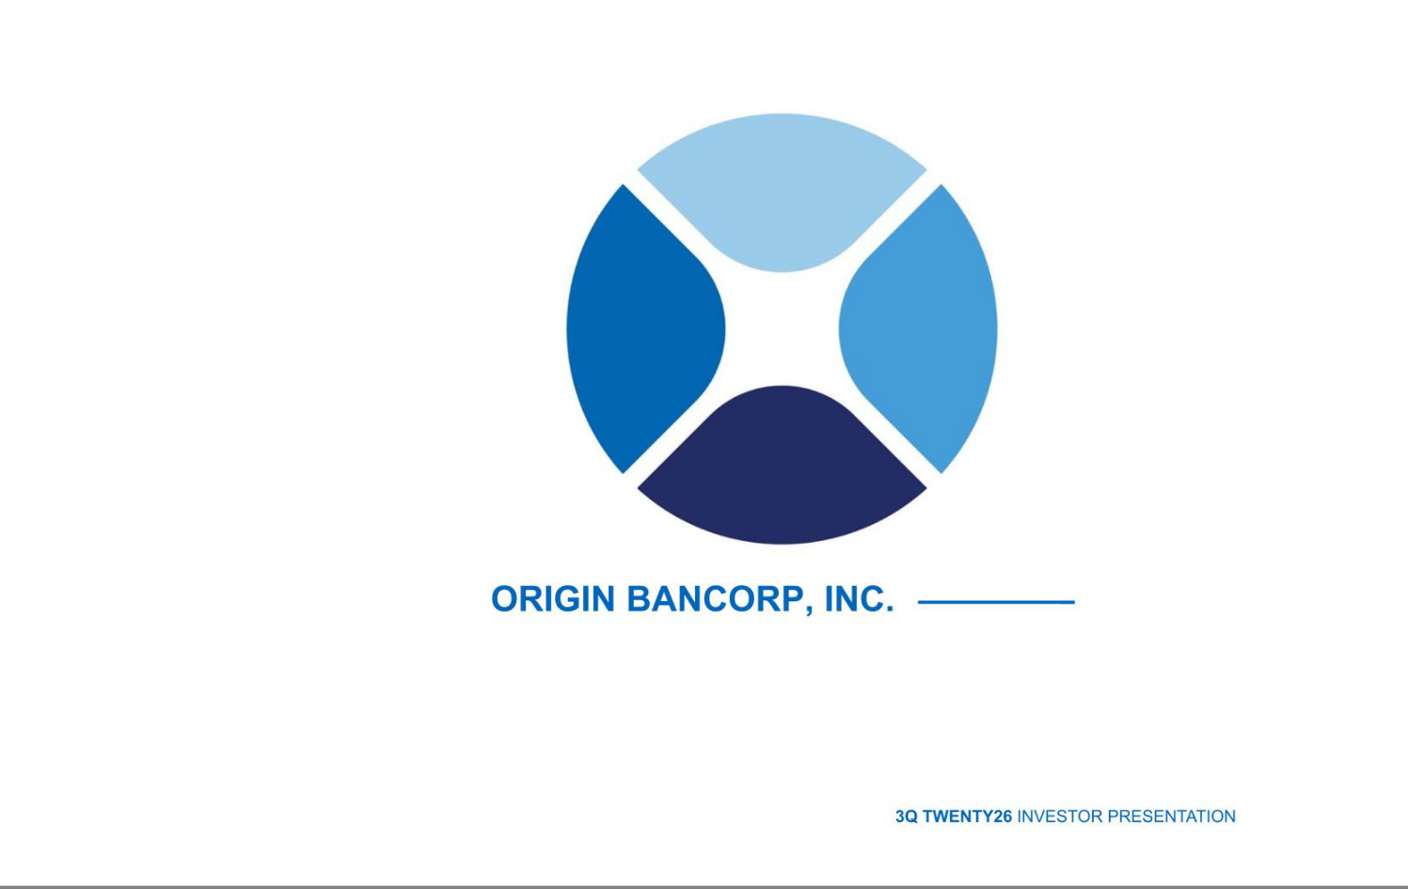

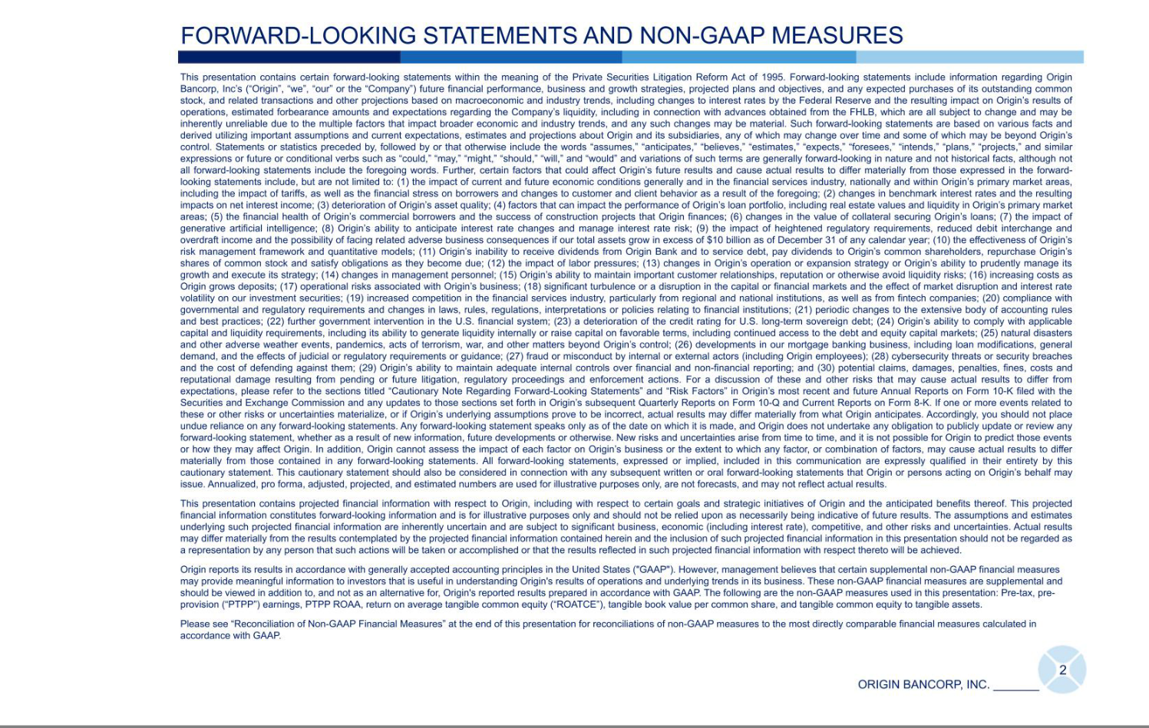

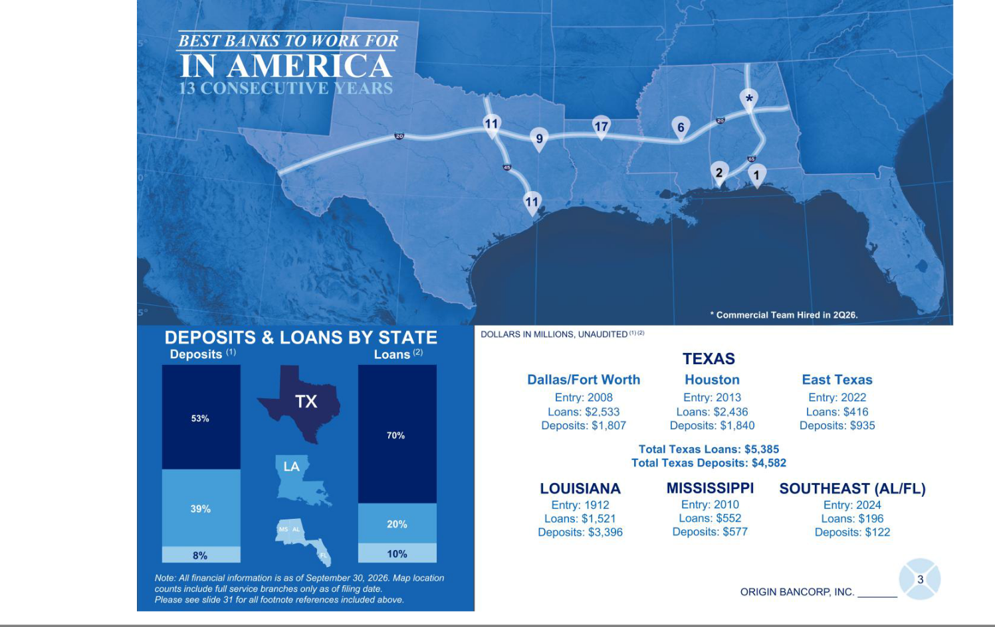

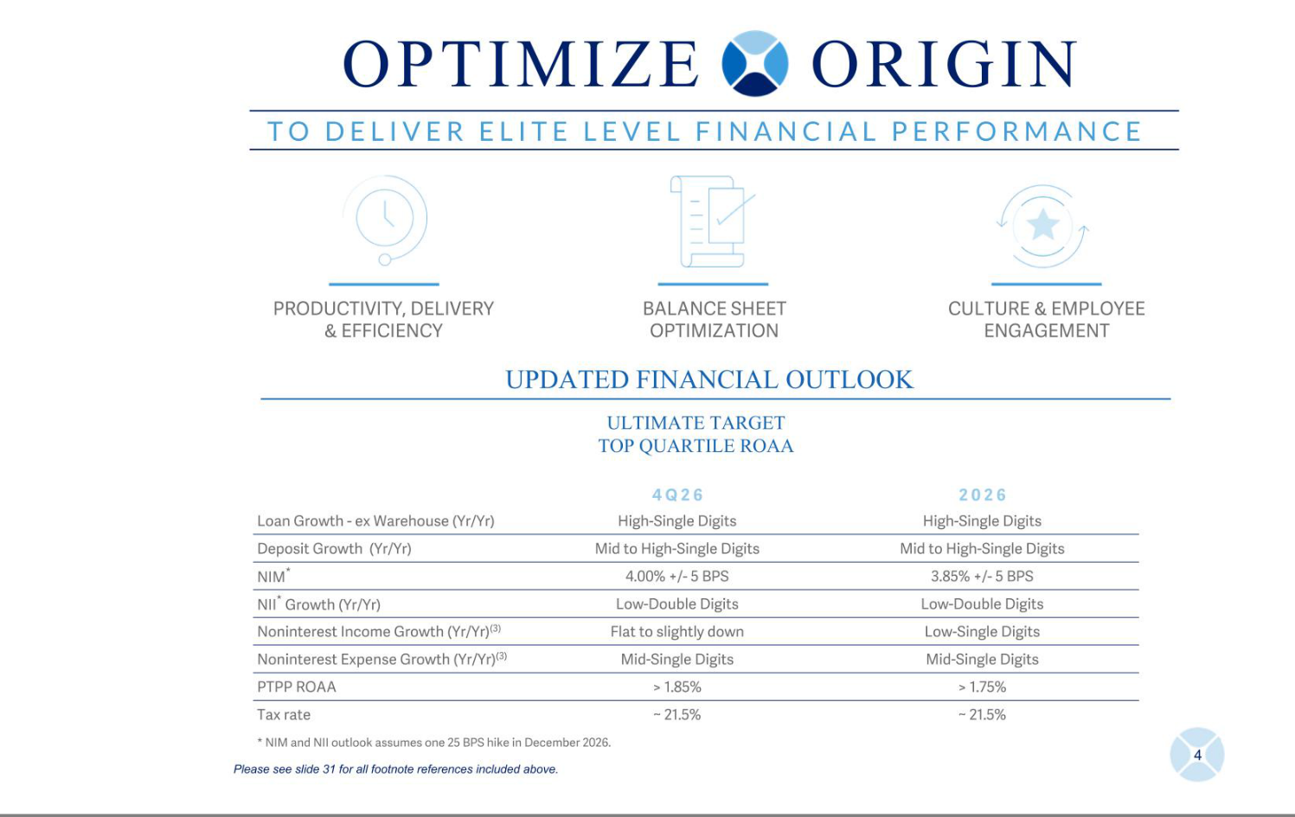

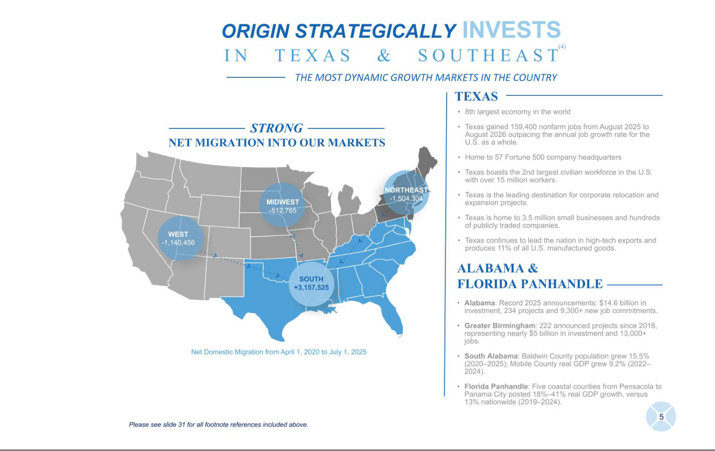

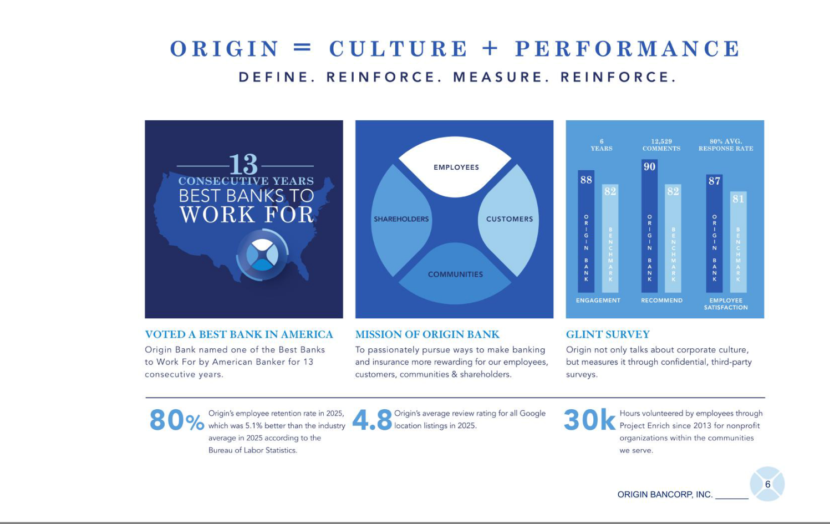

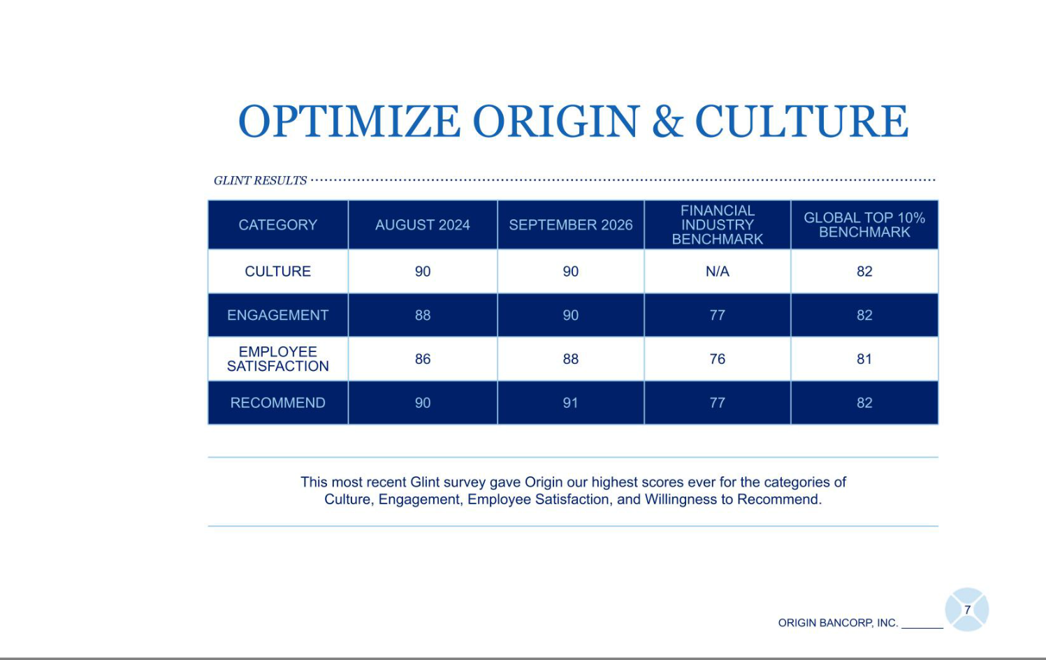

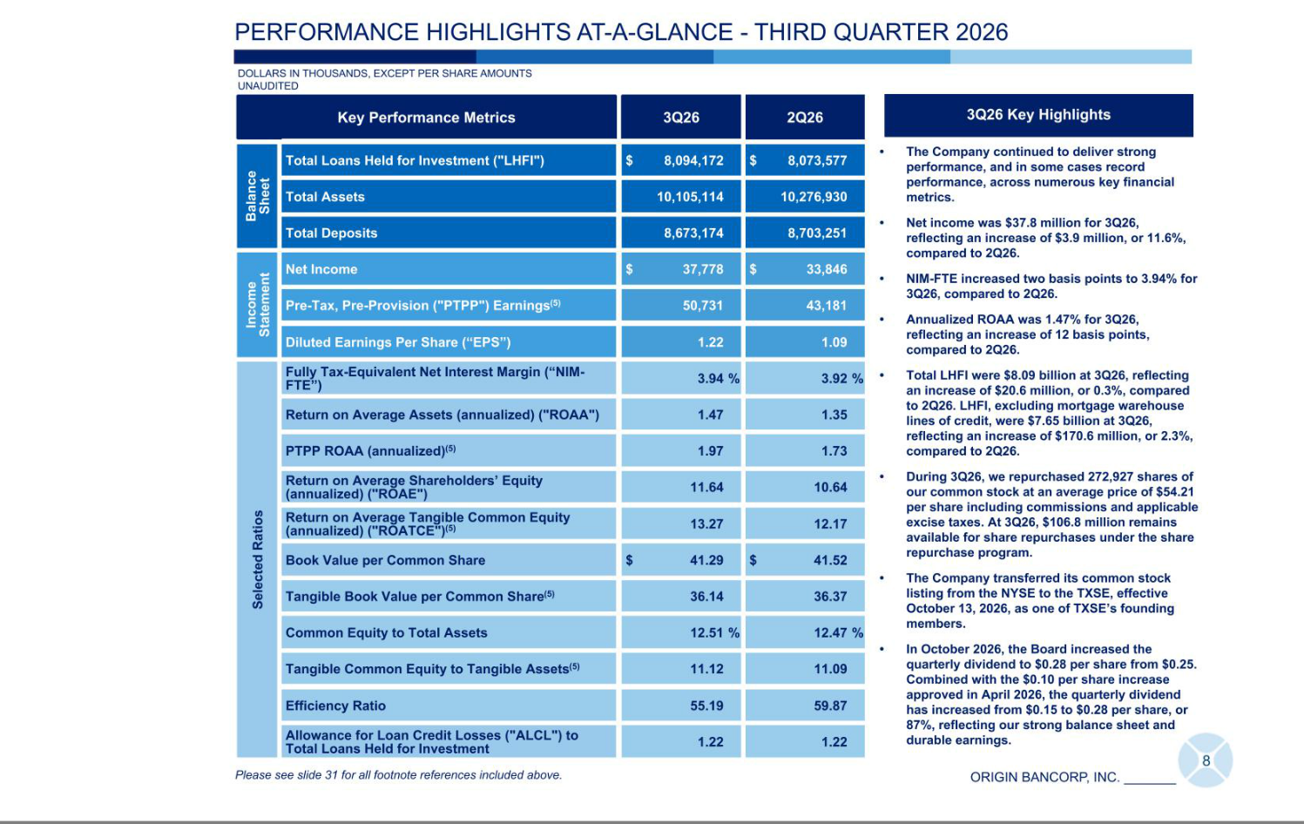

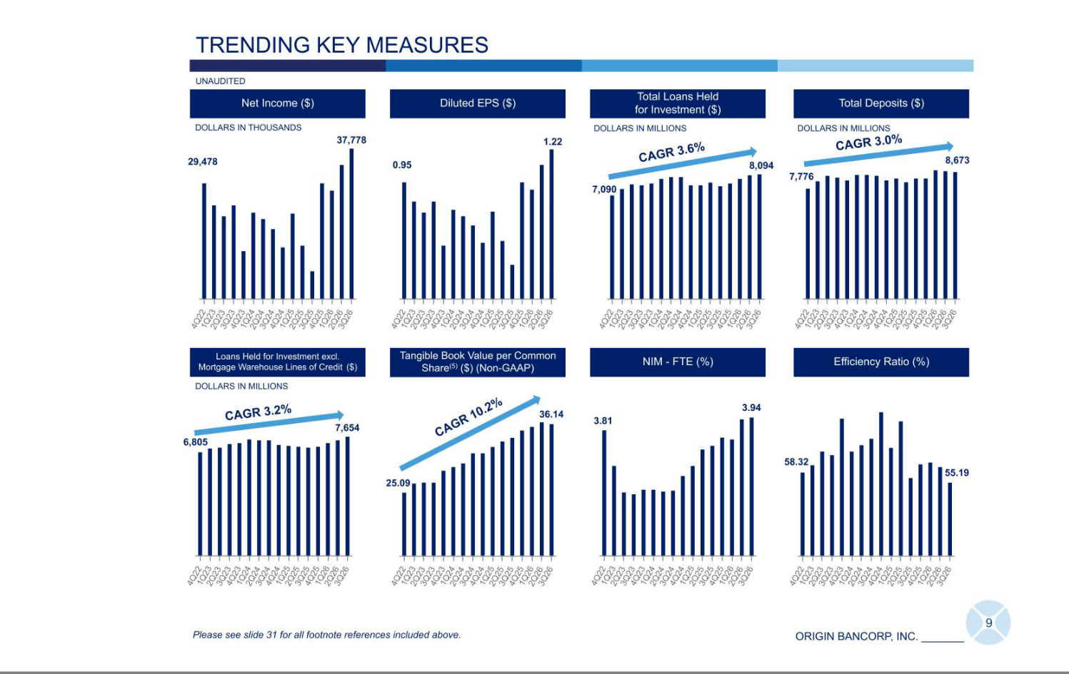

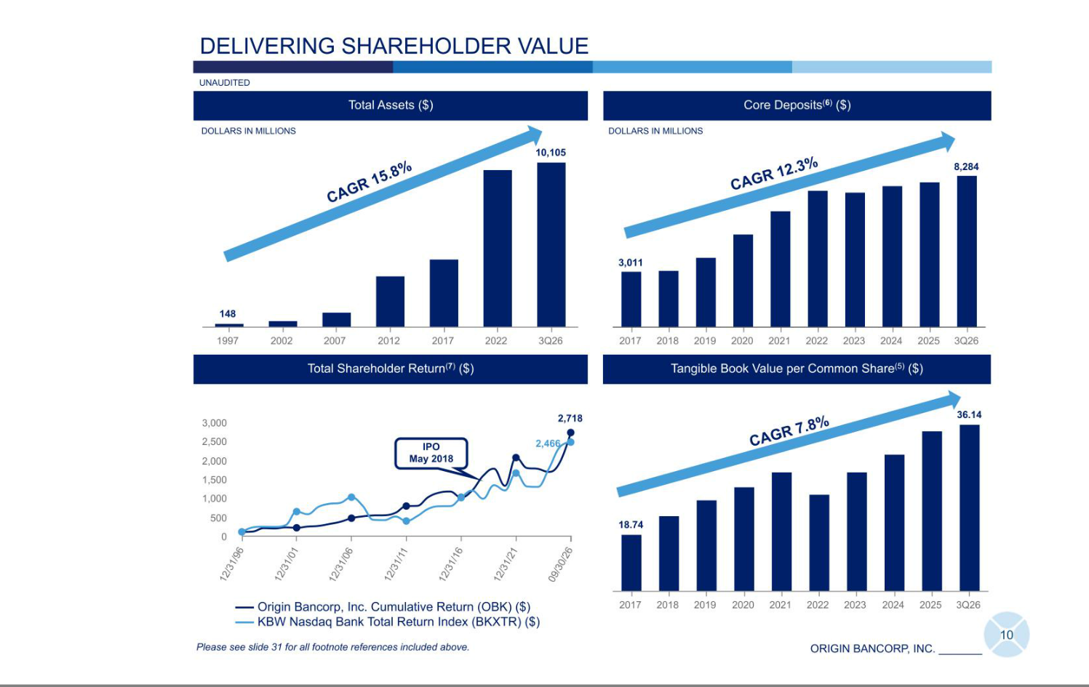

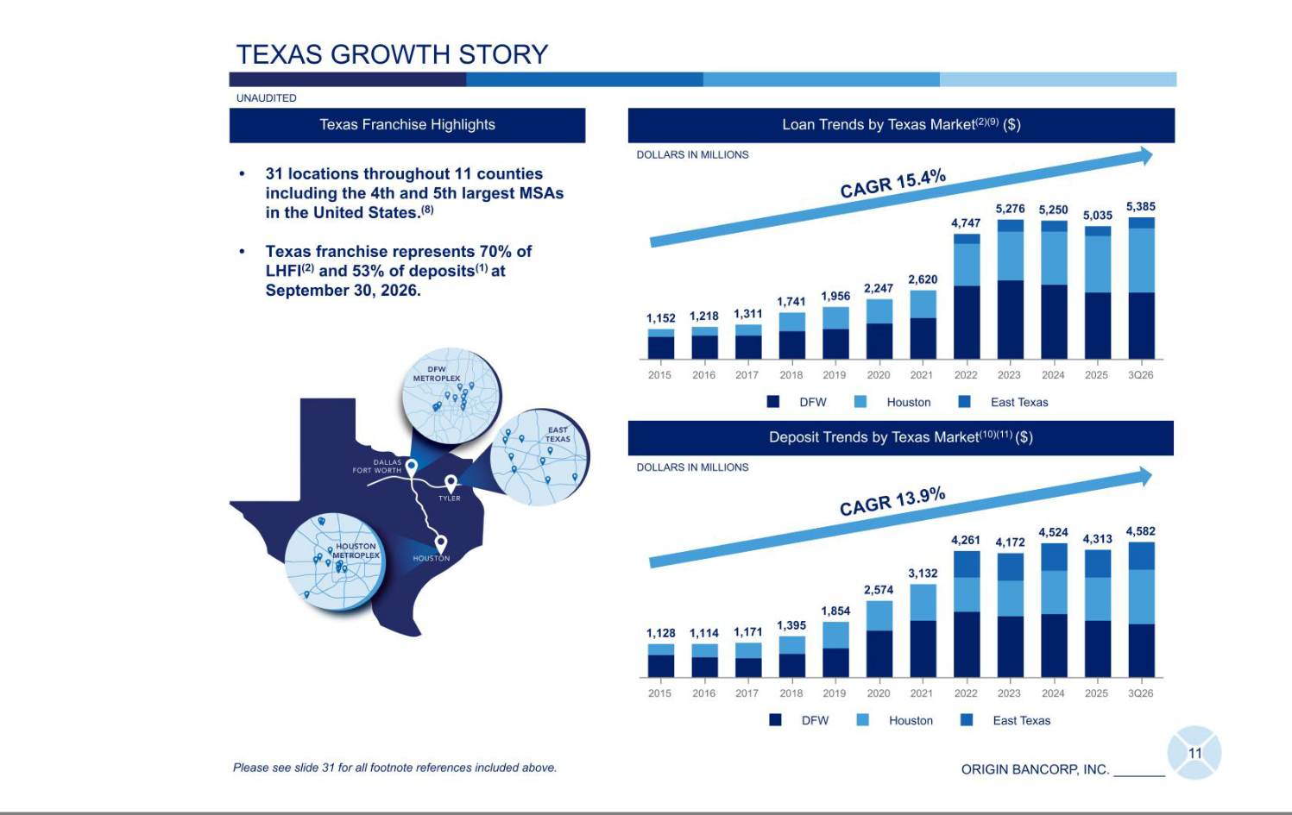

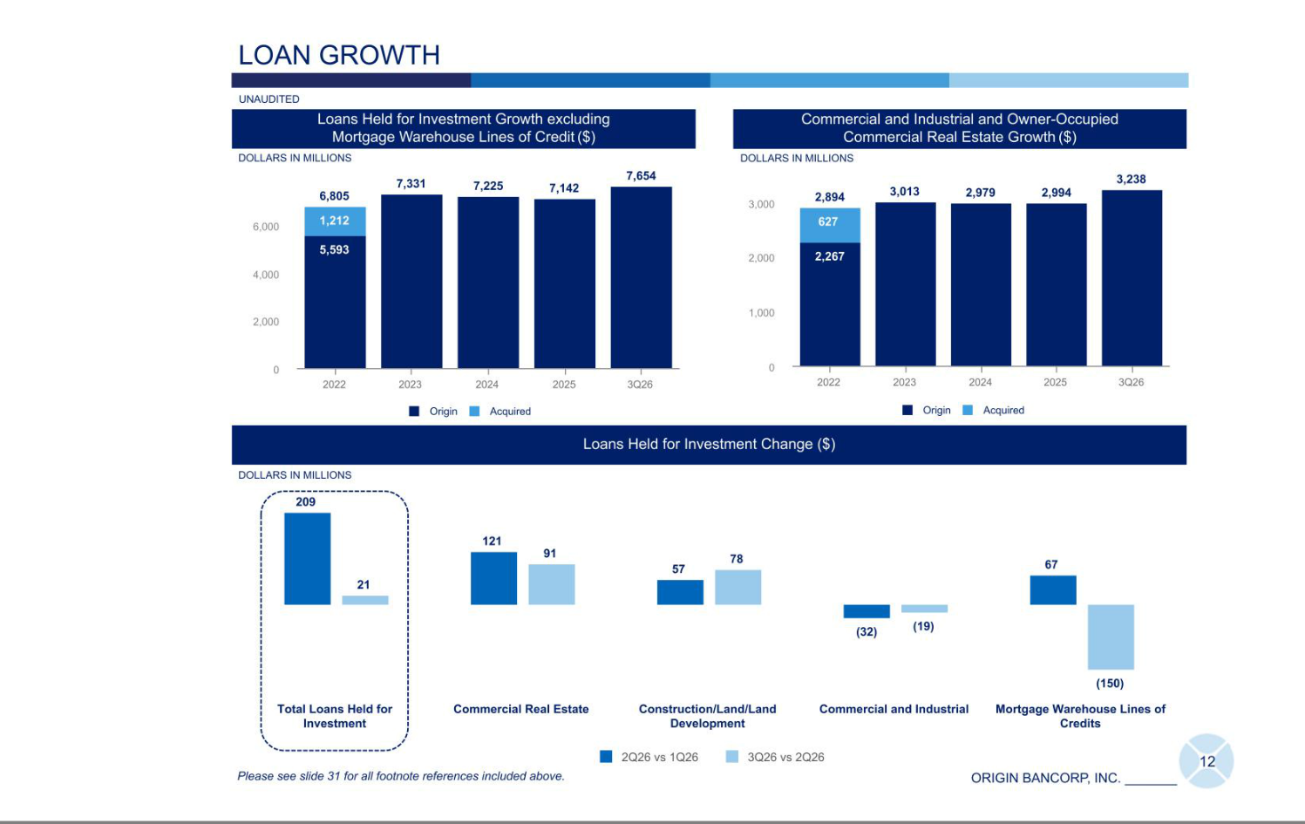

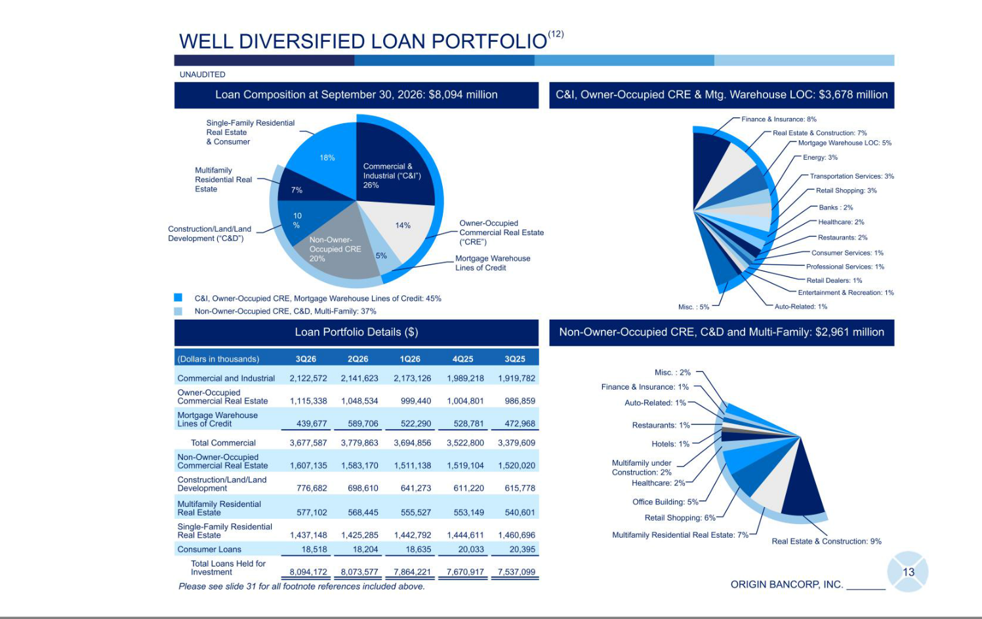

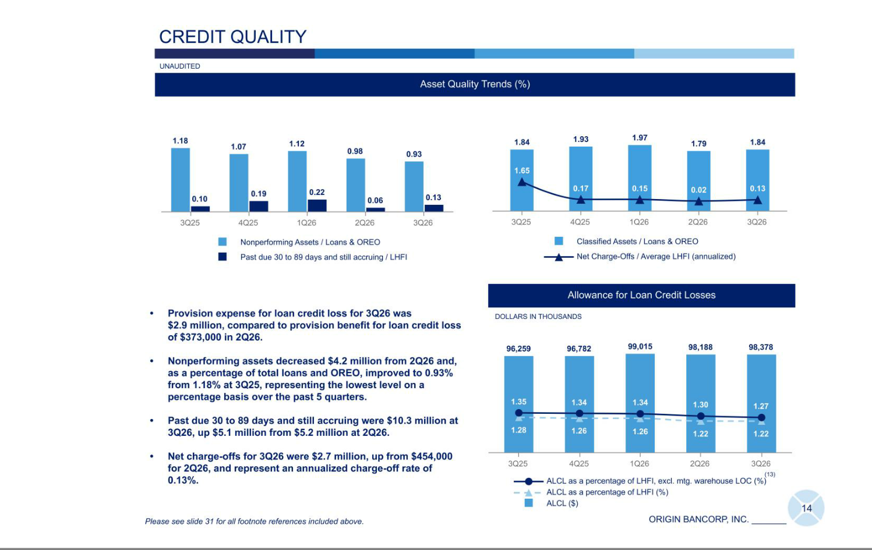

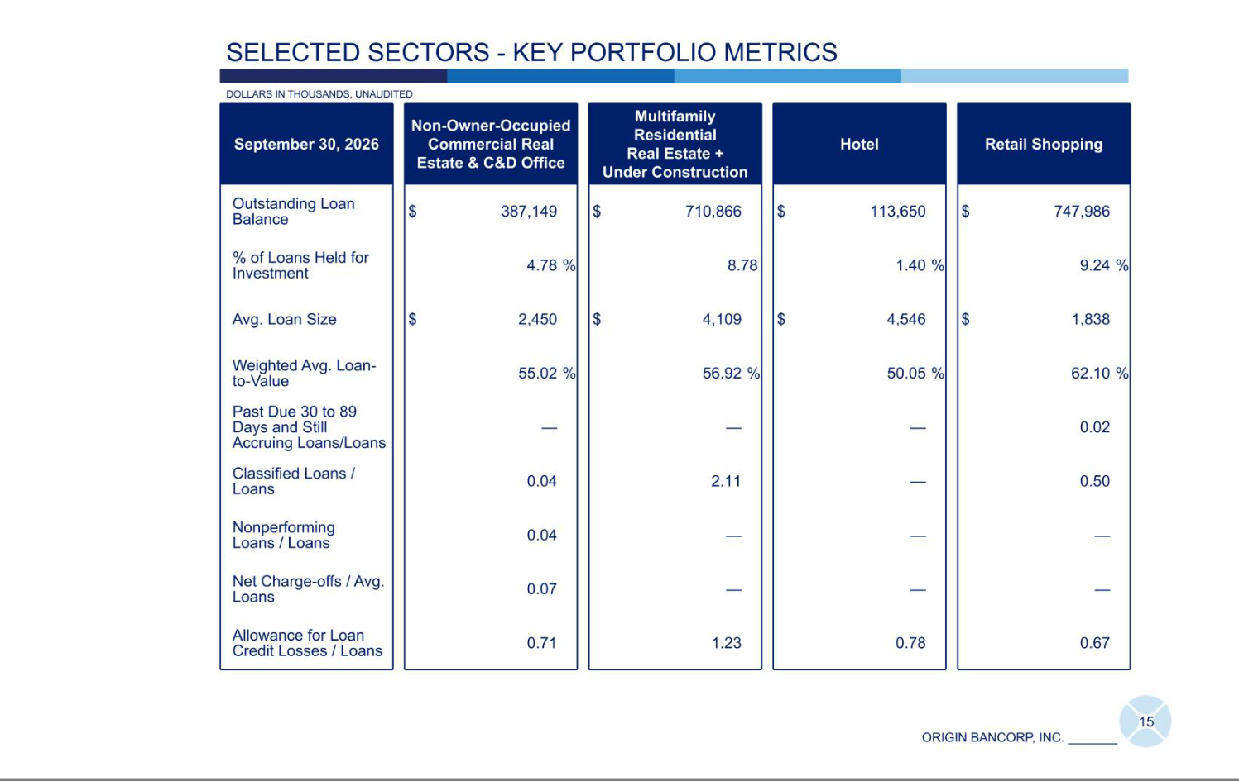

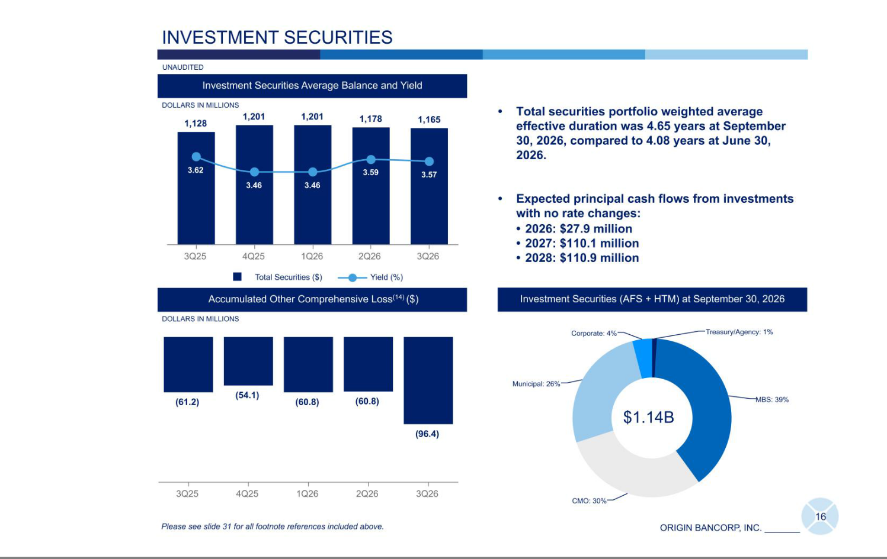

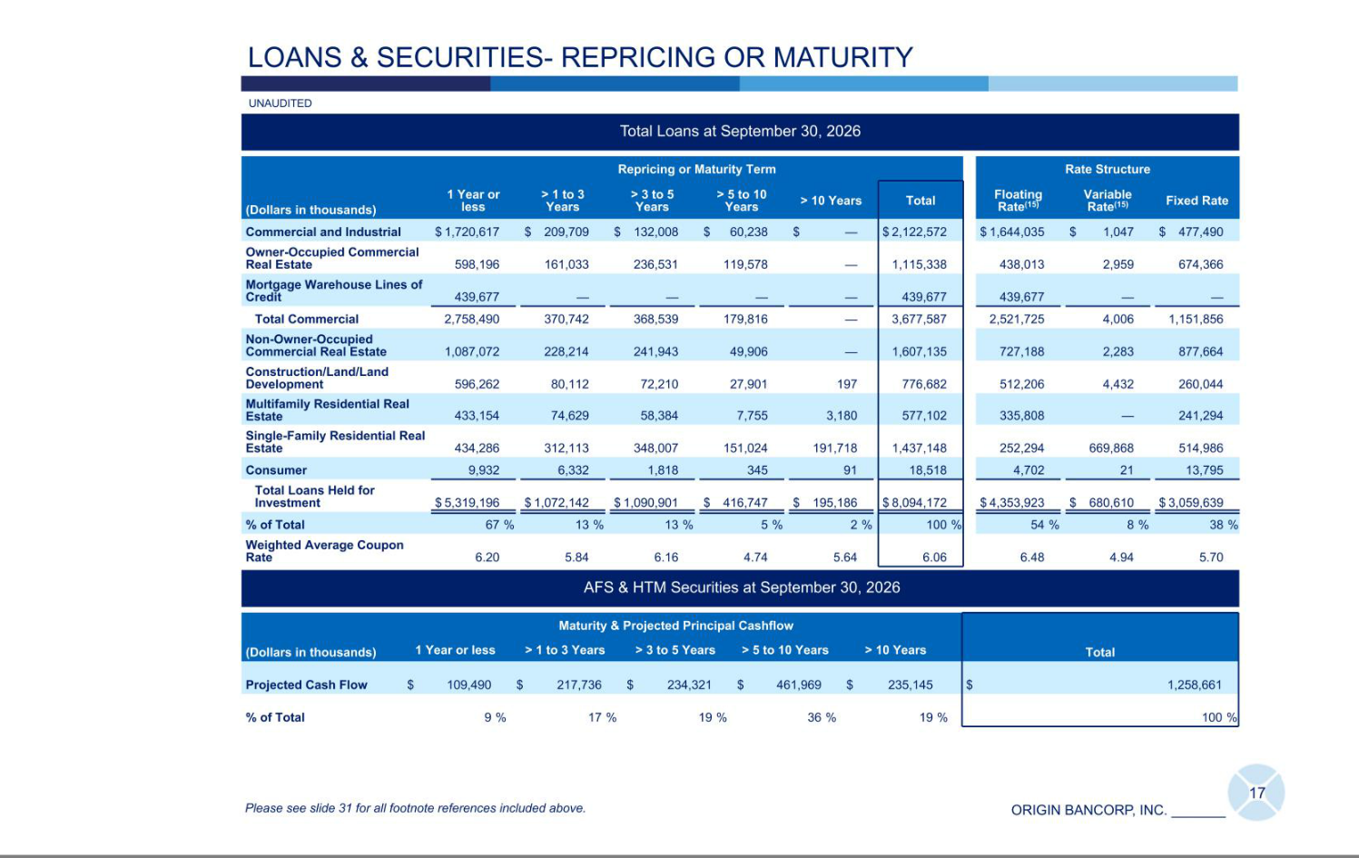

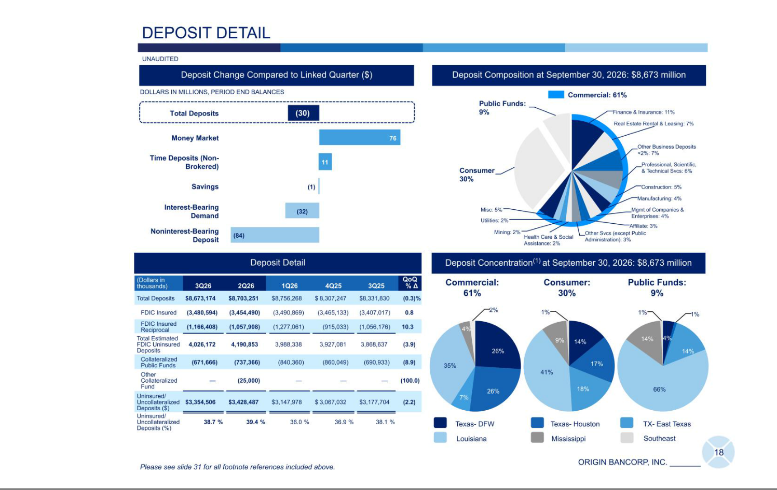

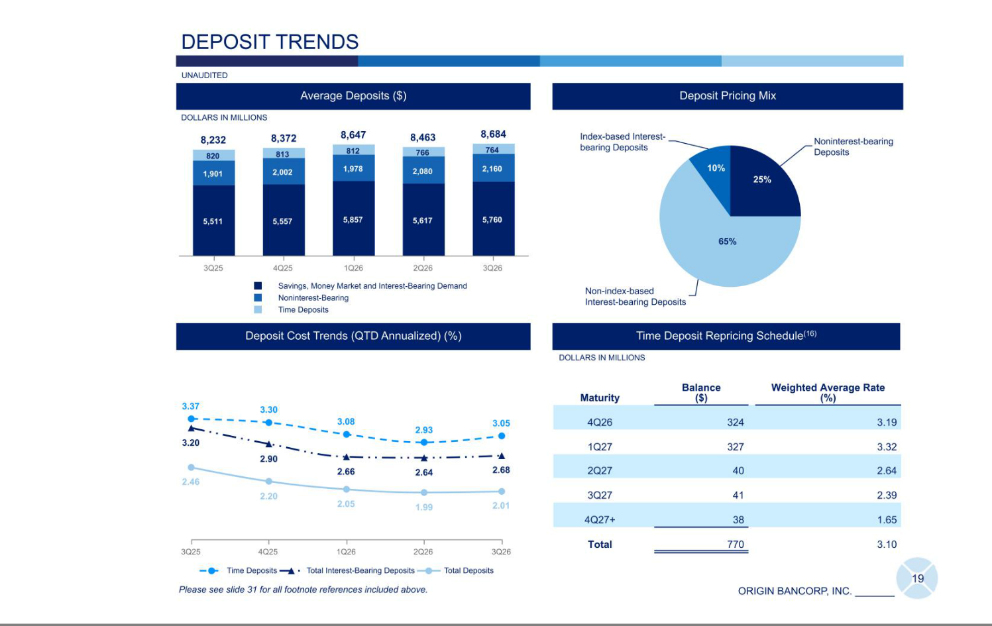

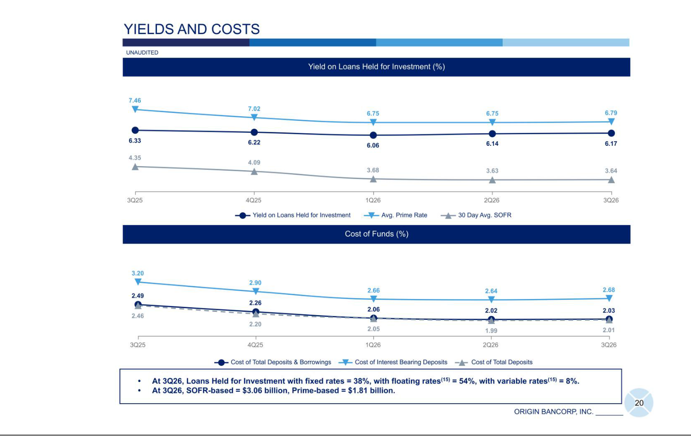

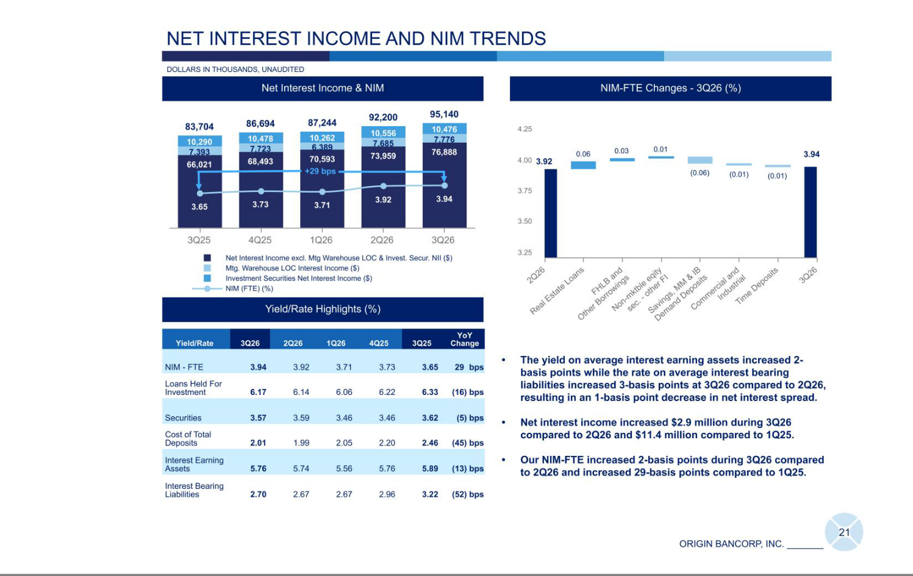

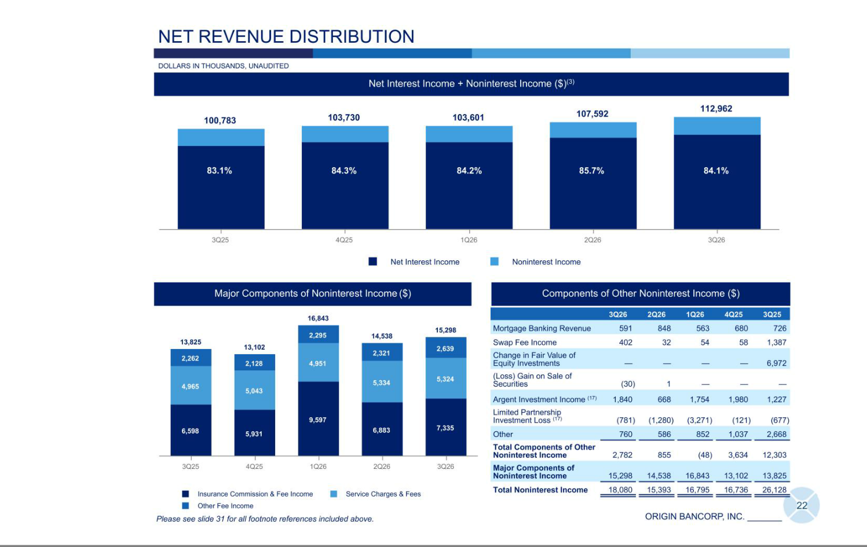

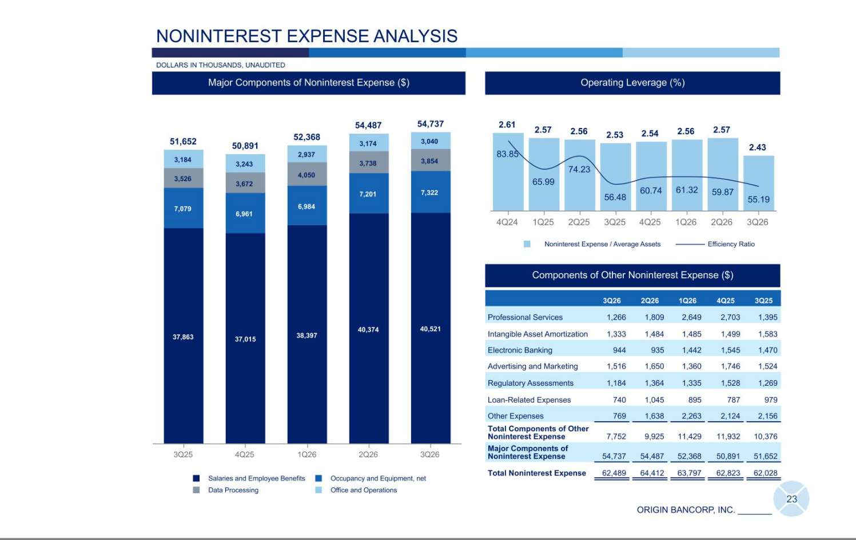

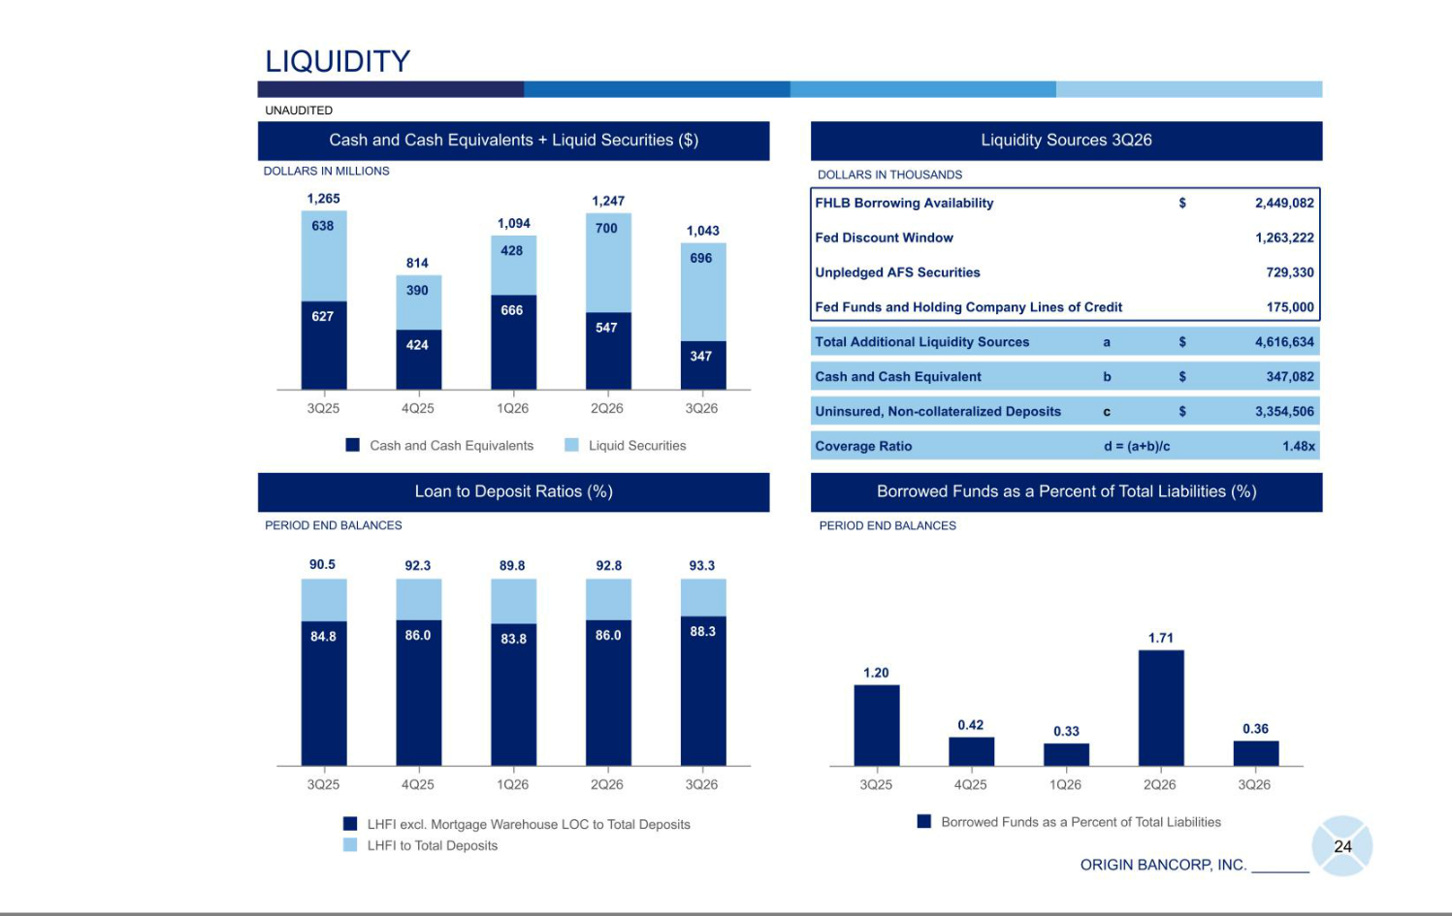

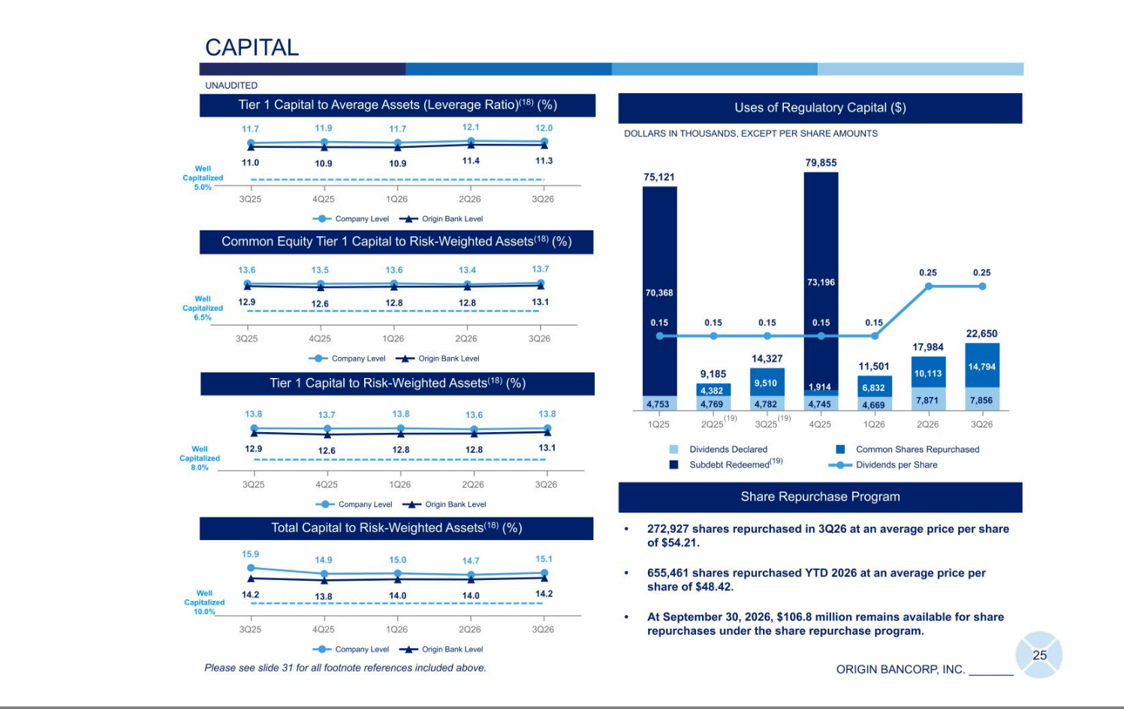

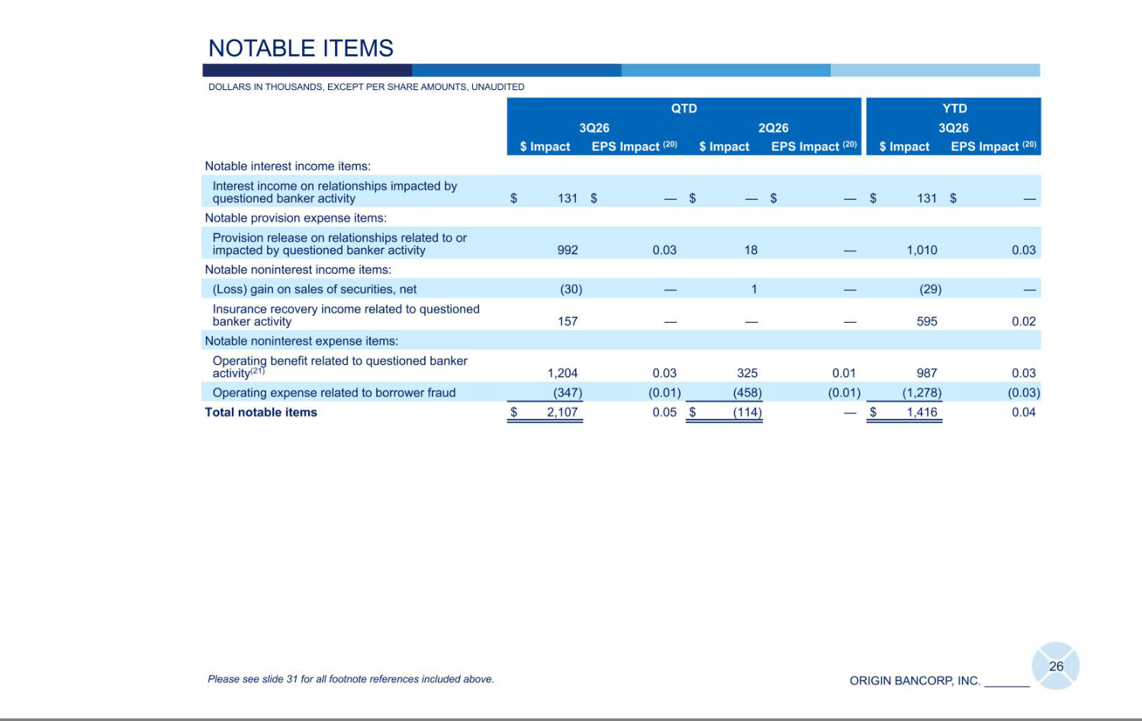

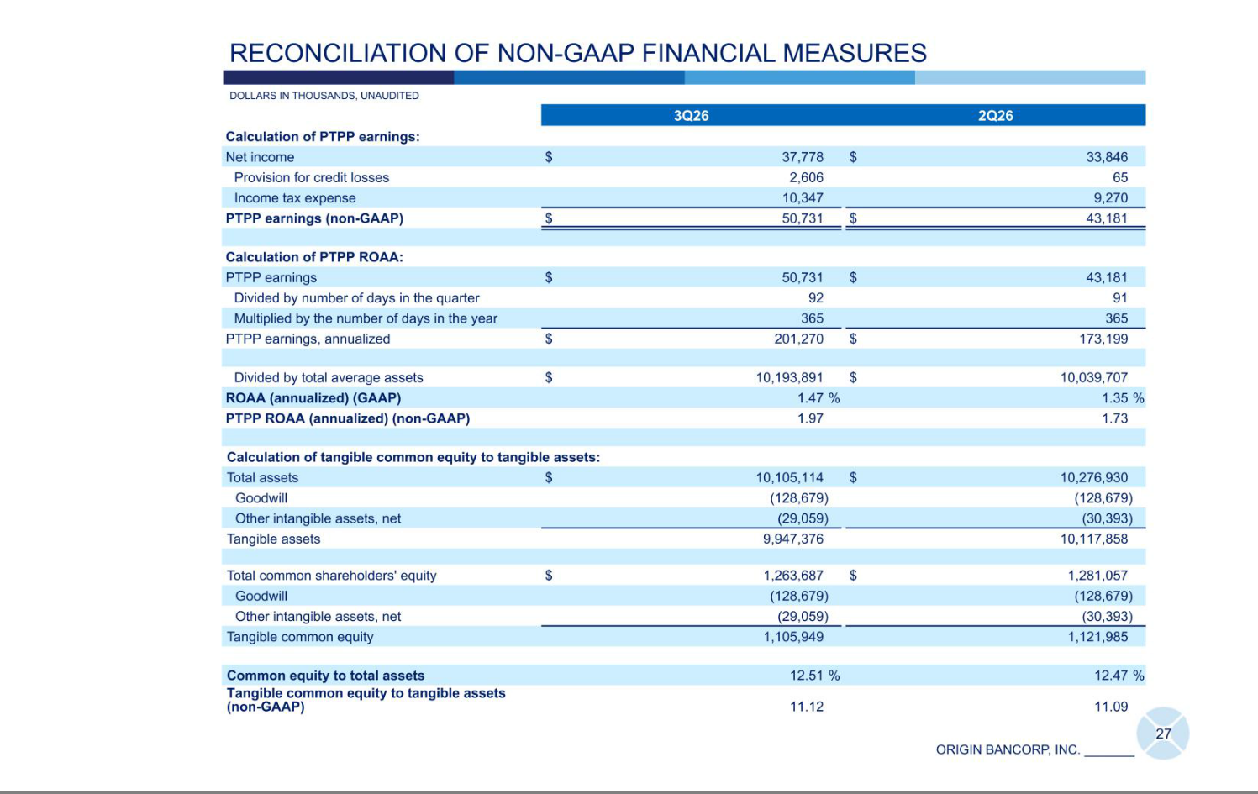

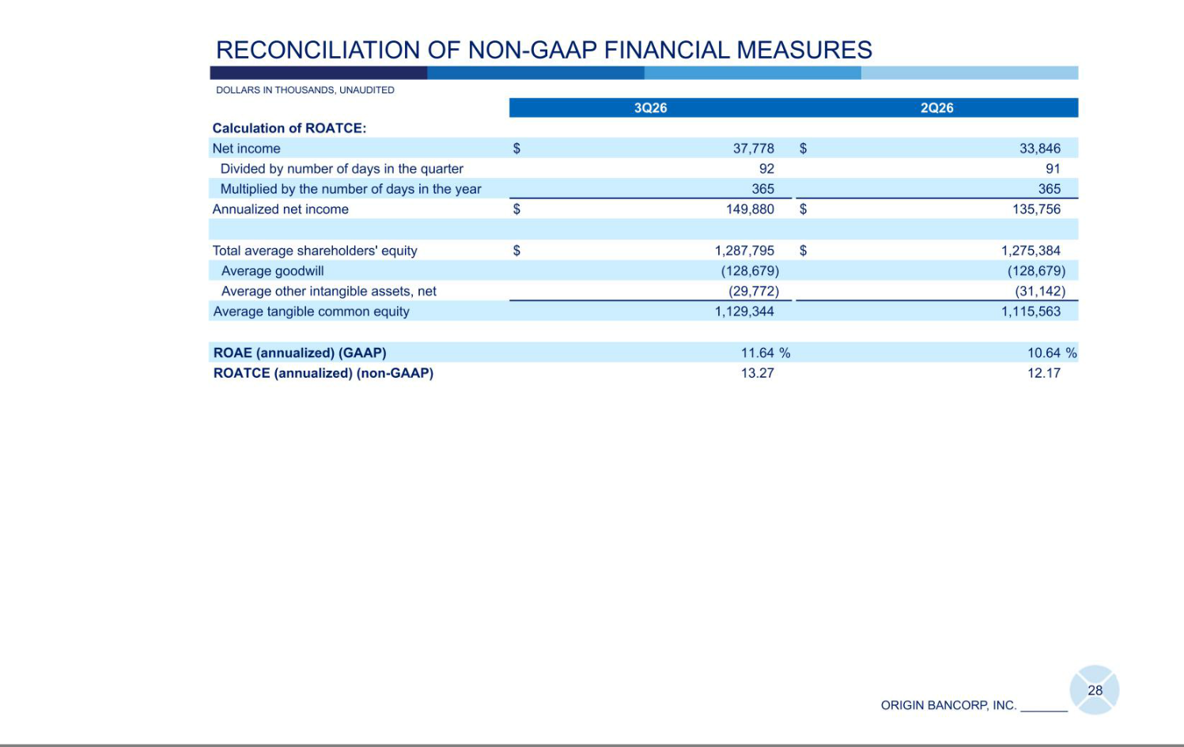

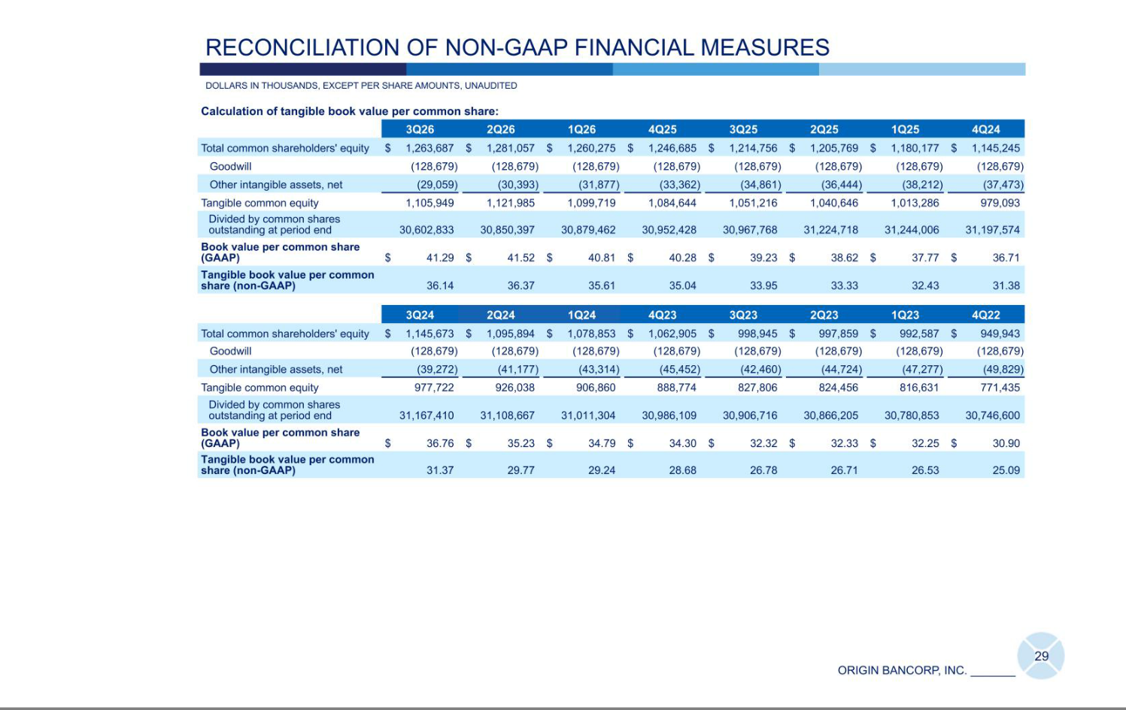

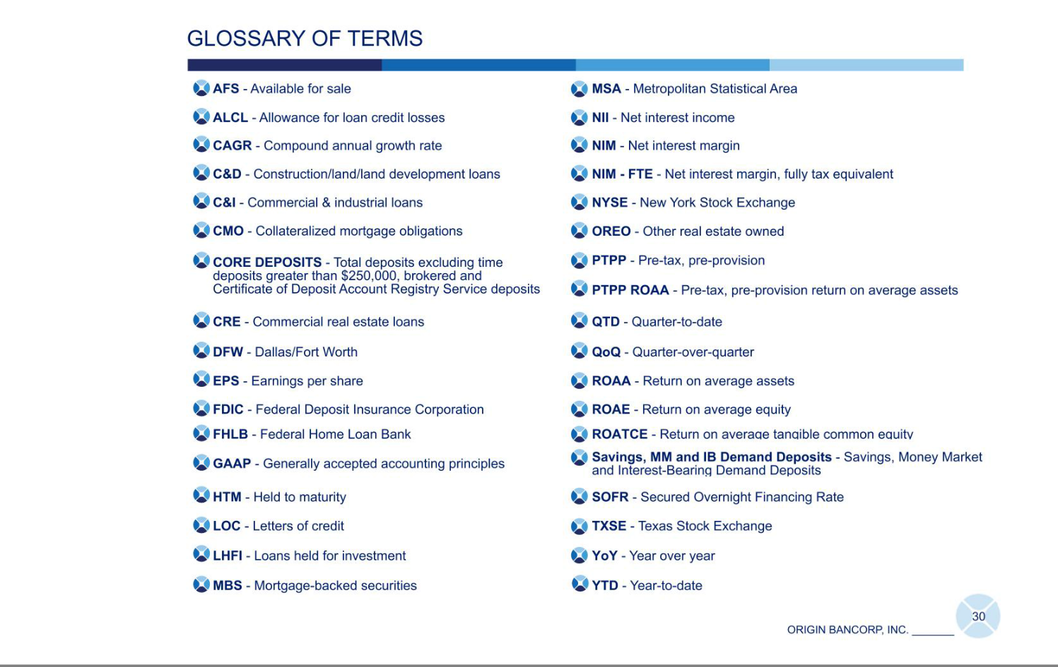

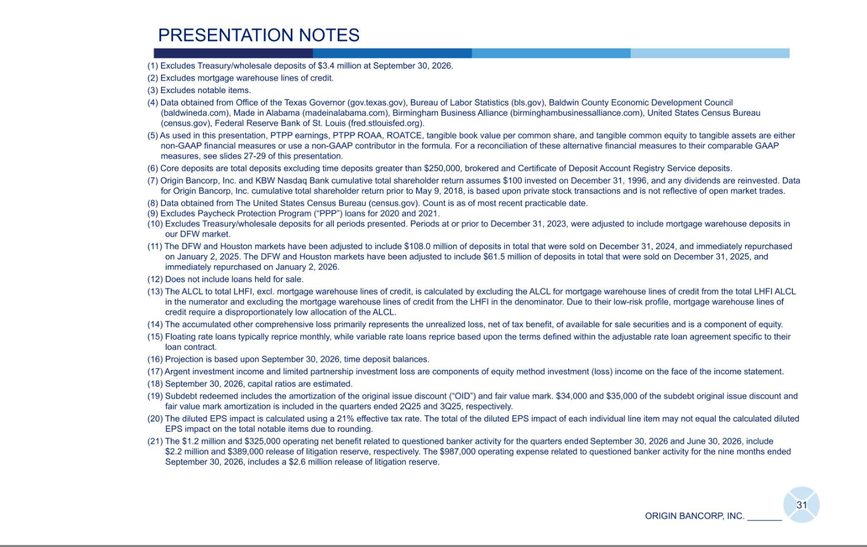

Exhibit 99.3


FOR IMMEDIATE RELEASE

October 28, 2026

Origin Bancorp, Inc. Announces Declaration of Quarterly Cash Dividend

RUSTON, LOUISIANA (October 28, 2026) - Origin Bancorp, Inc. (NYSE: OBK) ("Origin"), the holding company for Origin Bank, today announced that on October 28, 2026, its board of directors declared a quarterly cash dividend of $0.28 per share of its common stock. The cash dividend will be paid on November 30, 2026, to stockholders of record as of the close of business on November 13, 2026.

About Origin Bancorp, Inc.

Origin Bancorp, Inc. is a financial holding company headquartered in Ruston, Louisiana. Origin’s wholly owned bank subsidiary, Origin Bank, was founded in 1912 in Choudrant, Louisiana. Deeply rooted in Origin’s history is a culture committed to providing personalized relationship banking to businesses, municipalities, and personal clients to enrich the lives of the people in the communities it serves. Origin provides a broad range of financial services and currently operates more than 57 locations in Dallas/Fort Worth, East Texas, Houston, North Louisiana, Mississippi, Alabama and the Florida Panhandle. In addition, Origin provides a broad range of insurance agency products and services through its wholly owned insurance agency subsidiary, Forth Insurance, LLC. For more information, visit www.origin.bank and www.forthinsurance.com.

Forward-Looking Statements

When used in filings by Origin Bancorp, Inc. (the "Company") with the Securities and Exchange Commission (the "SEC"), in the Company's press releases or other public or stockholder communications, and in oral statements made with the approval of an authorized executive officer, the words or phrases "anticipates," "believes," "estimates," "expects," “foresees,” "intends," "plans," "projects," and similar expressions or future or conditional verbs such as "could," "may," “might,” "should," "will," and "would" or variations of such terms" are intended to identify "forward-looking statements" within the meaning of the Private Securities Litigation Reform Act of 1995. Such statements are subject to certain risks and uncertainties that could cause actual results to differ materially from historical earnings and those presently anticipated or projected. Factors that might cause such a difference include among other things: the expected payment date of its quarterly cash dividend; changes in economic conditions; other legislative changes generally; changes in policies by regulatory agencies; fluctuations in interest rates; the risks of lending and investing activities, including changes in the level and direction of loan delinquencies and write-offs and changes in estimates of the adequacy of the allowance for loan losses; the Company's ability to access cost-effective funding; fluctuations in real estate values and both residential and commercial real estate market conditions; demand for loans and deposits in the Company's market area; competition; and changes in management’s business strategies and other factors set forth in the Company's filings with the SEC.

The Company does not undertake and specifically declines any obligation - to update or revise any forward-looking statements to reflect events or circumstances that occur after the date of such statements or to reflect the occurrence of anticipated or unanticipated events.

Contact Information

Investor Relations

Chris Reigelman

318-497-3177

chris@origin.bank

Media Contact

Ryan Kilpatrick

318-232-7472

rkilpatrick@origin.bank

