UNITED STATES
SECURITIES AND EXCHANGE COMMISSION
Washington, D.C. 20549
FORM 8-K
CURRENT REPORT
Pursuant to Section 13 or 15(d) of the
Securities Exchange Act of 1934
Date of Report (Date of earliest event reported)
July 22, 2026
ORIGIN BANCORP, INC.
(Exact name of Registrant as specified in its charter)
Louisiana |  |  |  |  |  | 001-38487 |  |  |  |  |  | 72-1192928
(State or other jurisdiction of incorporation) |  |  |  |  |  | (Commission File No.) |  |  |  |  |  | (I.R.S. Employer Identification No.)

500 South Service Road East
Ruston, Louisiana 71270
(Address of principal executive offices including zip code)
(318) 255-2222
(Registrant's telephone number, including area code)
Not Applicable
(Former name or former address, if changed since last report)
Check the appropriate box below if the Form 8-K filing is intended to simultaneously satisfy the filing obligation of the registrant under any of the following provisions:
☐ Written communications pursuant to Rule 425 under the Securities Act (17 CFR 230.425)
☐ Soliciting material pursuant to Rule 14a-12 under the Exchange Act (17 CFR 240.14a-12)
☐ Pre-commencement communications pursuant to Rule 14d-2(b) under the Exchange Act (17 CFR 240.14d-2(b))
☐ Pre-commencement communications pursuant to Rule 13e-4(c) under the Exchange Act (17 CFR 240.13e-4(c))

Securities registered pursuant to Section 12(b) of the Act:
Title of each class |  |  |  |  |  | Trading Symbol(s) |  |  |  |  |  | Name of each exchange on which registered
Common Stock, par value $5.00 per share |  |  |  |  |  | OBK |  |  |  |  |  | New York Stock Exchange
Indicate by check mark whether the registrant is an emerging growth company as defined in Rule 405 of the Securities Act of 1933 (§230.405 of this chapter) or Rule 12b-2 of the Securities Exchange Act of 1934 (§240.12b-2 of this chapter).
Emerging growth company ☐

If an emerging growth company, indicate by check mark if the registrant has elected not to use the extended transition period for complying with any new or revised financial accounting standards provided pursuant to Section 13(a) of the Exchange Act. ☐

ITEM 2.02 |  |  | Results of Operations and Financial Condition
On July 22, 2026, Origin Bancorp, Inc. (the "Company" or the "Registrant") issued a press release announcing its second quarter 2026 results of operations. A copy of the press release is attached hereto as Exhibit 99.1, which is incorporated herein by reference.
On Thursday, July 23, 2026, at 8:00 a.m. Central Time, the Company will host an investor conference call and webcast to review its second quarter 2026 financial results. The webcast will include presentation materials, which consist of information regarding the Company's results of operations and financial performance. The presentation materials will be posted on the Company's website on July 22, 2026. The presentation materials are attached hereto as Exhibit 99.2, which is incorporated herein by reference.
As provided in General Instructions B.2 to Form 8-K, the information furnished in Item 2.02, Exhibit 99.1 and Exhibit 99.2 of this Current Report on Form 8-K shall not be deemed "filed" for purposes of Section 18 of the Securities Exchange Act of 1934, as amended (the "Exchange Act"), or otherwise subject to the liabilities of that section, and such information shall not be deemed incorporated by reference in any filing under the Securities Act of 1933, as amended, or the Exchange Act, except as shall be expressly set forth by specific reference in such filing.
ITEM 8.01 |  |  | Other Events
On July 22, 2026, the Company issued a press release announcing that the board of directors of the Company declared a quarterly cash dividend of $0.25 per share of its common stock. The cash dividend will be paid on August 31, 2026, to stockholders of record as of the close of business on August 14, 2026. The press release is attached hereto as Exhibit 99.3, and incorporated herein by reference.
ITEM 9.01 |  |  | Financial Statements and Exhibits
(d) |  |  | Exhibits.
Exhibit 99.1 |  |  | Press release, dated July 22, 2026, announcing second quarter 2026 earnings
Exhibit 99.2 |  |  | Presentation materials
Exhibit 99.3 |  |  | Press release, dated July 22, 2026, announcing quarterly dividend
Exhibit 104 |  |  | Cover Page Interactive Data File (embedded within the Inline XBRL document)

SIGNATURES
Pursuant to the requirements of the Securities Exchange Act of 1934, as amended, the Registrant has duly caused this report to be signed on its behalf by the undersigned thereunto duly authorized.
Dated: July 22, 2026 |  |  |  |  |  | ORIGIN BANCORP, INC.
 |  |  |  |  |  | By: /s/ William J. Wallace, IV
 |  |  |  |  |  | William J. Wallace, IV
 |  |  |  |  |  | Senior Executive Officer and Chief Financial Officer

Exhibit 99.1
For Immediate Release

ORIGIN BANCORP, INC. REPORTS EARNINGS FOR SECOND QUARTER 2026
RUSTON, Louisiana (July 22, 2026) - Origin Bancorp, Inc. (NYSE: OBK) (“Origin,” “we,” “our” or the “Company”), the holding company for Origin Bank (the “Bank”), today announced net income of $33.8 million, or $1.09 diluted earnings per share (“EPS”) for the quarter ended June 30, 2026, compared to net income of $27.7 million, or $0.89 diluted EPS, for the quarter ended March 31, 2026. Pre-tax, pre-provision (“PTPP”)(1) earnings were $43.2 million for the quarter ended June 30, 2026, compared to $40.2 million for the linked quarter.
“This quarter’s results represent another meaningful step forward in the journey we began with Optimize Origin a year and a half ago,” said Drake Mills, chairman, president and CEO of Origin Bancorp, Inc. “As we move through the remainder of 2026, our objectives remain clear. We will continue to execute on Optimize Origin, invest strategically across our footprint, attract exceptional talent, and appropriately deploy excess capital.”

(1) PTPP earnings is a non-GAAP financial measure, please see the last few pages of this document for a reconciliation of this alternative financial measure to its most directly comparable GAAP measure.
Optimize Origin
•In January 2025, we announced our Optimize Origin initiative to drive elite financial performance and enhance our award-winning culture, and it continues to be an important part of our corporate DNA.
•Built on three primary pillars:
◦Productivity, Delivery & Efficiency
◦Balance Sheet Optimization
◦Culture & Employee Engagement
•As announced in our Fourth Quarter and Full Year 2025 Earnings Release, our near term ROAA run rate target is 1.15% or higher by 4Q26, as we continue towards our ultimate top quartile ROAA target.
Financial Highlights
•The Company delivered strong performance, and in some cases, record performance across numerous key financial metrics including, but not limited to, net income, net interest income, fully tax-equivalent net interest margin (“NIM-FTE”), annualized ROAA, annualized ROAE, and book value per common share.
•Net income was $33.8 million for the quarter ended June 30, 2026, reflecting an increase of $6.2 million, or 22.2%, compared to the linked quarter.
•Our NIM-FTE increased 21 basis points to 3.92% for the quarter ended June 30, 2026, compared to the quarter ended March 31, 2026. Our net interest spread increased to 3.07%, or 18 basis points, compared to the linked quarter.
•Annualized ROAA was 1.35% for the quarter ended June 30, 2026, reflecting an increase of 24 basis points, compared to the quarter ended March 31, 2026.
•Total loans held for investment (“LHFI”) were $8.07 billion at June 30, 2026, reflecting an increase of $209.4 million, or 2.7%, compared to March 31, 2026. LHFI, excluding mortgage warehouse lines of credit, were $7.48 billion at June 30, 2026, reflecting an increase of $141.9 million, or 1.9%, compared to March 31, 2026.
1
•During the quarter ended June 30, 2026, we repurchased 217,034 shares of our common stock at an average price of $46.60 per share, including commissions and applicable excise taxes. Also, in July 2026, our board of directors approved a $100 million increase in repurchase authority under our current stock repurchase program, which expires in July 2028. As of the date of this release, $121.6 million remains available for share repurchases under the stock repurchase program.
•During April 2026, our board approved an increase in our quarterly dividend from $0.15 to $0.25 per share, a 67% increase, reflecting balance sheet strength and earnings durability.

Results of Operations for the Quarter Ended June 30, 2026
Net Interest Income and Net Interest Margin
Net interest income for the quarter ended June 30, 2026, was $92.2 million, an increase of $5.0 million, or 5.7%, compared to the quarter ended March 31, 2026. The expansion in net interest income was primarily driven by a $4.4 million increase in interest income and a $529,000 decrease in interest expense.
The $4.4 million increase in interest income was primarily due to a $7.7 million increase in interest income on loans held for investment, partially offset by a $3.6 million decrease in interest income on interest-earning balances due from banks. The increase in interest income on loans held for investment was mainly driven by higher average loan balances, which contributed $5.1 million of the increase. An additional $1.3 million resulted from one additional calendar day during the current quarter, while the remaining $1.3 million was attributable to higher loan yields. The decrease in interest income on interest-earning balances due from banks was primarily driven by lower average balances, which decreased to $309.5 million, from $714.0 million for the quarter ended March 31, 2026.
The $529,000 decrease in interest expense was primarily attributable to a $1.7 million decrease in interest expense on interest-bearing deposits, partially offset by a $1.2 million increase in interest expense on FHLB advances and other borrowings. The decrease in interest expense on interest-bearing deposits was primarily driven by lower average balances, which reduced interest expense on interest-bearing demand deposits by $1.0 million. Lower average balances and rates on time deposits decreased interest expense by $634,000. The increase in interest expense on FHLB and other borrowings was mainly attributable to higher average borrowing balances, which increased interest expense by approximately $841,000.
The Federal Reserve Board sets various benchmark rates, including the federal funds rate, and thereby influences the general market rates of interest, including loan and deposit rates offered by financial institutions. On October 29, 2025, and December 10, 2025, the Federal Reserve Board reduced the federal funds target rate range by 25 basis points each, to a range of 3.50% to 3.75%, and has maintained that target rate range.
Our NIM-FTE was 3.92% for the quarter ended June 30, 2026, up 21 basis points from the linked quarter and 31 basis points from the quarter ended June 30, 2025. The yield earned on interest-earning assets was 5.74%, representing an 18-basis-point increase and a 13-basis-point decrease compared to the linked quarter and the quarter ended June 30, 2025, respectively. The average rate paid on total interest-bearing liabilities was 2.67%, unchanged from the linked quarter and down 58 basis points compared to the quarter ended June 30, 2025.

2
Credit Quality
The table below includes key credit quality information:
 |  |  | At and For the Three Months Ended |  |  |  |  |  |  |  |  |  |  |  |  |  |  |  |  |  |  | Change |  |  |  |  |  | % Change
(Dollars in thousands, unaudited) |  |  | June 30,  2026 |  |  |  |  |  | March 31,  2026 |  |  |  |  |  | June 30,  2025 |  |  |  |  |  |  | Linked  Quarter |  |  |  |  |  | Linked  Quarter
Past due 30 to 89 days and still accruing |  |  | $ | 5,203 |  |  |  |  | $ | 17,624 |  |  |  |  | $ | 12,495 |  |  |  |  |  | $ | (12,421) |  |  |  |  | (70.5) |  | %
Allowance for loan credit losses (“ALCL”) |  |  | 98,188 |  |  |  |  |  | 99,015 |  |  |  |  |  | 92,426 |  |  |  |  |  |  | (827) |  |  |  |  |  | (0.8)
Total nonperforming LHFI |  |  | 78,522 |  |  |  |  |  | 87,266 |  |  |  |  |  | 85,315 |  |  |  |  |  |  | (8,744) |  |  |  |  |  | (10.0)
Provision for credit losses |  |  | 65 |  |  |  |  |  | 4,965 |  |  |  |  |  | 2,862 |  |  |  |  |  |  | (4,900) |  |  |  |  |  | (98.7)
Net charge-offs |  |  | 454 |  |  |  |  |  | 2,777 |  |  |  |  |  | 2,300 |  |  |  |  |  |  | (2,323) |  |  |  |  |  | (83.7)
Credit quality ratios(1):
ALCL to nonperforming LHFI |  |  | 125.05 |  | % |  |  |  | 113.46 |  | % |  |  |  | 108.33 |  | % |  |  |  |  | 11.59 |  | % |  |  |  | N/A
ALCL to total LHFI |  |  | 1.22 |  |  |  |  |  | 1.26 |  |  |  |  |  | 1.20 |  |  |  |  |  |  | (0.04) |  |  |  |  |  | N/A
ALCL to total LHFI, adjusted(2) |  |  | 1.30 |  |  |  |  |  | 1.34 |  |  |  |  |  | 1.29 |  |  |  |  |  |  | (0.04) |  |  |  |  |  | N/A
Nonperforming LHFI to LHFI |  |  | 0.97 |  |  |  |  |  | 1.11 |  |  |  |  |  | 1.11 |  |  |  |  |  |  | (0.14) |  |  |  |  |  | N/A
Net charge-offs to total average LHFI (annualized) |  |  | 0.02 |  |  |  |  |  | 0.15 |  |  |  |  |  | 0.12 |  |  |  |  |  |  | (0.13) |  |  |  |  |  | N/A
___________________________
N/A = Not applicable.
(1)Please see the Loan Data schedule at the back of this document for additional information.
(2)The ALCL to total LHFI, adjusted, is calculated by excluding the ALCL for mortgage warehouse lines of credit loans from the total LHFI ALCL in the numerator and excluding the mortgage warehouse lines of credit loans from the LHFI in the denominator. Due to their low-risk profile, mortgage warehouse lines of credit loans require a disproportionately low allocation of the ALCL.
Our results included a total provision for credit losses of $65,000 during the quarter ended June 30, 2026, compared to $5.0 million for the linked quarter, which includes the provision for loan credit losses, the off-balance sheet commitment credit losses and any provision for security credit losses. The decrease was primarily the result of reduced risk embedded in our loan portfolio at June 30, 2026, resulting in a net benefit provision for loan credit losses of $373,000 compared to a provision expense of $5.0 million during the linked quarter and lower net charge-offs during the current quarter. For the current quarter, we recorded reserves of $5.5 million related to new loan production which was primarily offset by $4.5 million and $1.6 million in reserve releases related to net credit migration and the reduction in historical loss factors within the CECL model, respectively. Net credit migration reflects the combined impact of loan risk rating changes, specific reserve adjustments, and loan balance movements, such as loan balance changes and payoffs.
The ALCL totaled $98.2 million at June 30, 2026, an $827,000 decrease compared to the ALCL as of March 31, 2026, and was 1.22% as a percentage of LHFI at June 30, 2026, compared to 1.26% at March 31, 2026.
Past due 30 to 89 days and still accruing decreased $12.4 million to $5.2 million at June 30, 2026, when compared to March 31, 2026, and represented 0.06% of total LHFI, compared to 0.22% as of March 31, 2026. The decrease of 30 to 89 days and still accruing past dues was primarily driven by the decreases of $7.6 million and $3.1 million in the single-family residential real estate and commercial real estate sectors, respectively.
Total nonperforming LHFI decreased $8.7 million at June 30, 2026, when compared to March 31, 2026. The decrease in nonperforming LHFI was driven by decreases in the sectors of commercial real estate, construction/land/land development and single-family residential real estate offset by an increase in commercial and industrial nonperforming LHFI.
Net charge-offs were $454,000 for the quarter ended June 30, 2026, reflecting a decrease of $2.3 million compared to the quarter ended March 31, 2026. The decrease was primarily due to a decrease of $1.5 million in charge-offs and an increase of $856,000 in recoveries, both the result of charge-offs/recoveries in commercial and industrial loans.

Noninterest Income
Noninterest income for the quarter ended June 30, 2026, was $15.4 million, a decrease of $1.4 million from the linked quarter, primarily driven by a decrease of $2.7 million in insurance commission and fee income, which was partially offset by a $905,000 decrease in equity method investment losses.
The $2.7 million decrease in insurance commission and fee income was primarily driven by seasonality in renewals and contingency fee income recognized in the first quarter.
3
The $905,000 decrease in equity method investment loss was primarily driven by downward adjustments in two limited partnership investments during the linked quarter, compared to smaller downward adjustments of $1.3 million in limited partnership investments recorded during the current quarter. Of the $1.3 million total downward adjustments during the quarter ended June 30, 2026, $985,000 was from one limited partnership investment. Argent investment income declined $1.1 million compared to the linked quarter.
The components of equity method investment (loss) income are as follows:
 |  |  | At and For the Three Months Ended |  |  |  |  |  |  |  |  |  |  |  |  |  |  |  |  |  | $ Change |  |  |  |  |  | % Change
(Dollars in thousands, unaudited) |  |  | June 30,  2026 |  |  |  |  |  | March 31,  2026 |  |  |  |  |  | June 30,  2025 |  |  |  |  |  | Linked  Quarter |  |  |  |  |  | Linked  Quarter
Argent investment income |  |  | $ | 668 |  |  |  |  | $ | 1,754 |  |  |  |  | $ | — |  |  |  |  | $ | (1,086) |  |  |  |  | (61.9) |  | %
Limited partnership investment loss |  |  | (1,280) |  |  |  |  |  | (3,271) |  |  |  |  |  | (1,909) |  |  |  |  |  | 1,991 |  |  |  |  |  | 60.9
Total equity method investment loss |  |  | $ | (612) |  |  |  |  | $ | (1,517) |  |  |  |  | $ | (1,909) |  |  |  |  | $ | 905 |  |  |  |  | 59.7 |  | %

Noninterest Expense
Noninterest expense for the quarter ended June 30, 2026, was $64.4 million, an increase of $615,000, or 1.0% from the linked quarter. The increase was primarily due to an increase of $2.0 million in salaries and employee benefits expense, which was offset by decreases of $840,000 and $625,000 in professional services and other expense, respectively.
The $2.0 million increase in salaries and employee benefits was primarily attributed to an increase of $1.6 million in medical insurance expense, primarily due to favorable adjustments to prior estimates recognized during the linked quarter. Additionally contributing to the increase was a $549,000 increase in incentive compensation, including stock-based incentive compensation. These increases were slightly offset by a decrease of $416,000 primarily due to lower insurance commissions as a result of the seasonal decrease in revenue mentioned above.

The $840,000 decrease in professional services was primarily due to a decrease of $478,000 in expense related to the questioned banker activity previously disclosed. Also contributing to the decrease was a $280,000 decrease in consultant fees related to contract renegotiations that occurred during the linked period. Those negotiations, driven by our Optimize Origin initiative, resulted in meaningful reductions in electronic banking and data processing expenses during the current quarter.
The $625,000 decrease in other expense was primarily due to a $389,000 release of litigation reserve during the quarter ended June 30, 2026.

Financial Condition
Loans
•Total LHFI at June 30, 2026, were $8.07 billion, an increase of $209.4 million, or 2.7%, from $7.86 billion at March 31, 2026, and an increase of $389.1 million, or 5.1%, compared to June 30, 2025.
•Excluding mortgage warehouse lines of credit, LHFI increased $141.9 million, or 1.9%, from March 31, 2026. The increase was primarily driven by increases of $72.0 million, $57.3 million and $49.1 million in non-owner-occupied commercial real estate, construction/land/land development and owner-occupied commercial real estate loans, respectively. These increases were partially offset by a decrease of $31.5 million in commercial and industrial loans.
•Mortgage warehouse lines of credit at June 30, 2026, were $589.7 million, an increase of $67.4 million, or 12.9%, from $522.3 million at March 31, 2026, and an increase of $15.0 million, or 2.6%, compared to June 30, 2025.
Securities
•Total securities at June 30, 2026, were $1.16 billion, a decrease of $9.5 million, or 0.8%, from $1.17 billion at March 31, 2026, and an increase of $14.6 million, or 1.3%, compared to June 30, 2025.
•Accumulated other comprehensive loss, net of taxes, primarily associated with unrealized losses within the available for sale portfolio, was $60.8 million at both June 30, 2026 and March 31, 2026, and decreased $12.7 million, or 17.3%, from June 30, 2025.
•The weighted average effective duration for the total securities portfolio was 4.08 years as of June 30, 2026, compared to 4.14 years as of March 31, 2026.
4
Deposits
•Total deposits at June 30, 2026, were $8.70 billion, a decrease of $53.0 million, or 0.6%, compared to March 31, 2026, and an increase of $580.2 million, or 7.1%, from June 30, 2025. The decrease was primarily due to a $270.2 million decrease in public funds due to seasonality. Also contributing were decreases of $79.7 million and $59.7 million in other and consumer deposits, respectively. Offsetting these decreases was an increase of $356.7 million in business deposits.
•At June 30, 2026, and March 31, 2026, noninterest-bearing deposits as a percentage of total deposits were 26.0% and 23.6%, respectively. At June 30, 2025, noninterest-bearing deposits as a percentage of total deposits were 22.7%.
Borrowings
•FHLB advances and other borrowings at June 30, 2026, were $136.9 million, an increase of $124.3 million from $12.6 million at March 31, 2026, and an increase of $9.0 million, or 7.1% from June 30, 2025. The increase in the current quarter compared to the linked quarter is primarily due to an increase in FHLB short-term borrowings of $125.0 million used primarily to meet seasonal liquidity needs.
•Average FHLB advances were $140.9 million for the quarter ended June 30, 2026, an increase of $124.5 million from $16.4 million for the quarter ended March 31, 2026, and an increase of $28.9 million from June 30, 2025.
Subordinate debentures
•Total subordinated debentures at June 30, 2026, were $16.6 million, a decrease of $73.1 million, or 81.5%, compared to June 30, 2025, due to the redemption of $74.0 million in subordinated debentures during the quarter ended December 31, 2025, in conjunction with our Optimize Origin initiative.
Capital
•Total stockholders’ equity at June 30, 2026, was $1.28 billion, an increase of $20.8 million, or 1.6%, compared to March 31, 2026, and an increase of $75.3 million, or 6.2%, from June 30, 2025.
•Uses of regulatory capital since the beginning of 2025 consist of the following:
◦Repurchased 833,539 shares of our common stock at an average price of $39.29 per share, for a total of $32.7 million, including commissions and applicable excise taxes. Also, in July 2026, our board of directors approved a $100 million increase in repurchase authority under our current stock repurchase program, which expires in July 2028. As of the date of this release, $121.6 million remains available for share repurchases under the stock repurchase program.
◦Redeemed $143.6 million of subordinated debentures, including the amortization of the original issue discount and fair value mark.
◦Declared $31.6 million in dividends to our stockholders, excluding dividends declared in July 2026.

Conference Call
Origin will hold a conference call to discuss its second quarter 2026 results on Thursday, July 23, 2026, at 8:00 a.m. Central Time (9:00 a.m. Eastern Time). To participate in the live conference call, please dial +1 (929) 272-1574 (U.S. Local / International 1); +1 (857) 999-3259 (U.S. Local / International 2); +1 (888) 700-7550 (U.S. Toll Free), enter Conference ID: 75275 and request to be joined into the Origin Bancorp, Inc. (OBK) call. A simultaneous audio-only webcast may be accessed via Origin’s website at www.origin.bank under the Investor Relations, News & Events, Events & Presentations link or directly by visiting https://dealroadshow.com/e/ORIGIN2Q26.
If you are unable to participate during the live webcast, the webcast will be archived on the Investor Relations section of Origin’s website at www.origin.bank, under Investor Relations, News & Events, Events & Presentations.
About Origin
Origin Bancorp, Inc. is a financial holding company headquartered in Ruston, Louisiana. Origin’s wholly owned bank subsidiary, Origin Bank, was founded in 1912 in Choudrant, Louisiana. Deeply rooted in Origin’s history is a culture committed to providing personalized relationship banking to businesses, municipalities, and personal clients to enrich the lives of the people in the communities it serves. Origin provides a broad range of financial services and currently operates more than 57 locations in Dallas/Fort Worth, East Texas, Houston, North Louisiana, Mississippi, Alabama and the Florida Panhandle. In addition, Origin provides a broad range of insurance agency products and services through its wholly owned insurance agency subsidiary, Forth Insurance, LLC. For more information, visit www.origin.bank and www.forthinsurance.com.
5
Non-GAAP Financial Measures
Origin reports its results in accordance with generally accepted accounting principles in the United States of America ("GAAP"). However, management believes that certain supplemental non-GAAP financial measures may provide meaningful information to investors that is useful in understanding Origin's results of operations and underlying trends in its business. These non-GAAP financial measures are supplemental and should be viewed in addition to, and not as an alternative for, Origin's reported results prepared in accordance with GAAP. The following are the non-GAAP measures used in this release: PTPP earnings, PTPP ROAA, tangible book value per common share, and ROATCE.
Please see the last few pages of this release for reconciliations of non-GAAP measures to the most directly comparable financial measures calculated in accordance with GAAP.
6
Forward-Looking Statements
This press release contains certain forward-looking statements within the meaning of the Private Securities Litigation Reform Act of 1995. Forward-looking statements include information regarding Origin Bancorp, Inc’s (“Origin”, “we”, “our” or the “Company”) future financial performance, business and growth strategies, projected plans and objectives, and any expected purchases of its outstanding common stock, and related transactions and other projections based on macroeconomic and industry trends, including changes to interest rates by the Federal Reserve and the resulting impact on Origin’s results of operations, estimated forbearance amounts and expectations regarding the Company’s liquidity, including in connection with advances obtained from the FHLB, which are all subject to change and may be inherently unreliable due to the multiple factors that impact broader economic and industry trends, and any such changes may be material. Such forward-looking statements are based on various facts and derived utilizing important assumptions and current expectations, estimates and projections about Origin and its subsidiaries, any of which may change over time and some of which may be beyond Origin’s control. Statements or statistics preceded by, followed by or that otherwise include the words “assumes,” “anticipates,” “believes,” “estimates,” “expects,” “foresees,” “intends,” “plans,” “projects,” and similar expressions or future or conditional verbs such as “could,” “may,” “might,” “should,” “will,” and “would” and variations of such terms are generally forward-looking in nature and not historical facts, although not all forward-looking statements include the foregoing words. Further, certain factors that could affect Origin’s future results and cause actual results to differ materially from those expressed in the forward-looking statements include, but are not limited to: (1) the impact of current and future economic conditions generally and in the financial services industry, nationally and within Origin’s primary market areas, including the impact of tariffs, as well as the financial stress on borrowers and changes to customer and client behavior as a result of the foregoing; (2) changes in benchmark interest rates and the resulting impacts on net interest income; (3) deterioration of Origin’s asset quality; (4) factors that can impact the performance of Origin’s loan portfolio, including real estate values and liquidity in Origin’s primary market areas; (5) the financial health of Origin’s commercial borrowers and the success of construction projects that Origin finances; (6) changes in the value of collateral securing Origin’s loans; (7) the impact of generative artificial intelligence; (8) Origin’s ability to anticipate interest rate changes and manage interest rate risk; (9) the impact of heightened regulatory requirements, reduced debit interchange and overdraft income and the possibility of facing related adverse business consequences if our total assets grow in excess of $10 billion as of December 31 of any calendar year; (10) the effectiveness of Origin’s risk management framework and quantitative models; (11) Origin’s inability to receive dividends from Origin Bank and to service debt, pay dividends to Origin’s common stockholders, repurchase Origin’s shares of common stock and satisfy obligations as they become due; (12) the impact of labor pressures; (13) changes in Origin’s operation or expansion strategy or Origin’s ability to prudently manage its growth and execute its strategy; (14) changes in management personnel; (15) Origin’s ability to maintain important customer relationships, reputation or otherwise avoid liquidity risks; (16) increasing costs as Origin grows deposits; (17) operational risks associated with Origin’s business; (18) significant turbulence or a disruption in the capital or financial markets and the effect of market disruption and interest rate volatility on our investment securities; (19) increased competition in the financial services industry, particularly from regional and national institutions, as well as from fintech companies; (20) compliance with governmental and regulatory requirements and changes in laws, rules, regulations, interpretations or policies relating to financial institutions; (21) periodic changes to the extensive body of accounting rules and best practices; (22) further government intervention in the U.S. financial system; (23) a deterioration of the credit rating for U.S. long-term sovereign debt; (24) Origin’s ability to comply with applicable capital and liquidity requirements, including its ability to generate liquidity internally or raise capital on favorable terms, including continued access to the debt and equity capital markets; (25) natural disasters and other adverse weather events, pandemics, acts of terrorism, war, and other matters beyond Origin’s control; (26) developments in our mortgage banking business, including loan modifications, general demand, and the effects of judicial or regulatory requirements or guidance; (27) fraud or misconduct by internal or external actors (including Origin employees); (28) cybersecurity threats or security breaches and the cost of defending against them; (29) Origin’s ability to maintain adequate internal controls over financial and non-financial reporting; and (30) potential claims, damages, penalties, fines, costs and reputational damage resulting from pending or future litigation, regulatory proceedings and enforcement actions. For a discussion of these and other risks that may cause actual results to differ from expectations, please refer to the sections titled “Cautionary Note Regarding Forward-Looking Statements” and “Risk Factors” in Origin’s most recent and future Annual Reports on Form 10-K filed with the Securities and Exchange Commission and any updates to those sections set forth in Origin’s subsequent Quarterly Reports on Form 10-Q and Current Reports on Form 8-K. If one or more events related to these or other risks or uncertainties materialize, or if Origin’s underlying assumptions prove to be incorrect, actual results may differ materially from what Origin anticipates. Accordingly, you should not place undue reliance on any forward-looking statements. Any forward-looking statement speaks only as of the date on which it is made, and Origin does not undertake any obligation to publicly update or review any forward-looking statement, whether as a result of new information, future developments or otherwise.
7
New risks and uncertainties arise from time to time, and it is not possible for Origin to predict those events or how they may affect Origin. In addition, Origin cannot assess the impact of each factor on Origin’s business or the extent to which any factor, or combination of factors, may cause actual results to differ materially from those contained in any forward-looking statements. All forward-looking statements, expressed or implied, included in this communication are expressly qualified in their entirety by this cautionary statement. This cautionary statement should also be considered in connection with any subsequent written or oral forward-looking statements that Origin or persons acting on Origin’s behalf may issue. Annualized, pro forma, adjusted, projected, and estimated numbers are used for illustrative purposes only, are not forecasts, and may not reflect actual results.
This press release contains projected financial information with respect to Origin, including with respect to certain goals and strategic initiatives of Origin and the anticipated benefits thereof. This projected financial information constitutes forward-looking information and is for illustrative purposes only and should not be relied upon as necessarily being indicative of future results. The assumptions and estimates underlying such projected financial information are inherently uncertain and are subject to significant business, economic (including interest rate), competitive, and other risks and uncertainties. Actual results may differ materially from the results contemplated by the projected financial information contained herein and the inclusion of such projected financial information in this release should not be regarded as a representation by any person that such actions will be taken or accomplished or that the results reflected in such projected financial information with respect thereto will be achieved.

Contact:
Investor Relations
Chris Reigelman
318-497-3177
chris@origin.bank
Media Contact
Ryan Kilpatrick
318-232-7472
rkilpatrick@origin.bank

Origin Bancorp, Inc.
8
Selected Quarterly Financial Data
(Unaudited)

 |  |  | Three Months Ended
 |  |  | June 30,  2026 |  |  |  |  |  | March 31,  2026 |  |  |  |  |  | December 31,  2025 |  |  |  |  |  | September 30,  2025 |  |  |  |  |  | June 30,  2025
Income statement and share amounts |  |  | (Dollars in thousands, except per share amounts)
Net interest income |  |  | $ | 92,200 |  |  |  |  | $ | 87,244 |  |  |  |  | $ | 86,694 |  |  |  |  | $ | 83,704 |  |  |  |  | $ | 82,136
Provision for credit losses |  |  | 65 |  |  |  |  |  | 4,965 |  |  |  |  |  | 3,158 |  |  |  |  |  | 36,820 |  |  |  |  |  | 2,862
Noninterest income |  |  | 15,393 |  |  |  |  |  | 16,795 |  |  |  |  |  | 16,736 |  |  |  |  |  | 26,128 |  |  |  |  |  | 1,368
Noninterest expense |  |  | 64,412 |  |  |  |  |  | 63,797 |  |  |  |  |  | 62,823 |  |  |  |  |  | 62,028 |  |  |  |  |  | 61,983
Income before income tax expense |  |  | 43,116 |  |  |  |  |  | 35,277 |  |  |  |  |  | 37,449 |  |  |  |  |  | 10,984 |  |  |  |  |  | 18,659
Income tax expense |  |  | 9,270 |  |  |  |  |  | 7,584 |  |  |  |  |  | 7,933 |  |  |  |  |  | 2,361 |  |  |  |  |  | 4,012
Net income |  |  | $ | 33,846 |  |  |  |  | $ | 27,693 |  |  |  |  | $ | 29,516 |  |  |  |  | $ | 8,623 |  |  |  |  | $ | 14,647
PTPP earnings(1) |  |  | $ | 43,181 |  |  |  |  | $ | 40,242 |  |  |  |  | $ | 40,607 |  |  |  |  | $ | 47,804 |  |  |  |  | $ | 21,521
Basic earnings per common share |  |  | 1.10 |  |  |  |  |  | 0.89 |  |  |  |  |  | 0.95 |  |  |  |  |  | 0.28 |  |  |  |  |  | 0.47
Diluted earnings per common share |  |  | 1.09 |  |  |  |  |  | 0.89 |  |  |  |  |  | 0.95 |  |  |  |  |  | 0.27 |  |  |  |  |  | 0.47
Dividends declared per common share |  |  | 0.25 |  |  |  |  |  | 0.15 |  |  |  |  |  | 0.15 |  |  |  |  |  | 0.15 |  |  |  |  |  | 0.15
Weighted average common shares outstanding - basic |  |  | 30,848,905 |  |  |  |  |  | 30,942,565 |  |  |  |  |  | 30,964,128 |  |  |  |  |  | 31,183,092 |  |  |  |  |  | 31,192,622
Weighted average common shares outstanding - diluted |  |  | 31,157,927 |  |  |  |  |  | 31,203,348 |  |  |  |  |  | 31,168,548 |  |  |  |  |  | 31,363,571 |  |  |  |  |  | 31,327,818
Balance sheet data
Total LHFI |  |  | $ | 8,073,577 |  |  |  |  | $ | 7,864,221 |  |  |  |  | $ | 7,670,917 |  |  |  |  | $ | 7,537,099 |  |  |  |  | $ | 7,684,446
Total LHFI excluding mortgage warehouse lines of credit |  |  | 7,483,871 |  |  |  |  |  | 7,341,931 |  |  |  |  |  | 7,142,136 |  |  |  |  |  | 7,064,131 |  |  |  |  |  | 7,109,698
Total assets |  |  | 10,276,930 |  |  |  |  |  | 10,188,144 |  |  |  |  |  | 9,724,722 |  |  |  |  |  | 9,791,306 |  |  |  |  |  | 9,678,158
Total deposits |  |  | 8,703,251 |  |  |  |  |  | 8,756,268 |  |  |  |  |  | 8,307,247 |  |  |  |  |  | 8,331,830 |  |  |  |  |  | 8,123,036
Total stockholders’ equity |  |  | 1,281,057 |  |  |  |  |  | 1,260,275 |  |  |  |  |  | 1,246,685 |  |  |  |  |  | 1,214,756 |  |  |  |  |  | 1,205,769
Performance metrics and capital ratios
Yield on LHFI |  |  | 6.14 |  | % |  |  |  | 6.06 |  | % |  |  |  | 6.22 |  | % |  |  |  | 6.33 |  | % |  |  |  | 6.33 |  | %
Yield on interest-earning assets |  |  | 5.74 |  |  |  |  |  | 5.56 |  |  |  |  |  | 5.76 |  |  |  |  |  | 5.89 |  |  |  |  |  | 5.87
Cost of interest-bearing deposits |  |  | 2.64 |  |  |  |  |  | 2.66 |  |  |  |  |  | 2.90 |  |  |  |  |  | 3.20 |  |  |  |  |  | 3.20
Cost of total deposits |  |  | 1.99 |  |  |  |  |  | 2.05 |  |  |  |  |  | 2.20 |  |  |  |  |  | 2.46 |  |  |  |  |  | 2.47
NIM - fully tax equivalent ("FTE") |  |  | 3.92 |  |  |  |  |  | 3.71 |  |  |  |  |  | 3.73 |  |  |  |  |  | 3.65 |  |  |  |  |  | 3.61
Return on average assets (annualized) ("ROAA") |  |  | 1.35 |  |  |  |  |  | 1.11 |  |  |  |  |  | 1.19 |  |  |  |  |  | 0.35 |  |  |  |  |  | 0.60
PTPP ROAA (annualized)(1) |  |  | 1.73 |  |  |  |  |  | 1.61 |  |  |  |  |  | 1.64 |  |  |  |  |  | 1.95 |  |  |  |  |  | 0.89
Return on average stockholders’ equity (annualized) ("ROAE") |  |  | 10.64 |  |  |  |  |  | 8.86 |  |  |  |  |  | 9.50 |  |  |  |  |  | 2.79 |  |  |  |  |  | 4.94
Return on average tangible common equity (annualized) ("ROATCE")(1) |  |  | 12.17 |  |  |  |  |  | 10.15 |  |  |  |  |  | 10.95 |  |  |  |  |  | 3.22 |  |  |  |  |  | 5.74
Book value per common share |  |  | $ | 41.52 |  |  |  |  | $ | 40.81 |  |  |  |  | $ | 40.28 |  |  |  |  | $ | 39.23 |  |  |  |  | $ | 38.62
Tangible book value per common share (1) |  |  | 36.37 |  |  |  |  |  | 35.61 |  |  |  |  |  | 35.04 |  |  |  |  |  | 33.95 |  |  |  |  |  | 33.33
Efficiency ratio(2) |  |  | 59.87 |  | % |  |  |  | 61.32 |  | % |  |  |  | 60.74 |  | % |  |  |  | 56.48 |  | % |  |  |  | 74.23 |  | %
Common equity tier 1 to risk-weighted assets(3) |  |  | 13.42 |  |  |  |  |  | 13.60 |  |  |  |  |  | 13.54 |  |  |  |  |  | 13.59 |  |  |  |  |  | 13.47
Tier 1 capital to risk-weighted assets(3) |  |  | 13.60 |  |  |  |  |  | 13.79 |  |  |  |  |  | 13.73 |  |  |  |  |  | 13.79 |  |  |  |  |  | 13.67
Total capital to risk-weighted assets(3) |  |  | 14.76 |  |  |  |  |  | 14.99 |  |  |  |  |  | 14.91 |  |  |  |  |  | 15.90 |  |  |  |  |  | 15.68
Tier 1 leverage ratio(3) |  |  | 12.05 |  |  |  |  |  | 11.74 |  |  |  |  |  | 11.86 |  |  |  |  |  | 11.69 |  |  |  |  |  | 11.70
__________________________
(1)PTPP earnings, PTPP ROAA, ROATCE and tangible book value per common share are either non-GAAP financial measures or use a non-GAAP contributor in the formula. For a reconciliation of these alternative financial measures to their most directly comparable GAAP measures, please see the last few pages of this release.
(2)Calculated by dividing noninterest expense by the sum of net interest income plus noninterest income.
(3)Ratios are calculated at the Company level, which is subject to the capital adequacy requirements of the Federal Reserve Board. June 30, 2026 ratios are estimated.

Origin Bancorp, Inc.
9
Selected Year-To-Date Financial Data
(Unaudited)
 |  |  | Six Months Ended June 30,
(Dollars in thousands, except per share amounts) |  |  | 2026 |  |  |  |  |  | 2025
Income statement and share amounts
Net interest income |  |  | $ | 179,444 |  |  |  |  | $ | 160,595
Provision for credit losses |  |  | 5,030 |  |  |  |  |  | 6,306
Noninterest income |  |  | 32,188 |  |  |  |  |  | 16,970
Noninterest expense |  |  | 128,209 |  |  |  |  |  | 124,051
Income before income tax expense |  |  | 78,393 |  |  |  |  |  | 47,208
Income tax expense |  |  | 16,854 |  |  |  |  |  | 10,150
Net income |  |  | $ | 61,539 |  |  |  |  | $ | 37,058
PTPP earnings(1) |  |  | $ | 83,423 |  |  |  |  | $ | 53,514
Basic earnings per common share |  |  | 1.99 |  |  |  |  |  | 1.19
Diluted earnings per common share |  |  | 1.97 |  |  |  |  |  | 1.18
Dividends declared per common share |  |  | 0.40 |  |  |  |  |  | 0.30
Weighted average common shares outstanding - basic |  |  | 30,895,477 |  |  |  |  |  | 31,199,151
Weighted average common shares outstanding - diluted |  |  | 31,199,987 |  |  |  |  |  | 31,375,804
Performance metrics
Yield on LHFI |  |  | 6.10 |  | % |  |  |  | 6.33 |  | %
Yield on interest-earning assets |  |  | 5.65 |  |  |  |  |  | 5.83
Cost of interest-bearing deposits |  |  | 2.65 |  |  |  |  |  | 3.21
Cost of total deposits |  |  | 2.02 |  |  |  |  |  | 2.49
NIM-FTE |  |  | 3.82 |  |  |  |  |  | 3.52
ROAA (annualized) |  |  | 1.23 |  |  |  |  |  | 0.77
PTPP ROAA (annualized)(1) |  |  | 1.67 |  |  |  |  |  | 1.11
ROAE (annualized) |  |  | 9.76 |  |  |  |  |  | 6.34
ROATCE (annualized)(1) |  |  | 11.17 |  |  |  |  |  | 7.38
Efficiency ratio(2) |  |  | 60.58 |  |  |  |  |  | 69.86
____________________________
(1)PTPP earnings, PTPP ROAA, and ROATCE are either non-GAAP financial measures or use a non-GAAP contributor in the formula. For a reconciliation of these alternative financial measures to their most directly comparable GAAP measures, please see the last few pages of this release.
(2)Calculated by dividing noninterest expense by the sum of net interest income plus noninterest income.

Origin Bancorp, Inc.
10
Consolidated Quarterly Statements of Income
(Unaudited)

 |  |  | Three Months Ended
 |  |  | June 30,  2026 |  |  |  |  |  | March 31,  2026 |  |  |  |  |  | December 31,  2025 |  |  |  |  |  | September 30,  2025 |  |  |  |  |  | June 30,  2025
Interest and dividend income |  |  | (Dollars in thousands, except per share amounts)
Interest and fees on loans |  |  | $ | 121,857 |  |  |  |  | $ | 114,161 |  |  |  |  | $ | 119,282 |  |  |  |  | $ | 120,096 |  |  |  |  | $ | 121,239
Investment securities-taxable |  |  | 9,039 |  |  |  |  |  | 8,776 |  |  |  |  |  | 8,991 |  |  |  |  |  | 8,767 |  |  |  |  |  | 7,692
Investment securities-nontaxable |  |  | 1,517 |  |  |  |  |  | 1,486 |  |  |  |  |  | 1,487 |  |  |  |  |  | 1,523 |  |  |  |  |  | 1,425
Interest and dividend income on assets held in other financial institutions |  |  | 3,310 |  |  |  |  |  | 6,873 |  |  |  |  |  | 4,884 |  |  |  |  |  | 5,753 |  |  |  |  |  | 4,281
Total interest and dividend income |  |  | 135,723 |  |  |  |  |  | 131,296 |  |  |  |  |  | 134,644 |  |  |  |  |  | 136,139 |  |  |  |  |  | 134,637
Interest expense
Interest-bearing deposits |  |  | 42,001 |  |  |  |  |  | 43,702 |  |  |  |  |  | 46,510 |  |  |  |  |  | 51,026 |  |  |  |  |  | 50,152
FHLB advances and other borrowings |  |  | 1,283 |  |  |  |  |  | 111 |  |  |  |  |  | 102 |  |  |  |  |  | 273 |  |  |  |  |  | 1,216
Subordinated indebtedness |  |  | 239 |  |  |  |  |  | 239 |  |  |  |  |  | 1,338 |  |  |  |  |  | 1,136 |  |  |  |  |  | 1,133
Total interest expense |  |  | 43,523 |  |  |  |  |  | 44,052 |  |  |  |  |  | 47,950 |  |  |  |  |  | 52,435 |  |  |  |  |  | 52,501
Net interest income |  |  | 92,200 |  |  |  |  |  | 87,244 |  |  |  |  |  | 86,694 |  |  |  |  |  | 83,704 |  |  |  |  |  | 82,136
Provision for credit losses |  |  | 65 |  |  |  |  |  | 4,965 |  |  |  |  |  | 3,158 |  |  |  |  |  | 36,820 |  |  |  |  |  | 2,862
Net interest income after provision for credit losses |  |  | 92,135 |  |  |  |  |  | 82,279 |  |  |  |  |  | 83,536 |  |  |  |  |  | 46,884 |  |  |  |  |  | 79,274
Noninterest income
Insurance commission and fee income |  |  | 6,883 |  |  |  |  |  | 9,597 |  |  |  |  |  | 5,931 |  |  |  |  |  | 6,598 |  |  |  |  |  | 6,661
Service charges and fees |  |  | 5,334 |  |  |  |  |  | 4,951 |  |  |  |  |  | 5,043 |  |  |  |  |  | 4,965 |  |  |  |  |  | 4,927
Other fee income |  |  | 2,321 |  |  |  |  |  | 2,295 |  |  |  |  |  | 2,128 |  |  |  |  |  | 2,262 |  |  |  |  |  | 2,809
Mortgage banking revenue |  |  | 848 |  |  |  |  |  | 563 |  |  |  |  |  | 680 |  |  |  |  |  | 726 |  |  |  |  |  | 1,369
Swap fee income |  |  | 32 |  |  |  |  |  | 54 |  |  |  |  |  | 58 |  |  |  |  |  | 1,387 |  |  |  |  |  | 1,435
Change in fair value of equity investments |  |  | — |  |  |  |  |  | — |  |  |  |  |  | — |  |  |  |  |  | 6,972 |  |  |  |  |  | —
Gain (loss) on sales of securities, net |  |  | 1 |  |  |  |  |  | — |  |  |  |  |  | — |  |  |  |  |  | — |  |  |  |  |  | (14,448)
Equity method investment (loss) income |  |  | (612) |  |  |  |  |  | (1,517) |  |  |  |  |  | 1,859 |  |  |  |  |  | 550 |  |  |  |  |  | (1,909)
Other income |  |  | 586 |  |  |  |  |  | 852 |  |  |  |  |  | 1,037 |  |  |  |  |  | 2,668 |  |  |  |  |  | 524
Total noninterest income |  |  | 15,393 |  |  |  |  |  | 16,795 |  |  |  |  |  | 16,736 |  |  |  |  |  | 26,128 |  |  |  |  |  | 1,368
Noninterest expense
Salaries and employee benefits |  |  | 40,374 |  |  |  |  |  | 38,397 |  |  |  |  |  | 37,015 |  |  |  |  |  | 37,863 |  |  |  |  |  | 38,280
Occupancy and equipment, net |  |  | 7,201 |  |  |  |  |  | 6,984 |  |  |  |  |  | 6,961 |  |  |  |  |  | 7,079 |  |  |  |  |  | 7,187
Data processing |  |  | 3,738 |  |  |  |  |  | 4,050 |  |  |  |  |  | 3,672 |  |  |  |  |  | 3,526 |  |  |  |  |  | 3,432
Office and operations |  |  | 3,174 |  |  |  |  |  | 2,937 |  |  |  |  |  | 3,243 |  |  |  |  |  | 3,184 |  |  |  |  |  | 3,337
Professional services |  |  | 1,809 |  |  |  |  |  | 2,649 |  |  |  |  |  | 2,703 |  |  |  |  |  | 1,395 |  |  |  |  |  | 1,285
Intangible asset amortization |  |  | 1,484 |  |  |  |  |  | 1,485 |  |  |  |  |  | 1,499 |  |  |  |  |  | 1,583 |  |  |  |  |  | 1,768
Electronic banking |  |  | 935 |  |  |  |  |  | 1,442 |  |  |  |  |  | 1,545 |  |  |  |  |  | 1,470 |  |  |  |  |  | 1,359
Advertising and marketing |  |  | 1,650 |  |  |  |  |  | 1,360 |  |  |  |  |  | 1,746 |  |  |  |  |  | 1,524 |  |  |  |  |  | 1,158
Regulatory assessments |  |  | 1,364 |  |  |  |  |  | 1,335 |  |  |  |  |  | 1,528 |  |  |  |  |  | 1,269 |  |  |  |  |  | 1,345
Loan-related expenses |  |  | 1,045 |  |  |  |  |  | 895 |  |  |  |  |  | 787 |  |  |  |  |  | 979 |  |  |  |  |  | 669
Other expenses |  |  | 1,638 |  |  |  |  |  | 2,263 |  |  |  |  |  | 2,124 |  |  |  |  |  | 2,156 |  |  |  |  |  | 2,163
Total noninterest expense |  |  | 64,412 |  |  |  |  |  | 63,797 |  |  |  |  |  | 62,823 |  |  |  |  |  | 62,028 |  |  |  |  |  | 61,983
Income before income tax expense |  |  | 43,116 |  |  |  |  |  | 35,277 |  |  |  |  |  | 37,449 |  |  |  |  |  | 10,984 |  |  |  |  |  | 18,659
Income tax expense |  |  | 9,270 |  |  |  |  |  | 7,584 |  |  |  |  |  | 7,933 |  |  |  |  |  | 2,361 |  |  |  |  |  | 4,012
Net income |  |  | $ | 33,846 |  |  |  |  | $ | 27,693 |  |  |  |  | $ | 29,516 |  |  |  |  | $ | 8,623 |  |  |  |  | $ | 14,647

Origin Bancorp, Inc.
11
Consolidated Balance Sheets
(Unaudited)
(Dollars in thousands) |  |  | June 30,  2026 |  |  |  |  |  | March 31,  2026 |  |  |  |  |  | December 31,  2025 |  |  |  |  |  | September 30,  2025 |  |  |  |  |  | June 30,  2025
Assets
Cash and due from banks |  |  | $ | 87,315 |  |  |  |  | $ | 90,641 |  |  |  |  | $ | 73,122 |  |  |  |  | $ | 94,062 |  |  |  |  | $ | 113,918
Interest-bearing deposits in banks |  |  | 459,216 |  |  |  |  |  | 575,562 |  |  |  |  |  | 351,095 |  |  |  |  |  | 532,847 |  |  |  |  |  | 220,193
Total cash and cash equivalents |  |  | 546,531 |  |  |  |  |  | 666,203 |  |  |  |  |  | 424,217 |  |  |  |  |  | 626,909 |  |  |  |  |  | 334,111
Securities:
AFS |  |  | 1,142,223 |  |  |  |  |  | 1,151,402 |  |  |  |  |  | 1,117,176 |  |  |  |  |  | 1,104,789 |  |  |  |  |  | 1,126,721
Held to maturity, net of allowance for credit losses |  |  | 10,557 |  |  |  |  |  | 10,557 |  |  |  |  |  | 10,559 |  |  |  |  |  | 10,559 |  |  |  |  |  | 11,093
Securities carried at fair value through income |  |  | 5,872 |  |  |  |  |  | 6,197 |  |  |  |  |  | 6,215 |  |  |  |  |  | 6,203 |  |  |  |  |  | 6,218
Total securities |  |  | 1,158,652 |  |  |  |  |  | 1,168,156 |  |  |  |  |  | 1,133,950 |  |  |  |  |  | 1,121,551 |  |  |  |  |  | 1,144,032
Non-marketable equity securities held in other financial institutions |  |  | 37,662 |  |  |  |  |  | 31,193 |  |  |  |  |  | 31,069 |  |  |  |  |  | 31,041 |  |  |  |  |  | 75,181
Equity method investments |  |  | 63,141 |  |  |  |  |  | 66,091 |  |  |  |  |  | 67,502 |  |  |  |  |  | 65,643 |  |  |  |  |  | 15,863
Loans held for sale |  |  | 1,146 |  |  |  |  |  | 2,935 |  |  |  |  |  | 1,032 |  |  |  |  |  | 312 |  |  |  |  |  | 8,878
LHFI |  |  | 8,073,577 |  |  |  |  |  | 7,864,221 |  |  |  |  |  | 7,670,917 |  |  |  |  |  | 7,537,099 |  |  |  |  |  | 7,684,446
Less: ALCL |  |  | 98,188 |  |  |  |  |  | 99,015 |  |  |  |  |  | 96,782 |  |  |  |  |  | 96,259 |  |  |  |  |  | 92,426
LHFI, net of ALCL |  |  | 7,975,389 |  |  |  |  |  | 7,765,206 |  |  |  |  |  | 7,574,135 |  |  |  |  |  | 7,440,840 |  |  |  |  |  | 7,592,020
Premises and equipment, net |  |  | 133,783 |  |  |  |  |  | 126,916 |  |  |  |  |  | 124,249 |  |  |  |  |  | 122,899 |  |  |  |  |  | 122,618
Cash surrender value of bank-owned life insurance |  |  | 42,215 |  |  |  |  |  | 41,968 |  |  |  |  |  | 41,726 |  |  |  |  |  | 41,478 |  |  |  |  |  | 41,265
Goodwill |  |  | 128,679 |  |  |  |  |  | 128,679 |  |  |  |  |  | 128,679 |  |  |  |  |  | 128,679 |  |  |  |  |  | 128,679
Other intangible assets, net |  |  | 30,393 |  |  |  |  |  | 31,877 |  |  |  |  |  | 33,362 |  |  |  |  |  | 34,861 |  |  |  |  |  | 36,444
Accrued interest receivable and other assets |  |  | 159,339 |  |  |  |  |  | 158,920 |  |  |  |  |  | 164,801 |  |  |  |  |  | 177,093 |  |  |  |  |  | 179,067
Total assets |  |  | $ | 10,276,930 |  |  |  |  | $ | 10,188,144 |  |  |  |  | $ | 9,724,722 |  |  |  |  | $ | 9,791,306 |  |  |  |  | $ | 9,678,158
Liabilities and Stockholders’ Equity
Noninterest-bearing deposits |  |  | $ | 2,260,015 |  |  |  |  | $ | 2,062,982 |  |  |  |  | $ | 1,979,875 |  |  |  |  | $ | 2,000,324 |  |  |  |  | $ | 1,841,684
Interest-bearing deposits excluding brokered interest-bearing deposits, if any |  |  | 5,684,879 |  |  |  |  |  | 5,895,932 |  |  |  |  |  | 5,497,920 |  |  |  |  |  | 5,516,821 |  |  |  |  |  | 5,450,710
Time deposits |  |  | 758,357 |  |  |  |  |  | 797,354 |  |  |  |  |  | 829,452 |  |  |  |  |  | 814,685 |  |  |  |  |  | 805,642
Brokered deposits |  |  | — |  |  |  |  |  | — |  |  |  |  |  | — |  |  |  |  |  | — |  |  |  |  |  | 25,000
Total deposits |  |  | 8,703,251 |  |  |  |  |  | 8,756,268 |  |  |  |  |  | 8,307,247 |  |  |  |  |  | 8,331,830 |  |  |  |  |  | 8,123,036
FHLB advances and other borrowings |  |  | 136,878 |  |  |  |  |  | 12,609 |  |  |  |  |  | 19,050 |  |  |  |  |  | 12,790 |  |  |  |  |  | 127,843
Subordinated indebtedness |  |  | 16,594 |  |  |  |  |  | 16,569 |  |  |  |  |  | 16,544 |  |  |  |  |  | 89,715 |  |  |  |  |  | 89,657
Accrued expenses and other liabilities |  |  | 139,150 |  |  |  |  |  | 142,423 |  |  |  |  |  | 135,196 |  |  |  |  |  | 142,215 |  |  |  |  |  | 131,853
Total liabilities |  |  | 8,995,873 |  |  |  |  |  | 8,927,869 |  |  |  |  |  | 8,478,037 |  |  |  |  |  | 8,576,550 |  |  |  |  |  | 8,472,389
Stockholders’ equity:
Common stock |  |  | 154,252 |  |  |  |  |  | 154,397 |  |  |  |  |  | 154,762 |  |  |  |  |  | 154,839 |  |  |  |  |  | 156,124
Additional paid-in capital |  |  | 530,959 |  |  |  |  |  | 532,773 |  |  |  |  |  | 533,541 |  |  |  |  |  | 532,975 |  |  |  |  |  | 537,819
Retained earnings |  |  | 656,674 |  |  |  |  |  | 633,949 |  |  |  |  |  | 612,523 |  |  |  |  |  | 588,106 |  |  |  |  |  | 585,387
Accumulated other comprehensive loss |  |  | (60,828) |  |  |  |  |  | (60,844) |  |  |  |  |  | (54,141) |  |  |  |  |  | (61,164) |  |  |  |  |  | (73,561)
Total stockholders’ equity |  |  | 1,281,057 |  |  |  |  |  | 1,260,275 |  |  |  |  |  | 1,246,685 |  |  |  |  |  | 1,214,756 |  |  |  |  |  | 1,205,769
Total liabilities and stockholders’ equity |  |  | $ | 10,276,930 |  |  |  |  | $ | 10,188,144 |  |  |  |  | $ | 9,724,722 |  |  |  |  | $ | 9,791,306 |  |  |  |  | $ | 9,678,158

Origin Bancorp, Inc.
12
Loan Data
(Unaudited)
 |  |  | At and For the Three Months Ended
 |  |  | June 30,  2026 |  |  |  |  |  | March 31,  2026 |  |  |  |  |  | December 31,  2025 |  |  |  |  |  | September 30,  2025 |  |  |  |  |  | June 30,  2025
LHFI |  |  | (Dollars in thousands)
Owner-occupied commercial real estate |  |  | $ | 1,048,534 |  |  |  |  | $ | 999,440 |  |  |  |  | $ | 1,004,801 |  |  |  |  | $ | 986,859 |  |  |  |  | $ | 972,788
Non-owner-occupied commercial real estate |  |  | 1,583,170 |  |  |  |  |  | 1,511,138 |  |  |  |  |  | 1,519,104 |  |  |  |  |  | 1,520,020 |  |  |  |  |  | 1,455,771
Construction/land/land development |  |  | 698,610 |  |  |  |  |  | 641,273 |  |  |  |  |  | 611,220 |  |  |  |  |  | 615,778 |  |  |  |  |  | 653,748
Single-family residential real estate |  |  | 1,425,285 |  |  |  |  |  | 1,442,792 |  |  |  |  |  | 1,444,611 |  |  |  |  |  | 1,460,696 |  |  |  |  |  | 1,465,535
Multifamily residential real estate |  |  | 568,445 |  |  |  |  |  | 555,527 |  |  |  |  |  | 553,149 |  |  |  |  |  | 540,601 |  |  |  |  |  | 529,899
Total real estate loans |  |  | 5,324,044 |  |  |  |  |  | 5,150,170 |  |  |  |  |  | 5,132,885 |  |  |  |  |  | 5,123,954 |  |  |  |  |  | 5,077,741
Commercial and industrial |  |  | 2,141,623 |  |  |  |  |  | 2,173,126 |  |  |  |  |  | 1,989,218 |  |  |  |  |  | 1,919,782 |  |  |  |  |  | 2,011,178
Mortgage warehouse lines of credit |  |  | 589,706 |  |  |  |  |  | 522,290 |  |  |  |  |  | 528,781 |  |  |  |  |  | 472,968 |  |  |  |  |  | 574,748
Consumer |  |  | 18,204 |  |  |  |  |  | 18,635 |  |  |  |  |  | 20,033 |  |  |  |  |  | 20,395 |  |  |  |  |  | 20,779
Total LHFI |  |  | 8,073,577 |  |  |  |  |  | 7,864,221 |  |  |  |  |  | 7,670,917 |  |  |  |  |  | 7,537,099 |  |  |  |  |  | 7,684,446
Less: ALCL |  |  | 98,188 |  |  |  |  |  | 99,015 |  |  |  |  |  | 96,782 |  |  |  |  |  | 96,259 |  |  |  |  |  | 92,426
LHFI, net |  |  | $ | 7,975,389 |  |  |  |  | $ | 7,765,206 |  |  |  |  | $ | 7,574,135 |  |  |  |  | $ | 7,440,840 |  |  |  |  | $ | 7,592,020
Nonperforming assets(1)
Nonperforming LHFI
Commercial real estate |  |  | $ | 15,479 |  |  |  |  | $ | 19,891 |  |  |  |  | $ | 13,212 |  |  |  |  | $ | 11,736 |  |  |  |  | $ | 12,814
Construction/land/land development |  |  | 16,365 |  |  |  |  |  | 19,427 |  |  |  |  |  | 16,388 |  |  |  |  |  | 17,047 |  |  |  |  |  | 17,720
Single-family residential real estate |  |  | 35,595 |  |  |  |  |  | 37,809 |  |  |  |  |  | 39,480 |  |  |  |  |  | 41,964 |  |  |  |  |  | 35,592
Multifamily residential real estate |  |  | — |  |  |  |  |  | — |  |  |  |  |  | — |  |  |  |  |  | 2,404 |  |  |  |  |  | 2,404
Commercial and industrial |  |  | 11,015 |  |  |  |  |  | 10,074 |  |  |  |  |  | 11,919 |  |  |  |  |  | 15,043 |  |  |  |  |  | 16,655
Consumer |  |  | 68 |  |  |  |  |  | 65 |  |  |  |  |  | 185 |  |  |  |  |  | 88 |  |  |  |  |  | 130
Total nonperforming LHFI |  |  | 78,522 |  |  |  |  |  | 87,266 |  |  |  |  |  | 81,184 |  |  |  |  |  | 88,282 |  |  |  |  |  | 85,315
Other real estate owned/repossessed assets |  |  | 759 |  |  |  |  |  | 1,007 |  |  |  |  |  | 694 |  |  |  |  |  | 577 |  |  |  |  |  | 1,991
Total nonperforming assets |  |  | $ | 79,281 |  |  |  |  | $ | 88,273 |  |  |  |  | $ | 81,878 |  |  |  |  | $ | 88,859 |  |  |  |  | $ | 87,306
Classified assets |  |  | $ | 144,410 |  |  |  |  | $ | 154,599 |  |  |  |  | $ | 148,322 |  |  |  |  | $ | 138,910 |  |  |  |  | $ | 129,628
Past due 30 to 89 days and still accruing |  |  | 5,203 |  |  |  |  |  | 17,624 |  |  |  |  |  | 14,764 |  |  |  |  |  | 7,739 |  |  |  |  |  | 12,495
Allowance for loan credit losses
Balance at beginning of period |  |  | $ | 99,015 |  |  |  |  | $ | 96,782 |  |  |  |  | $ | 96,259 |  |  |  |  | $ | 92,426 |  |  |  |  | $ | 92,011
Provision for loan credit losses |  |  | (373) |  |  |  |  |  | 5,010 |  |  |  |  |  | 3,693 |  |  |  |  |  | 35,216 |  |  |  |  |  | 2,715
Loans charged off |  |  | 2,496 |  |  |  |  |  | 3,963 |  |  |  |  |  | 4,328 |  |  |  |  |  | 32,206 |  |  |  |  |  | 3,700
Loan recoveries |  |  | 2,042 |  |  |  |  |  | 1,186 |  |  |  |  |  | 1,158 |  |  |  |  |  | 823 |  |  |  |  |  | 1,400
Net charge-offs |  |  | 454 |  |  |  |  |  | 2,777 |  |  |  |  |  | 3,170 |  |  |  |  |  | 31,383 |  |  |  |  |  | 2,300
Balance at end of period |  |  | $ | 98,188 |  |  |  |  | $ | 99,015 |  |  |  |  | $ | 96,782 |  |  |  |  | $ | 96,259 |  |  |  |  | $ | 92,426
Origin Bancorp, Inc.
13
Loan Data - Continued
(Unaudited)
 |  |  | At and For the Three Months Ended
 |  |  | June 30,  2026 |  |  |  |  |  | March 31,  2026 |  |  |  |  |  | December 31,  2025 |  |  |  |  |  | September 30,  2025 |  |  |  |  |  | June 30,  2025
Credit quality ratios
Total nonperforming assets to total assets |  |  | 0.77 |  | % |  |  |  | 0.87 |  | % |  |  |  | 0.84 |  | % |  |  |  | 0.91 |  | % |  |  |  | 0.90 |  | %
Total nonperforming assets to loans & OREO |  |  | 0.98 |  |  |  |  |  | 1.12 |  |  |  |  |  | 1.07 |  |  |  |  |  | 1.18 |  |  |  |  |  | 1.14
Nonperforming LHFI to LHFI |  |  | 0.97 |  |  |  |  |  | 1.11 |  |  |  |  |  | 1.06 |  |  |  |  |  | 1.17 |  |  |  |  |  | 1.11
Past due 30 to 89 days and still accruing to LHFI |  |  | 0.06 |  |  |  |  |  | 0.22 |  |  |  |  |  | 0.19 |  |  |  |  |  | 0.10 |  |  |  |  |  | 0.16
ALCL to nonperforming LHFI |  |  | 125.05 |  |  |  |  |  | 113.46 |  |  |  |  |  | 119.21 |  |  |  |  |  | 109.04 |  |  |  |  |  | 108.33
ALCL to total LHFI |  |  | 1.22 |  |  |  |  |  | 1.26 |  |  |  |  |  | 1.26 |  |  |  |  |  | 1.28 |  |  |  |  |  | 1.20
ALCL to total LHFI excl. mortgage warehouse lines of credit (2) |  |  | 1.30 |  |  |  |  |  | 1.34 |  |  |  |  |  | 1.34 |  |  |  |  |  | 1.35 |  |  |  |  |  | 1.29
Net charge-offs to total average LHFI (annualized) |  |  | 0.02 |  |  |  |  |  | 0.15 |  |  |  |  |  | 0.17 |  |  |  |  |  | 1.65 |  |  |  |  |  | 0.12
____________________________
(1)Nonperforming assets consist of nonperforming/nonaccrual loans and property acquired through foreclosures or repossession, as well as bank-owned property not in use and listed for sale, if any.
(2)The ALCL to total LHFI excl. mortgage warehouse lines of credit, is calculated by excluding the ALCL for mortgage warehouse lines of credit loans from the total LHFI ALCL in the numerator and excluding the mortgage warehouse lines of credit loans from the LHFI in the denominator. Due to their low-risk profile, mortgage warehouse lines of credit loans require a disproportionately low allocation of the ALCL.

Origin Bancorp, Inc.
14
Average Balances and Yields/Rates
(Unaudited)
 |  |  | Three Months Ended
 |  |  | June 30, 2026 |  |  |  |  |  |  |  |  |  |  |  |  |  |  |  |  |  | March 31, 2026 |  |  |  |  |  |  |  |  |  |  |  |  |  |  |  |  |  | June 30, 2025
 |  |  | Average Balance |  |  |  |  |  | Income/Expense |  |  |  |  |  | Yield/Rate(1) |  |  |  |  |  | Average Balance |  |  |  |  |  | Income/Expense |  |  |  |  |  | Yield/Rate(1) |  |  |  |  |  | Average Balance |  |  |  |  |  | Income/Expense |  |  |  |  |  | Yield/Rate(1)
Assets |  |  | (Dollars in thousands)
Commercial real estate |  |  | $ | 2,563,643 |  |  |  |  | $ | 37,196 |  |  |  |  | 5.82 |  | % |  |  |  | $ | 2,506,193 |  |  |  |  | $ | 35,222 |  |  |  |  | 5.70 |  | % |  |  |  | $ | 2,407,632 |  |  |  |  | $ | 34,668 |  |  |  |  | 5.78 |  | %
Construction/land/land development |  |  | 675,151 |  |  |  |  |  | 11,603 |  |  |  |  |  | 6.89 |  |  |  |  |  | 628,332 |  |  |  |  |  | 10,402 |  |  |  |  |  | 6.71 |  |  |  |  |  | 739,601 |  |  |  |  |  | 12,759 |  |  |  |  |  | 6.92
Single-family residential real estate |  |  | 1,428,511 |  |  |  |  |  | 19,627 |  |  |  |  |  | 5.51 |  |  |  |  |  | 1,448,774 |  |  |  |  |  | 19,765 |  |  |  |  |  | 5.53 |  |  |  |  |  | 1,462,025 |  |  |  |  |  | 19,904 |  |  |  |  |  | 5.46
Multifamily residential real estate |  |  | 572,052 |  |  |  |  |  | 8,688 |  |  |  |  |  | 6.09 |  |  |  |  |  | 549,475 |  |  |  |  |  | 8,104 |  |  |  |  |  | 5.98 |  |  |  |  |  | 493,397 |  |  |  |  |  | 7,478 |  |  |  |  |  | 6.08
Commercial and industrial ("C&I") |  |  | 2,212,814 |  |  |  |  |  | 36,675 |  |  |  |  |  | 6.65 |  |  |  |  |  | 2,076,837 |  |  |  |  |  | 33,910 |  |  |  |  |  | 6.62 |  |  |  |  |  | 2,068,175 |  |  |  |  |  | 37,619 |  |  |  |  |  | 7.30
Mortgage warehouse lines of credit |  |  | 483,340 |  |  |  |  |  | 7,685 |  |  |  |  |  | 6.38 |  |  |  |  |  | 406,072 |  |  |  |  |  | 6,389 |  |  |  |  |  | 6.38 |  |  |  |  |  | 480,587 |  |  |  |  |  | 8,217 |  |  |  |  |  | 6.86
Consumer |  |  | 19,158 |  |  |  |  |  | 351 |  |  |  |  |  | 7.35 |  |  |  |  |  | 19,823 |  |  |  |  |  | 345 |  |  |  |  |  | 7.06 |  |  |  |  |  | 21,851 |  |  |  |  |  | 397 |  |  |  |  |  | 7.29
LHFI |  |  | 7,954,669 |  |  |  |  |  | 121,825 |  |  |  |  |  | 6.14 |  |  |  |  |  | 7,635,506 |  |  |  |  |  | 114,137 |  |  |  |  |  | 6.06 |  |  |  |  |  | 7,673,268 |  |  |  |  |  | 121,042 |  |  |  |  |  | 6.33
Loans held for sale |  |  | 2,161 |  |  |  |  |  | 32 |  |  |  |  |  | 5.94 |  |  |  |  |  | 1,712 |  |  |  |  |  | 24 |  |  |  |  |  | 5.69 |  |  |  |  |  | 11,422 |  |  |  |  |  | 197 |  |  |  |  |  | 6.92
Loans receivable |  |  | 7,956,830 |  |  |  |  |  | 121,857 |  |  |  |  |  | 6.14 |  |  |  |  |  | 7,637,218 |  |  |  |  |  | 114,161 |  |  |  |  |  | 6.06 |  |  |  |  |  | 7,684,690 |  |  |  |  |  | 121,239 |  |  |  |  |  | 6.33
Investment securities-taxable |  |  | 992,478 |  |  |  |  |  | 9,039 |  |  |  |  |  | 3.65 |  |  |  |  |  | 1,017,777 |  |  |  |  |  | 8,776 |  |  |  |  |  | 3.50 |  |  |  |  |  | 980,430 |  |  |  |  |  | 7,692 |  |  |  |  |  | 3.15
Investment securities-nontaxable |  |  | 185,851 |  |  |  |  |  | 1,517 |  |  |  |  |  | 3.27 |  |  |  |  |  | 183,691 |  |  |  |  |  | 1,486 |  |  |  |  |  | 3.28 |  |  |  |  |  | 175,101 |  |  |  |  |  | 1,425 |  |  |  |  |  | 3.26
Non-marketable equity securities held in other financial institutions |  |  | 39,526 |  |  |  |  |  | 392 |  |  |  |  |  | 3.98 |  |  |  |  |  | 31,112 |  |  |  |  |  | 399 |  |  |  |  |  | 5.20 |  |  |  |  |  | 77,240 |  |  |  |  |  | 1,277 |  |  |  |  |  | 6.63
Interest-earning balances due from banks |  |  | 309,510 |  |  |  |  |  | 2,918 |  |  |  |  |  | 3.78 |  |  |  |  |  | 713,959 |  |  |  |  |  | 6,474 |  |  |  |  |  | 3.68 |  |  |  |  |  | 276,372 |  |  |  |  |  | 3,004 |  |  |  |  |  | 4.36
Total interest-earning assets |  |  | 9,484,195 |  |  |  |  |  | 135,723 |  |  |  |  |  | 5.74 |  |  |  |  |  | 9,583,757 |  |  |  |  |  | 131,296 |  |  |  |  |  | 5.56 |  |  |  |  |  | 9,193,833 |  |  |  |  |  | 134,637 |  |  |  |  |  | 5.87
Noninterest-earning assets |  |  | 555,512 |  |  |  |  |  |  |  |  |  |  |  |  |  |  |  |  |  | 542,734 |  |  |  |  |  |  |  |  |  |  |  |  |  |  |  |  |  | 522,090
Total assets |  |  | $ | 10,039,707 |  |  |  |  |  |  |  |  |  |  |  |  |  |  |  |  | $ | 10,126,491 |  |  |  |  |  |  |  |  |  |  |  |  |  |  |  |  | $ | 9,715,923
Liabilities and Stockholders’ Equity
Liabilities
Interest-bearing liabilities
Interest-bearing demand deposits |  |  | $ | 1,892,759 |  |  |  |  | $ | 11,051 |  |  |  |  | 2.34 |  | % |  |  |  | $ | 2,068,810 |  |  |  |  | $ | 11,901 |  |  |  |  | 2.33 |  | % |  |  |  | $ | 1,888,173 |  |  |  |  | $ | 13,634 |  |  |  |  | 2.90 |  | %
Money market deposits |  |  | 3,420,399 |  |  |  |  |  | 24,491 |  |  |  |  |  | 2.87 |  |  |  |  |  | 3,487,443 |  |  |  |  |  | 24,783 |  |  |  |  |  | 2.88 |  |  |  |  |  | 3,196,349 |  |  |  |  |  | 27,752 |  |  |  |  |  | 3.48
Savings deposits |  |  | 304,088 |  |  |  |  |  | 866 |  |  |  |  |  | 1.14 |  |  |  |  |  | 301,161 |  |  |  |  |  | 852 |  |  |  |  |  | 1.15 |  |  |  |  |  | 324,835 |  |  |  |  |  | 1,304 |  |  |  |  |  | 1.61
Savings and interest-bearing transaction accounts |  |  | 5,617,246 |  |  |  |  |  | 36,408 |  |  |  |  |  | 2.60 |  |  |  |  |  | 5,857,414 |  |  |  |  |  | 37,536 |  |  |  |  |  | 2.60 |  |  |  |  |  | 5,409,357 |  |  |  |  |  | 42,690 |  |  |  |  |  | 3.17
Time deposits |  |  | 765,794 |  |  |  |  |  | 5,593 |  |  |  |  |  | 2.93 |  |  |  |  |  | 811,939 |  |  |  |  |  | 6,166 |  |  |  |  |  | 3.08 |  |  |  |  |  | 868,703 |  |  |  |  |  | 7,462 |  |  |  |  |  | 3.45
Total interest-bearing deposits |  |  | 6,383,040 |  |  |  |  |  | 42,001 |  |  |  |  |  | 2.64 |  |  |  |  |  | 6,669,353 |  |  |  |  |  | 43,702 |  |  |  |  |  | 2.66 |  |  |  |  |  | 6,278,060 |  |  |  |  |  | 50,152 |  |  |  |  |  | 3.20
FHLB advances and other borrowings |  |  | 140,897 |  |  |  |  |  | 1,283 |  |  |  |  |  | 3.65 |  |  |  |  |  | 16,434 |  |  |  |  |  | 111 |  |  |  |  |  | 2.74 |  |  |  |  |  | 111,951 |  |  |  |  |  | 1,216 |  |  |  |  |  | 4.36
Subordinated indebtedness |  |  | 16,582 |  |  |  |  |  | 239 |  |  |  |  |  | 5.78 |  |  |  |  |  | 16,558 |  |  |  |  |  | 239 |  |  |  |  |  | 5.85 |  |  |  |  |  | 89,633 |  |  |  |  |  | 1,133 |  |  |  |  |  | 5.07
Total interest-bearing liabilities |  |  | 6,540,519 |  |  |  |  |  | 43,523 |  |  |  |  |  | 2.67 |  |  |  |  |  | 6,702,345 |  |  |  |  |  | 44,052 |  |  |  |  |  | 2.67 |  |  |  |  |  | 6,479,644 |  |  |  |  |  | 52,501 |  |  |  |  |  | 3.25
Noninterest-bearing liabilities
Noninterest-bearing deposits |  |  | 2,080,382 |  |  |  |  |  |  |  |  |  |  |  |  |  |  |  |  |  | 1,978,098 |  |  |  |  |  |  |  |  |  |  |  |  |  |  |  |  |  | 1,881,301
Other liabilities |  |  | 143,422 |  |  |  |  |  |  |  |  |  |  |  |  |  |  |  |  |  | 178,160 |  |  |  |  |  |  |  |  |  |  |  |  |  |  |  |  |  | 164,647
Total liabilities |  |  | 8,764,323 |  |  |  |  |  |  |  |  |  |  |  |  |  |  |  |  |  | 8,858,603 |  |  |  |  |  |  |  |  |  |  |  |  |  |  |  |  |  | 8,525,592
Stockholders’ Equity |  |  | 1,275,384 |  |  |  |  |  |  |  |  |  |  |  |  |  |  |  |  |  | 1,267,888 |  |  |  |  |  |  |  |  |  |  |  |  |  |  |  |  |  | 1,190,331
Total liabilities and stockholders’ equity |  |  | $ | 10,039,707 |  |  |  |  |  |  |  |  |  |  |  |  |  |  |  |  | $ | 10,126,491 |  |  |  |  |  |  |  |  |  |  |  |  |  |  |  |  | $ | 9,715,923
Net interest spread |  |  |  |  |  |  |  |  |  |  |  |  |  |  | 3.07 |  | % |  |  |  |  |  |  |  |  |  |  |  |  |  |  |  | 2.89 |  | % |  |  |  |  |  |  |  |  |  |  |  |  |  |  |  | 2.62 |  | %
NIM |  |  |  |  |  |  |  |  | $ | 92,200 |  |  |  |  | 3.90 |  |  |  |  |  |  |  |  |  |  |  | $ | 87,244 |  |  |  |  | 3.69 |  |  |  |  |  |  |  |  |  |  |  | $ | 82,136 |  |  |  |  | 3.58
NIM-FTE(2) |  |  |  |  |  |  |  |  | $ | 92,668 |  |  |  |  | 3.92 |  |  |  |  |  |  |  |  |  |  |  | $ | 87,748 |  |  |  |  | 3.71 |  |  |  |  |  |  |  |  |  |  |  | $ | 82,636 |  |  |  |  | 3.61
____________________________
(1)Yields/Rates are calculated on an actual/actual day count basis.
(2)In order to present pre-tax income and resulting yields on tax-exempt investments comparable to those on taxable investments, a tax-equivalent adjustment has been computed. This adjustment also includes income tax credits received on Qualified School Construction Bonds.

Origin Bancorp, Inc.
15
Notable Items
(Unaudited)
 |  |  | At and For the Three Months Ended
 |  |  | June 30,  2026 |  |  |  |  |  |  |  |  |  |  |  | March 31,  2026 |  |  |  |  |  |  |  |  |  |  |  | December 31,  2025 |  |  |  |  |  |  |  |  |  |  |  | September 30,  2025 |  |  |  |  |  |  |  |  |  |  |  | June 30,  2025
 |  |  | $ Impact |  |  |  |  |  | EPS  Impact(1) |  |  |  |  |  | $ Impact |  |  |  |  |  | EPS  Impact(1) |  |  |  |  |  | $ Impact |  |  |  |  |  | EPS  Impact(1) |  |  |  |  |  | $ Impact |  |  |  |  |  | EPS  Impact(1) |  |  |  |  |  | $ Impact |  |  |  |  |  | EPS  Impact(1)
 |  |  | (Dollars in thousands, except per share amounts)
Notable interest income items:
Interest income reversal related to borrower fraud |  |  | $ | — |  |  |  |  | $ | — |  |  |  |  | $ | — |  |  |  |  | $ | — |  |  |  |  | $ | — |  |  |  |  | $ | — |  |  |  |  | $ | (206) |  |  |  |  | $ | (0.01) |  |  |  |  | $ | — |  |  |  |  | $ | —
Notable interest expense items:
OID amortization - subordinated debenture redemption |  |  | — |  |  |  |  |  | — |  |  |  |  |  | — |  |  |  |  |  | — |  |  |  |  |  | (783) |  |  |  |  |  | (0.02) |  |  |  |  |  | — |  |  |  |  |  | — |  |  |  |  |  | — |  |  |  |  |  | —
Notable provision expense items:
Provision release (expense) on relationships related to or impacted by questioned banker activity |  |  | 18 |  |  |  |  |  | — |  |  |  |  |  | — |  |  |  |  |  | — |  |  |  |  |  | (10) |  |  |  |  |  | — |  |  |  |  |  | (1,670) |  |  |  |  |  | (0.04) |  |  |  |  |  | — |  |  |  |  |  | —
Provision expense related to borrower fraud |  |  | — |  |  |  |  |  | — |  |  |  |  |  | — |  |  |  |  |  | — |  |  |  |  |  | (13) |  |  |  |  |  | — |  |  |  |  |  | (29,545) |  |  |  |  |  | (0.74) |  |  |  |  |  | — |  |  |  |  |  | —
Notable noninterest income items(2):
Gain (loss) on sales of securities, net |  |  | 1 |  |  |  |  |  | — |  |  |  |  |  | — |  |  |  |  |  | — |  |  |  |  |  | — |  |  |  |  |  | — |  |  |  |  |  | — |  |  |  |  |  | — |  |  |  |  |  | (14,448) |  |  |  |  |  | (0.36)
Positive valuation adjustment on non-marketable equity securities |  |  | — |  |  |  |  |  | — |  |  |  |  |  | — |  |  |  |  |  | — |  |  |  |  |  | — |  |  |  |  |  | — |  |  |  |  |  | 6,972 |  |  |  |  |  | 0.18 |  |  |  |  |  | — |  |  |  |  |  | —
Net loss on OREO properties(2) |  |  | — |  |  |  |  |  | — |  |  |  |  |  | — |  |  |  |  |  | — |  |  |  |  |  | — |  |  |  |  |  | — |  |  |  |  |  | — |  |  |  |  |  | — |  |  |  |  |  | (158) |  |  |  |  |  | —
Insurance recovery income related to questioned banker activity |  |  | — |  |  |  |  |  | — |  |  |  |  |  | 438 |  |  |  |  |  | 0.01 |  |  |  |  |  | 483 |  |  |  |  |  | 0.01 |  |  |  |  |  | 2,077 |  |  |  |  |  | 0.05 |  |  |  |  |  | — |  |  |  |  |  | —
Notable noninterest expense items:
Operating benefit (expense) related to questioned banker activity |  |  | 325 |  |  |  |  |  | 0.01 |  |  |  |  |  | (542) |  |  |  |  |  | (0.01) |  |  |  |  |  | (698) |  |  |  |  |  | (0.02) |  |  |  |  |  | (112) |  |  |  |  |  | — |  |  |  |  |  | (530) |  |  |  |  |  | (0.01)
Operating expense related to strategic Optimize Origin initiatives(4) |  |  | — |  |  |  |  |  | — |  |  |  |  |  | — |  |  |  |  |  | — |  |  |  |  |  | (51) |  |  |  |  |  | — |  |  |  |  |  | (577) |  |  |  |  |  | (0.01) |  |  |  |  |  | (428) |  |  |  |  |  | (0.01)
Operating expense related to borrower fraud |  |  | (458) |  |  |  |  |  | (0.01) |  |  |  |  |  | (473) |  |  |  |  |  | (0.01) |  |  |  |  |  | (587) |  |  |  |  |  | (0.01) |  |  |  |  |  | (285) |  |  |  |  |  | (0.01) |  |  |  |  |  | — |  |  |  |  |  | —
Total notable items |  |  | $ | (114) |  |  |  |  | — |  |  |  |  |  | $ | (577) |  |  |  |  | (0.01) |  |  |  |  |  | $ | (1,659) |  |  |  |  | (0.04) |  |  |  |  |  | $ | (23,346) |  |  |  |  | (0.59) |  |  |  |  |  | $ | (15,564) |  |  |  |  | (0.39)
____________________________
(1)The diluted EPS impact is calculated using a 21% effective tax rate. The total of the diluted EPS impact of each individual line item may not equal the calculated diluted EPS impact on the total notable items due to rounding.
(2)The $158,000 net loss on OREO properties for the quarter ended June 30, 2025, includes an $8,000 insurance settlement recovery that was included in noninterest income on the face of the income statement and $3,000 in repair costs that was included in noninterest expense.
(3)The $325,000 operating net benefit related to questioned banker activity for the quarter ended June 30, 2026, includes a $389,000 release of litigation reserve.
(4)Operating expenses related to strategic Optimize Origin initiatives are expected to be immaterial and, accordingly, will no longer be separately tracked beginning with the quarter ended March 31, 2026. The $51,000 and $577,000 operating expenses related to strategic Optimize Origin initiatives for the quarters ended December 31, 2025, and September 30, 2025, includes sub-lease income of $40,000 and $27,000, respectively, that were included in noninterest income on the face of the income statement.

Origin Bancorp, Inc.
16
Notable Items - Continued
(Unaudited)
 |  |  | Six Months Ended June 30,
 |  |  | 2026 |  |  |  |  |  |  |  |  |  |  |  | 2025
 |  |  | $ Impact |  |  |  |  |  | EPS Impact(1) |  |  |  |  |  | $ Impact |  |  |  |  |  | EPS Impact(1)
 |  |  | (Dollars in thousands, except per share amounts)
Notable interest expense items:
OID amortization - subordinated debenture redemption |  |  | $ | — |  |  |  |  | $ | — |  |  |  |  | $ | (681) |  |  |  |  | $ | (0.02)
Notable provision expense items:
Provision release on relationships related to or impacted by questioned banker activity |  |  | 18 |  |  |  |  |  | — |  |  |  |  |  | 375 |  |  |  |  |  | 0.01
Notable noninterest income items:
Gain (loss) on sales of securities, net |  |  | 1 |  |  |  |  |  | — |  |  |  |  |  | (14,448) |  |  |  |  |  | (0.36)
Net loss on OREO properties(2) |  |  | — |  |  |  |  |  | — |  |  |  |  |  | (370) |  |  |  |  |  | (0.01)
BOLI payout |  |  | — |  |  |  |  |  | — |  |  |  |  |  | 208 |  |  |  |  |  | 0.01
Insurance recovery income related to questioned banker activity |  |  | 438 |  |  |  |  |  | 0.01 |  |  |  |  |  | — |  |  |  |  |  | —
Notable noninterest expense items:
Operating expense related to questioned banker activity(3) |  |  | (217) |  |  |  |  |  | (0.01) |  |  |  |  |  | (1,073) |  |  |  |  |  | (0.03)
Operating expense related to strategic Optimize Origin initiatives(4) |  |  | — |  |  |  |  |  | — |  |  |  |  |  | (2,043) |  |  |  |  |  | (0.05)
Operating expense related to borrower fraud |  |  | (931) |  |  |  |  |  | (0.02) |  |  |  |  |  | — |  |  |  |  |  | —
Employee Retention Credit |  |  | — |  |  |  |  |  | — |  |  |  |  |  | 213 |  |  |  |  |  | 0.01
Total notable items |  |  | $ | (691) |  |  |  |  | (0.02) |  |  |  |  |  | $ | (17,819) |  |  |  |  | (0.45)
____________________________
(1)The diluted EPS impact is calculated using a 21% effective tax rate. The total of the diluted EPS impact of each individual line item may not equal the calculated diluted EPS impact on the total notable items due to rounding.
(2)The $370,000 net loss on OREO properties for the six months ended June 30, 2025, includes a $452,000 insurance settlement recovery that was included in noninterest income on the face of the income statement and a $151,000 repair cost that was included in noninterest expense.
(3)The $217,000 operating expense related to questioned banker activity for the six months ended June 30, 2026, includes a $389,000 release of litigation reserve.
(4)Operating expenses related to strategic Optimize Origin initiatives are expected to be immaterial and accordingly, will no longer be separately tracked beginning with the quarter ended March 31, 2026.

Origin Bancorp, Inc.
17
Non-GAAP Financial Measures
(Unaudited)
 |  |  | At and For the Three Months Ended
 |  |  | June 30,  2026 |  |  |  |  |  | March 31,  2026 |  |  |  |  |  | December 31,  2025 |  |  |  |  |  | September 30,  2025 |  |  |  |  |  | June 30,  2025
 |  |  | (Dollars in thousands, except per share amounts)
Calculation of PTPP earnings:
Net income |  |  | $ | 33,846 |  |  |  |  | $ | 27,693 |  |  |  |  | $ | 29,516 |  |  |  |  | $ | 8,623 |  |  |  |  | $ | 14,647
Provision for credit losses |  |  | 65 |  |  |  |  |  | 4,965 |  |  |  |  |  | 3,158 |  |  |  |  |  | 36,820 |  |  |  |  |  | 2,862
Income tax expense |  |  | 9,270 |  |  |  |  |  | 7,584 |  |  |  |  |  | 7,933 |  |  |  |  |  | 2,361 |  |  |  |  |  | 4,012
PTPP earnings (non-GAAP) |  |  | $ | 43,181 |  |  |  |  | $ | 40,242 |  |  |  |  | $ | 40,607 |  |  |  |  | $ | 47,804 |  |  |  |  | $ | 21,521
Calculation of PTPP ROAA:
PTPP earnings |  |  | $ | 43,181 |  |  |  |  | $ | 40,242 |  |  |  |  | $ | 40,607 |  |  |  |  | $ | 47,804 |  |  |  |  | $ | 21,521
Divided by number of days in the quarter |  |  | 91 |  |  |  |  |  | 90 |  |  |  |  |  | 92 |  |  |  |  |  | 92 |  |  |  |  |  | 91
Multiplied by the number of days in the year |  |  | 365 |  |  |  |  |  | 365 |  |  |  |  |  | 365 |  |  |  |  |  | 365 |  |  |  |  |  | 365
PTPP earnings, annualized |  |  | $ | 173,199 |  |  |  |  | $ | 163,204 |  |  |  |  | $ | 161,104 |  |  |  |  | $ | 189,657 |  |  |  |  | $ | 86,320
Divided by total average assets |  |  | 10,039,707 |  |  |  |  |  | 10,126,491 |  |  |  |  |  | 9,829,752 |  |  |  |  |  | 9,727,414 |  |  |  |  |  | 9,715,923
ROAA (annualized) (GAAP) |  |  | 1.35 |  | % |  |  |  | 1.11 |  | % |  |  |  | 1.19 |  | % |  |  |  | 0.35 |  | % |  |  |  | 0.60 |  | %
PTPP ROAA (annualized) (non-GAAP) |  |  | 1.73 |  |  |  |  |  | 1.61 |  |  |  |  |  | 1.64 |  |  |  |  |  | 1.95 |  |  |  |  |  | 0.89
Calculation of tangible book value per common share:
Total common stockholders’ equity |  |  | $ | 1,281,057 |  |  |  |  | $ | 1,260,275 |  |  |  |  | $ | 1,246,685 |  |  |  |  | $ | 1,214,756 |  |  |  |  | $ | 1,205,769
Goodwill |  |  | (128,679) |  |  |  |  |  | (128,679) |  |  |  |  |  | (128,679) |  |  |  |  |  | (128,679) |  |  |  |  |  | (128,679)
Other intangible assets, net |  |  | (30,393) |  |  |  |  |  | (31,877) |  |  |  |  |  | (33,362) |  |  |  |  |  | (34,861) |  |  |  |  |  | (36,444)
Tangible common equity |  |  | 1,121,985 |  |  |  |  |  | 1,099,719 |  |  |  |  |  | 1,084,644 |  |  |  |  |  | 1,051,216 |  |  |  |  |  | 1,040,646
Divided by common shares outstanding at the end of the period |  |  | 30,850,397 |  |  |  |  |  | 30,879,462 |  |  |  |  |  | 30,952,428 |  |  |  |  |  | 30,967,768 |  |  |  |  |  | 31,224,718
Book value per common share (GAAP) |  |  | $ | 41.52 |  |  |  |  | $ | 40.81 |  |  |  |  | $ | 40.28 |  |  |  |  | $ | 39.23 |  |  |  |  | $ | 38.62
Tangible book value per common share (non-GAAP) |  |  | 36.37 |  |  |  |  |  | 35.61 |  |  |  |  |  | 35.04 |  |  |  |  |  | 33.95 |  |  |  |  |  | 33.33
Calculation of ROATCE:
Net income |  |  | $ | 33,846 |  |  |  |  | $ | 27,693 |  |  |  |  | $ | 29,516 |  |  |  |  | $ | 8,623 |  |  |  |  | $ | 14,647
Divided by number of days in the quarter |  |  | 91 |  |  |  |  |  | 90 |  |  |  |  |  | 92 |  |  |  |  |  | 92 |  |  |  |  |  | 91
Multiplied by number of days in the year |  |  | 365 |  |  |  |  |  | 365 |  |  |  |  |  | 365 |  |  |  |  |  | 365 |  |  |  |  |  | 365
Annualized net income |  |  | $ | 135,756 |  |  |  |  | $ | 112,311 |  |  |  |  | $ | 117,102 |  |  |  |  | $ | 34,211 |  |  |  |  | $ | 58,749
Total average common stockholders’ equity |  |  | $ | 1,275,384 |  |  |  |  | $ | 1,267,888 |  |  |  |  | $ | 1,232,878 |  |  |  |  | $ | 1,227,431 |  |  |  |  | $ | 1,190,331
Average goodwill |  |  | (128,679) |  |  |  |  |  | (128,679) |  |  |  |  |  | (128,679) |  |  |  |  |  | (128,679) |  |  |  |  |  | (128,679)
Average other intangible assets, net |  |  | (31,142) |  |  |  |  |  | (32,679) |  |  |  |  |  | (34,293) |  |  |  |  |  | (35,741) |  |  |  |  |  | (37,459)
Average tangible common equity |  |  | 1,115,563 |  |  |  |  |  | 1,106,530 |  |  |  |  |  | 1,069,906 |  |  |  |  |  | 1,063,011 |  |  |  |  |  | 1,024,193
ROAE (annualized) (GAAP) |  |  | 10.64 |  | % |  |  |  | 8.86 |  | % |  |  |  | 9.50 |  | % |  |  |  | 2.79 |  | % |  |  |  | 4.94 |  | %
ROATCE (annualized) (non-GAAP) |  |  | 12.17 |  |  |  |  |  | 10.15 |  |  |  |  |  | 10.95 |  |  |  |  |  | 3.22 |  |  |  |  |  | 5.74

Origin Bancorp, Inc.
18
Non-GAAP Financial Measures - Continued
(Unaudited)
 |  |  | Six Months Ended June 30,
 |  |  | 2026 |  |  |  |  |  | 2025
 |  |  | (Dollars in thousands, except per share amounts)
Calculation of PTPP earnings:
Net income |  |  | $ | 61,539 |  |  |  |  | $ | 37,058
Provision for credit losses |  |  | 5,030 |  |  |  |  |  | 6,306
Income tax expense |  |  | 16,854 |  |  |  |  |  | 10,150
PTPP earnings (non-GAAP) |  |  | $ | 83,423 |  |  |  |  | $ | 53,514
Calculation of PTPP ROAA:
PTPP Earnings |  |  | $ | 83,423 |  |  |  |  | $ | 53,514
Divided by the year-to-date number of days |  |  | 181 |  |  |  |  |  | 181
Multiplied by number of days in the year |  |  | 365 |  |  |  |  |  | 365
Annualized PTPP Earnings |  |  | $ | 168,229 |  |  |  |  | $ | 107,915
Total average assets |  |  | $ | 10,082,859 |  |  |  |  | $ | 9,761,814
ROAA(annualized)(GAAP) |  |  | 1.23 |  | % |  |  |  | 0.77 |  | %
PTPP ROAA(annualized)(non-GAAP) |  |  | 1.67 |  |  |  |  |  | 1.11
Calculation of ROATCE:
Net income |  |  | $ | 61,539 |  |  |  |  | $ | 37,058
Divided by the year-to-date number of days |  |  | 181 |  |  |  |  |  | 181
Multiplied by number of days in the year |  |  | 365 |  |  |  |  |  | 365
Annualized net income |  |  | $ | 124,098 |  |  |  |  | $ | 74,730
Total average common stockholders’ equity |  |  | $ | 1,271,657 |  |  |  |  | $ | 1,178,605
Average goodwill |  |  | (128,679) |  |  |  |  |  | (128,679)
Average other intangible assets, net |  |  | (31,906) |  |  |  |  |  | (37,854)
Average tangible common equity |  |  | 1,111,072 |  |  |  |  |  | 1,012,072
ROAE(annualized)(GAAP) |  |  | 9.76 |  | % |  |  |  | 6.34 |  | %
ROATCE(annualized)(non-GAAP) |  |  | 11.17 |  |  |  |  |  | 7.38

19
2Q TWENTY26 INVESTOR PRESENTATION ORIGIN BANCORP, INC.

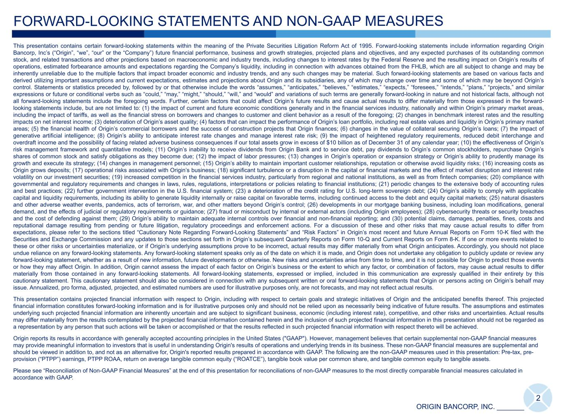
2 FORWARD-LOOKING STATEMENTS AND NON-GAAP MEASURES This presentation contains certain forward-looking statements within the meaning of the Private Securities Litigation Reform Act of 1995. Forward-looking statements include information regarding Origin Bancorp, Inc’s (“Origin”, “we”, “our” or the “Company”) future financial performance, business and growth strategies, projected plans and objectives, and any expected purchases of its outstanding common stock, and related transactions and other projections based on macroeconomic and industry trends, including changes to interest rates by the Federal Reserve and the resulting impact on Origin’s results of operations, estimated forbearance amounts and expectations regarding the Company’s liquidity, including in connection with advances obtained from the FHLB, which are all subject to change and may be inherently unreliable due to the multiple factors that impact broader economic and industry trends, and any such changes may be material. Such forward-looking statements are based on various facts and derived utilizing important assumptions and current expectations, estimates and projections about Origin and its subsidiaries, any of which may change over time and some of which may be beyond Origin’s control. Statements or statistics preceded by, followed by or that otherwise include the words “assumes,” “anticipates,” “believes,” “estimates,” “expects,” “foresees,” “intends,” “plans,” “projects,” and similar expressions or future or conditional verbs such as “could,” “may,” “might,” “should,” “will,” and “would” and variations of such terms are generally forward-looking in nature and not historical facts, although not all forward-looking statements include the foregoing words. Further, certain factors that could affect Origin’s future results and cause actual results to differ materially from those expressed in the forward- looking statements include, but are not limited to: (1) the impact of current and future economic conditions generally and in the financial services industry, nationally and within Origin’s primary market areas, including the impact of tariffs, as well as the financial stress on borrowers and changes to customer and client behavior as a result of the foregoing; (2) changes in benchmark interest rates and the resulting impacts on net interest income; (3) deterioration of Origin’s asset quality; (4) factors that can impact the performance of Origin’s loan portfolio, including real estate values and liquidity in Origin’s primary market areas; (5) the financial health of Origin’s commercial borrowers and the success of construction projects that Origin finances; (6) changes in the value of collateral securing Origin’s loans; (7) the impact of generative artificial intelligence; (8) Origin’s ability to anticipate interest rate changes and manage interest rate risk; (9) the impact of heightened regulatory requirements, reduced debit interchange and overdraft income and the possibility of facing related adverse business consequences if our total assets grow in excess of $10 billion as of December 31 of any calendar year; (10) the effectiveness of Origin’s risk management framework and quantitative models; (11) Origin’s inability to receive dividends from Origin Bank and to service debt, pay dividends to Origin’s common stockholders, repurchase Origin’s shares of common stock and satisfy obligations as they become due; (12) the impact of labor pressures; (13) changes in Origin’s operation or expansion strategy or Origin’s ability to prudently manage its growth and execute its strategy; (14) changes in management personnel; (15) Origin’s ability to maintain important customer relationships, reputation or otherwise avoid liquidity risks; (16) increasing costs as Origin grows deposits; (17) operational risks associated with Origin’s business; (18) significant turbulence or a disruption in the capital or financial markets and the effect of market disruption and interest rate volatility on our investment securities; (19) increased competition in the financial services industry, particularly from regional and national institutions, as well as from fintech companies; (20) compliance with governmental and regulatory requirements and changes in laws, rules, regulations, interpretations or policies relating to financial institutions; (21) periodic changes to the extensive body of accounting rules and best practices; (22) further government intervention in the U.S. financial system; (23) a deterioration of the credit rating for U.S. long-term sovereign debt; (24) Origin’s ability to comply with applicable capital and liquidity requirements, including its ability to generate liquidity internally or raise capital on favorable terms, including continued access to the debt and equity capital markets; (25) natural disasters and other adverse weather events, pandemics, acts of terrorism, war, and other matters beyond Origin’s control; (26) developments in our mortgage banking business, including loan modifications, general demand, and the effects of judicial or regulatory requirements or guidance; (27) fraud or misconduct by internal or external actors (including Origin employees); (28) cybersecurity threats or security breaches and the cost of defending against them; (29) Origin’s ability to maintain adequate internal controls over financial and non-financial reporting; and (30) potential claims, damages, penalties, fines, costs and reputational damage resulting from pending or future litigation, regulatory proceedings and enforcement actions. For a discussion of these and other risks that may cause actual results to differ from expectations, please refer to the sections titled “Cautionary Note Regarding Forward-Looking Statements” and “Risk Factors” in Origin’s most recent and future Annual Reports on Form 10-K filed with the Securities and Exchange Commission and any updates to those sections set forth in Origin’s subsequent Quarterly Reports on Form 10-Q and Current Reports on Form 8-K. If one or more events related to these or other risks or uncertainties materialize, or if Origin’s underlying assumptions prove to be incorrect, actual results may differ materially from what Origin anticipates. Accordingly, you should not place undue reliance on any forward-looking statements. Any forward-looking statement speaks only as of the date on which it is made, and Origin does not undertake any obligation to publicly update or review any forward-looking statement, whether as a result of new information, future developments or otherwise. New risks and uncertainties arise from time to time, and it is not possible for Origin to predict those events or how they may affect Origin. In addition, Origin cannot assess the impact of each factor on Origin’s business or the extent to which any factor, or combination of factors, may cause actual results to differ materially from those contained in any forward-looking statements. All forward-looking statements, expressed or implied, included in this communication are expressly qualified in their entirety by this cautionary statement. This cautionary statement should also be considered in connection with any subsequent written or oral forward-looking statements that Origin or persons acting on Origin’s behalf may issue. Annualized, pro forma, adjusted, projected, and estimated numbers are used for illustrative purposes only, are not forecasts, and may not reflect actual results. This presentation contains projected financial information with respect to Origin, including with respect to certain goals and strategic initiatives of Origin and the anticipated benefits thereof. This projected financial information constitutes forward-looking information and is for illustrative purposes only and should not be relied upon as necessarily being indicative of future results. The assumptions and estimates underlying such projected financial information are inherently uncertain and are subject to significant business, economic (including interest rate), competitive, and other risks and uncertainties. Actual results may differ materially from the results contemplated by the projected financial information contained herein and the inclusion of such projected financial information in this presentation should not be regarded as a representation by any person that such actions will be taken or accomplished or that the results reflected in such projected financial information with respect thereto will be achieved. Origin reports its results in accordance with generally accepted accounting principles in the United States ("GAAP"). However, management believes that certain supplemental non-GAAP financial measures may provide meaningful information to investors that is useful in understanding Origin's results of operations and underlying trends in its business. These non-GAAP financial measures are supplemental and should be viewed in addition to, and not as an alternative for, Origin's reported results prepared in accordance with GAAP. The following are the non-GAAP measures used in this presentation: Pre-tax, pre- provision (“PTPP”) earnings, PTPP ROAA, return on average tangible common equity (“ROATCE”), tangible book value per common share, and tangible common equity to tangible assets. Please see “Reconciliation of Non-GAAP Financial Measures” at the end of this presentation for reconciliations of non-GAAP measures to the most directly comparable financial measures calculated in accordance with GAAP. ORIGIN BANCORP, INC. _______

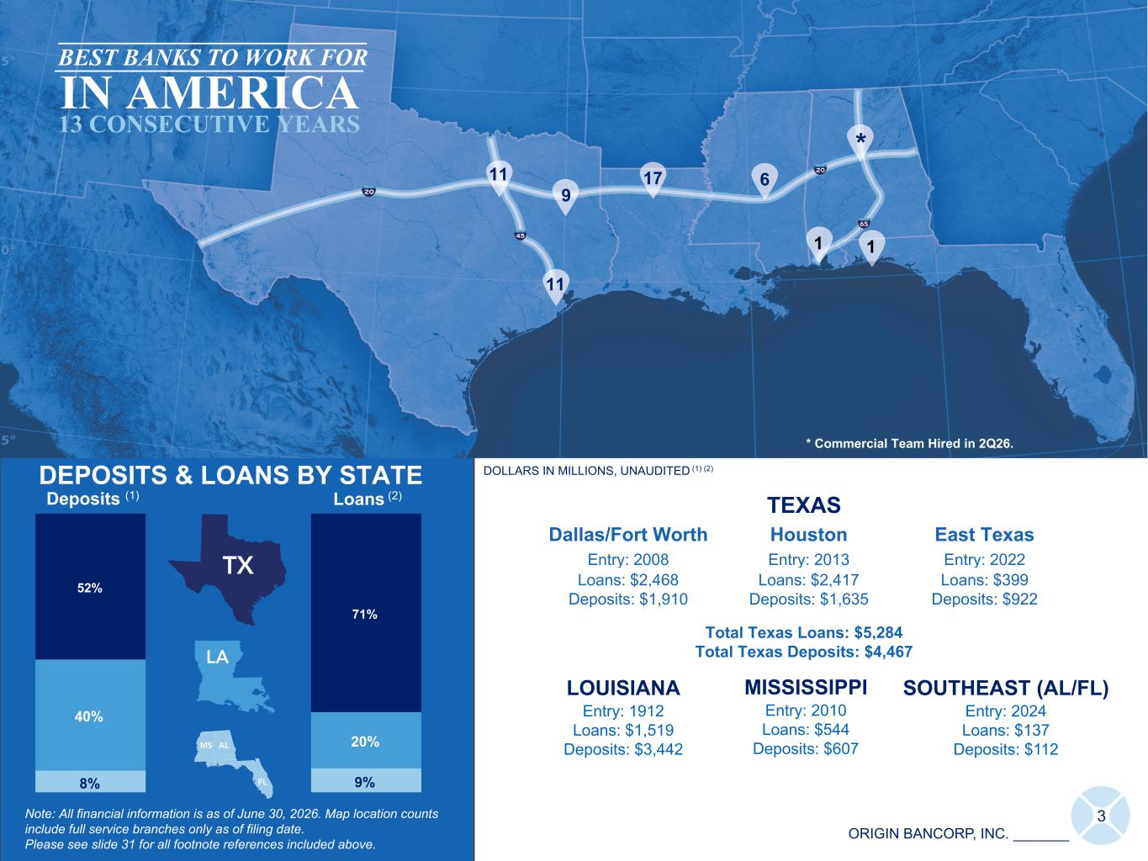
ORIGIN BANCORP, INC. _______ LOUISIANA Entry: 1912 Loans: $1,519 Deposits: $3,442 DOLLARS IN MILLIONS, UNAUDITED (1) (2) 3 DEPOSITS & LOANS BY STATE Note: All financial information is as of June 30, 2026. Map location counts include full service branches only as of filing date. Please see slide 31 for all footnote references included above. MISSISSIPPI Entry: 2010 Loans: $544 Deposits: $607 8% 9% 40% 20% 52% 71% Loans (2)Deposits (1) ICS ICS TEXAS Dallas/Fort Worth Houston East Texas Entry: 2008 Entry: 2013 Entry: 2022 Loans: $2,468 Loans: $2,417 Loans: $399 Deposits: $1,910 Deposits: $1,635 Deposits: $922 Total Texas Loans: $5,284 Total Texas Deposits: $4,467 SOUTHEAST (AL/FL) Entry: 2024 Loans: $137 Deposits: $112 11 11 9 17 6 1 BEST BANKS TO WORK FOR IN AMERICA 13 CONSECUTIVE YEARS * Commercial Team Hired in 2Q26. * 1

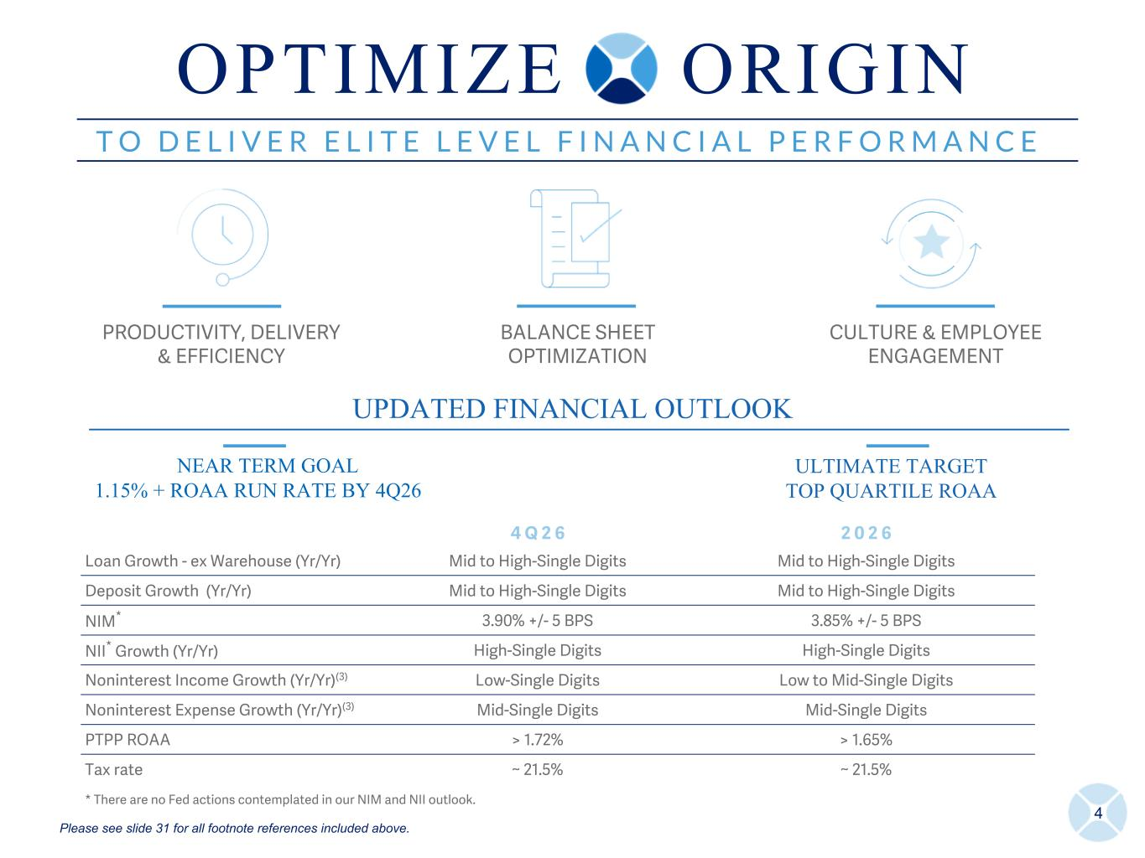
4 T O D E L I V E R E L I T E L E V E L F I N A N C I A L P E R F O R M A N C E PRODUCTIVITY, DELIVERY & EFFICIENCY BALANCE SHEET OPTIMIZATION CULTURE & EMPLOYEE ENGAGEMENT UPDATED FINANCIAL OUTLOOK 4 Q 2 6 2 0 2 6 Loan Growth - ex Warehouse (Yr/Yr) Mid to High-Single Digits Mid to High-Single Digits Deposit Growth (Yr/Yr) Mid to High-Single Digits Mid to High-Single Digits NIM* 3.90% +/- 5 BPS 3.85% +/- 5 BPS NII* Growth (Yr/Yr) High-Single Digits High-Single Digits Noninterest Income Growth (Yr/Yr)(3) Low-Single Digits Low to Mid-Single Digits Noninterest Expense Growth (Yr/Yr)(3) Mid-Single Digits Mid-Single Digits PTPP ROAA > 1.72% > 1.65% Tax rate ~ 21.5% ~ 21.5% * There are no Fed actions contemplated in our NIM and NII outlook. NEAR TERM GOAL 1.15% + ROAA RUN RATE BY 4Q26 ULTIMATE TARGET TOP QUARTILE ROAA O P T I M I Z E O R I G I N Please see slide 31 for all footnote references included above.

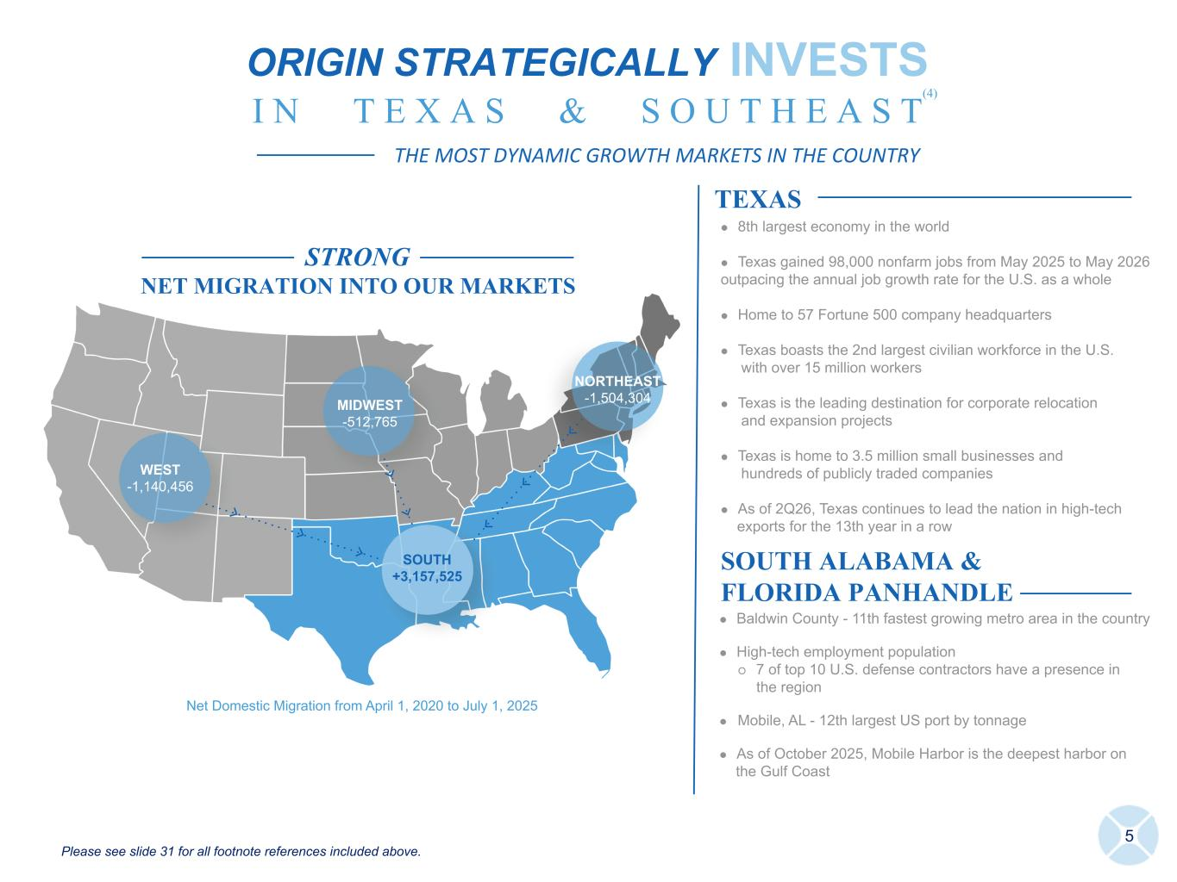
STRONG NET MIGRATION INTO OUR MARKETS WEST -1,140,456 MIDWEST -512,765 NORTHEAST -1,504,304 SOUTH +3,157,525 5 TEXAS SOUTH ALABAMA & FLORIDA PANHANDLE l Baldwin County - 11th fastest growing metro area in the country l High-tech employment population ö 7 of top 10 U.S. defense contractors have a presence in the region l Mobile, AL - 12th largest US port by tonnage l As of October 2025, Mobile Harbor is the deepest harbor on the Gulf Coast l 8th largest economy in the world l Texas gained 98,000 nonfarm jobs from May 2025 to May 2026 outpacing the annual job growth rate for the U.S. as a whole l Home to 57 Fortune 500 company headquarters l Texas boasts the 2nd largest civilian workforce in the U.S. with over 15 million workers l Texas is the leading destination for corporate relocation and expansion projects l Texas is home to 3.5 million small businesses and hundreds of publicly traded companies l As of 2Q26, Texas continues to lead the nation in high-tech exports for the 13th year in a row ORIGIN STRATEGICALLY INVESTS I N T E X A S & S O U T H E A S T THE MOST DYNAMIC GROWTH MARKETS IN THE COUNTRY (4) Please see slide 31 for all footnote references included above. Net Domestic Migration from April 1, 2020 to July 1, 2025

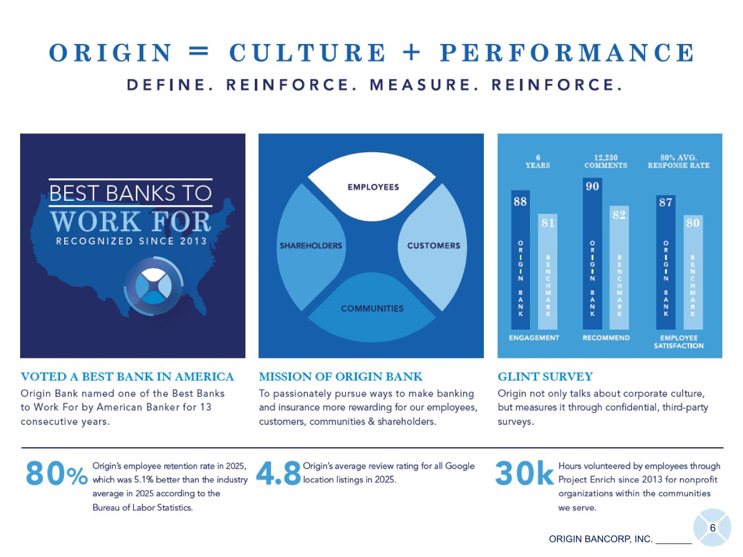
6 ORIGIN BANCORP, INC. _______

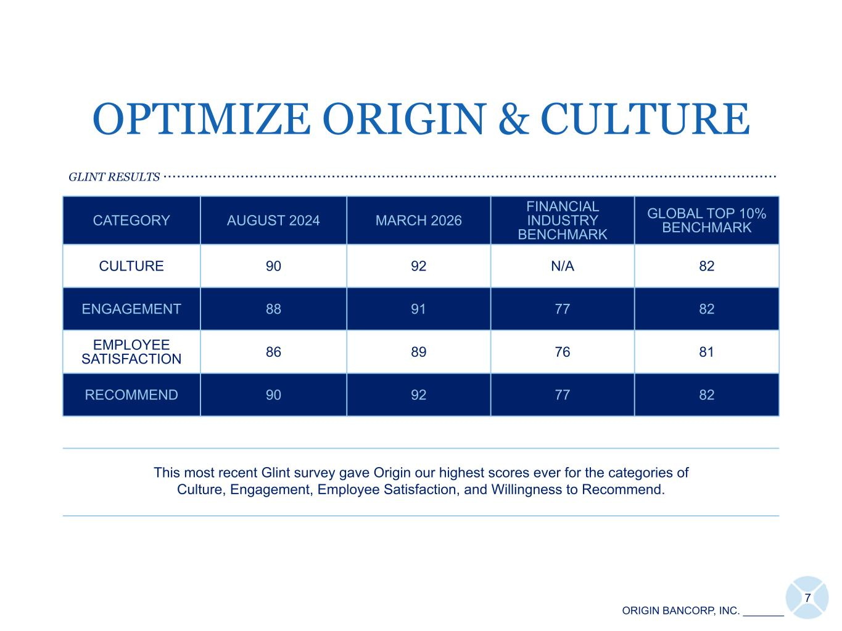
7 ORIGIN BANCORP, INC. _______ CATEGORY AUGUST 2024 MARCH 2026 FINANCIAL INDUSTRY BENCHMARK GLOBAL TOP 10% BENCHMARK CULTURE 90 92 N/A 82 ENGAGEMENT 88 91 77 82 EMPLOYEE SATISFACTION 86 89 76 81 RECOMMEND 90 92 77 82 This most recent Glint survey gave Origin our highest scores ever for the categories of Culture, Engagement, Employee Satisfaction, and Willingness to Recommend. OPTIMIZE ORIGIN & CULTURE GLINT RESULTS .......................................................................................................................................

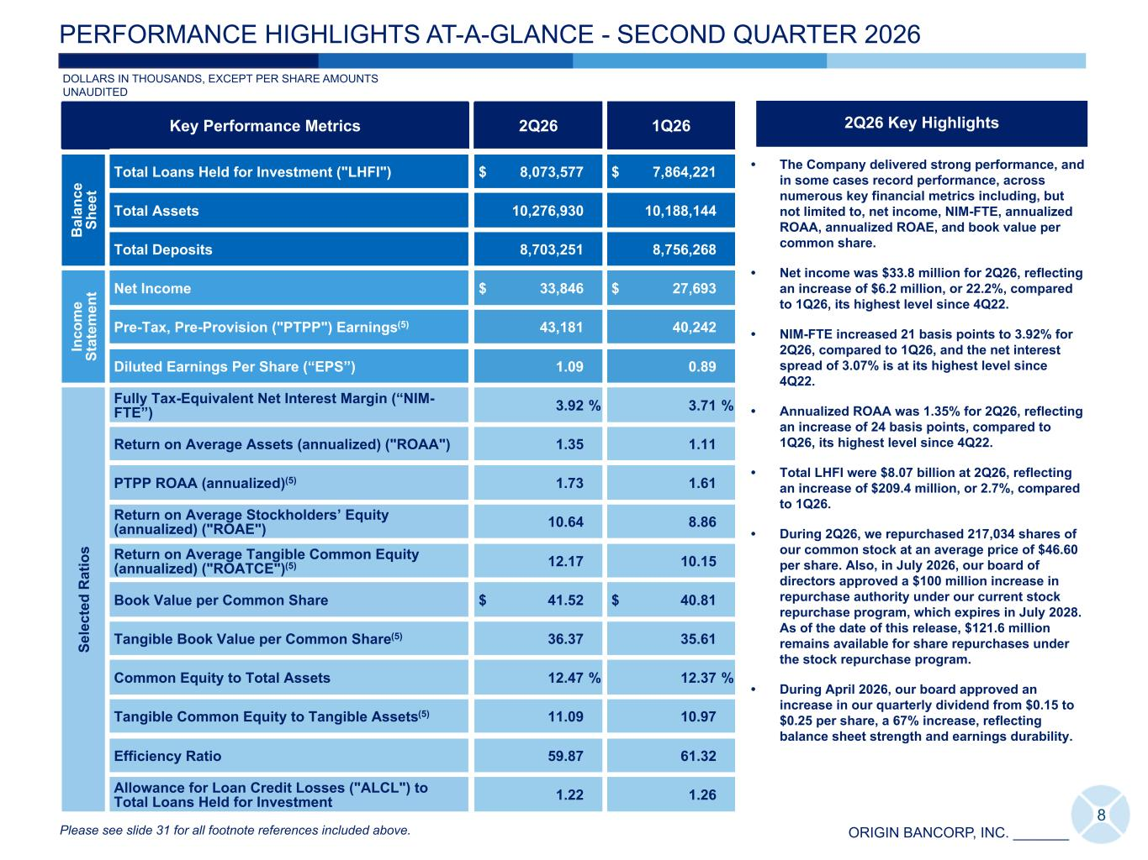
ORIGIN BANCORP, INC. _______ • The Company delivered strong performance, and in some cases record performance, across numerous key financial metrics including, but not limited to, net income, NIM-FTE, annualized ROAA, annualized ROAE, and book value per common share. • Net income was $33.8 million for 2Q26, reflecting an increase of $6.2 million, or 22.2%, compared to 1Q26, its highest level since 4Q22. • NIM-FTE increased 21 basis points to 3.92% for 2Q26, compared to 1Q26, and the net interest spread of 3.07% is at its highest level since 4Q22. • Annualized ROAA was 1.35% for 2Q26, reflecting an increase of 24 basis points, compared to 1Q26, its highest level since 4Q22. • Total LHFI were $8.07 billion at 2Q26, reflecting an increase of $209.4 million, or 2.7%, compared to 1Q26. • During 2Q26, we repurchased 217,034 shares of our common stock at an average price of $46.60 per share. Also, in July 2026, our board of directors approved a $100 million increase in repurchase authority under our current stock repurchase program, which expires in July 2028. As of the date of this release, $121.6 million remains available for share repurchases under the stock repurchase program. • During April 2026, our board approved an increase in our quarterly dividend from $0.15 to $0.25 per share, a 67% increase, reflecting balance sheet strength and earnings durability. Key Performance Metrics 2Q26 1Q26 B al an ce Sh ee t Total Loans Held for Investment ("LHFI") $ 8,073,577 $ 7,864,221 Total Assets 10,276,930 10,188,144 Total Deposits 8,703,251 8,756,268 In co m e St at em en t Net Income $ 33,846 $ 27,693 Pre-Tax, Pre-Provision ("PTPP") Earnings(5) 43,181 40,242 Diluted Earnings Per Share (“EPS”) 1.09 0.89 Se le ct ed R at io s Fully Tax-Equivalent Net Interest Margin (“NIM- FTE”) 3.92 % 3.71 % Return on Average Assets (annualized) ("ROAA") 1.35 1.11 PTPP ROAA (annualized)(5) 1.73 1.61 Return on Average Stockholders’ Equity (annualized) ("ROAE") 10.64 8.86 Return on Average Tangible Common Equity (annualized) ("ROATCE")(5) 12.17 10.15 Book Value per Common Share $ 41.52 $ 40.81 Tangible Book Value per Common Share(5) 36.37 35.61 Common Equity to Total Assets 12.47 % 12.37 % Tangible Common Equity to Tangible Assets(5) 11.09 10.97 Efficiency Ratio 59.87 61.32 Allowance for Loan Credit Losses ("ALCL") to Total Loans Held for Investment 1.22 1.26 DOLLARS IN THOUSANDS, EXCEPT PER SHARE AMOUNTS UNAUDITED 8 PERFORMANCE HIGHLIGHTS AT-A-GLANCE - SECOND QUARTER 2026 2Q26 Key Highlights Please see slide 31 for all footnote references included above.

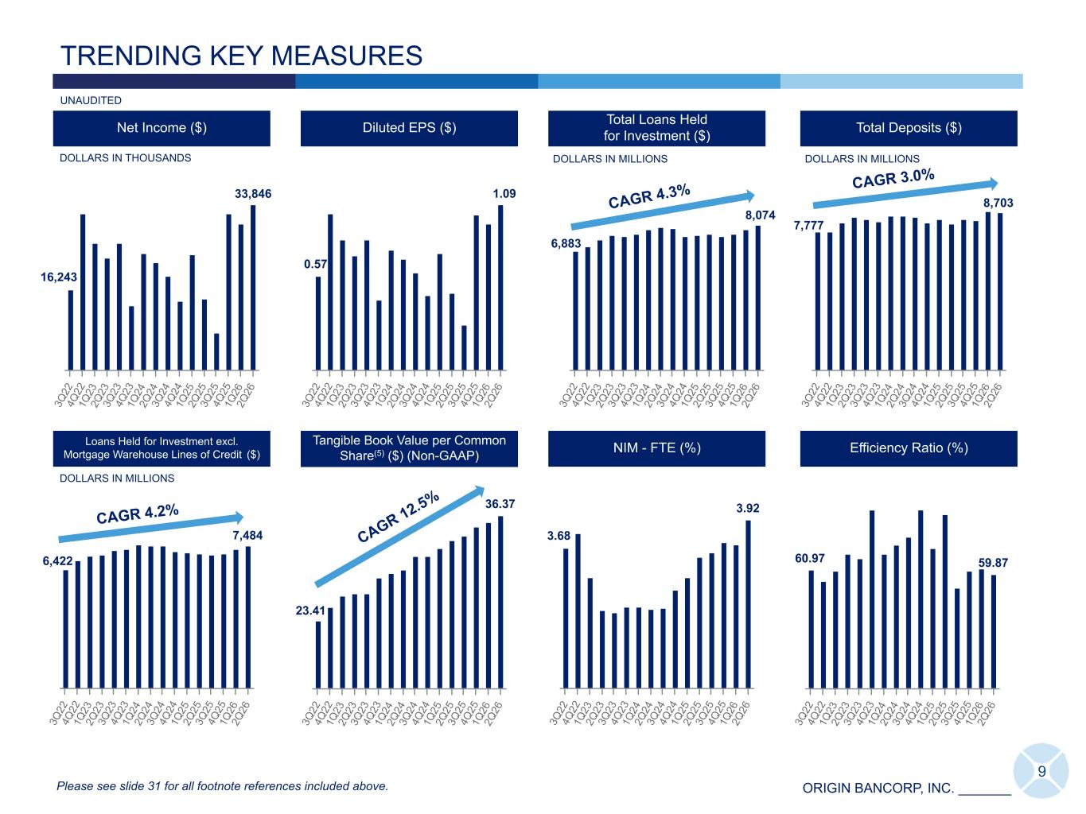
ORIGIN BANCORP, INC. _______ TRENDING KEY MEASURES UNAUDITED Diluted EPS ($)Net Income ($) Total Deposits ($) 3Q 22 4Q 22 1Q 23 2Q 23 3Q 23 4Q 23 1Q 24 2Q 24 3Q 24 4Q 24 1Q 25 2Q 25 3Q 25 4Q 25 1Q 26 2Q 26 3Q 22 4Q 22 1Q 23 2Q 23 3Q 23 4Q 23 1Q 24 2Q 24 3Q 24 4Q 24 1Q 25 2Q 25 3Q 25 4Q 25 1Q 26 2Q 26 3Q 22 4Q 22 1Q 23 2Q 23 3Q 23 4Q 23 1Q 24 2Q 24 3Q 24 4Q 24 1Q 25 2Q 25 3Q 25 4Q 25 1Q 26 2Q 26 7,484 3Q 22 4Q 22 1Q 23 2Q 23 3Q 23 4Q 23 1Q 24 2Q 24 3Q 24 4Q 24 1Q 25 2Q 25 3Q 25 4Q 25 1Q 26 2Q 26 DOLLARS IN THOUSANDS 9 Total Loans Held for Investment ($) DOLLARS IN MILLIONS 3Q 22 4Q 22 1Q 23 2Q 23 3Q 23 4Q 23 1Q 24 2Q 24 3Q 24 4Q 24 1Q 25 2Q 25 3Q 25 4Q 25 1Q 26 2Q 26 DOLLARS IN MILLIONS DOLLARS IN MILLIONS Please see slide 31 for all footnote references included above. CAGR 4.3% CAGR 4.2% CAGR 3.0% 7,777 16,243 33,846 Efficiency Ratio (%) 60.97 59.87 3Q 22 4Q 22 1Q 23 2Q 23 3Q 23 4Q 23 1Q 24 2Q 24 3Q 24 4Q 24 1Q 25 2Q 25 3Q 25 4Q 25 1Q 26 2Q 26 36.37 3Q 22 4Q 22 1Q 23 2Q 23 3Q 23 4Q 23 1Q 24 2Q 24 3Q 24 4Q 24 1Q 25 2Q 25 3Q 25 4Q 25 1Q 26 2Q 26 Tangible Book Value per Common Share(5) ($) (Non-GAAP) 3Q 22 4Q 22 1Q 23 2Q 23 3Q 23 4Q 23 1Q 24 2Q 24 3Q 24 4Q 24 1Q 25 2Q 25 3Q 25 4Q 25 1Q 26 2Q 26 Return on Average Assets (%) CAGR 12.5% 1.09 8,074 3.92 3Q 22 4Q 22 1Q 23 2Q 23 3Q 23 4Q 23 1Q 24 2Q 24 3Q 24 4Q 24 1Q 25 2Q 25 3Q 25 4Q 25 1Q 26 2Q 26 NIM - FTE (%) 3.68 1.35 0.70 6,422 6,883 8,703 0.57 Loans Held for Investment excl. Mortgage Warehouse Lines of Credit ($) 23.41

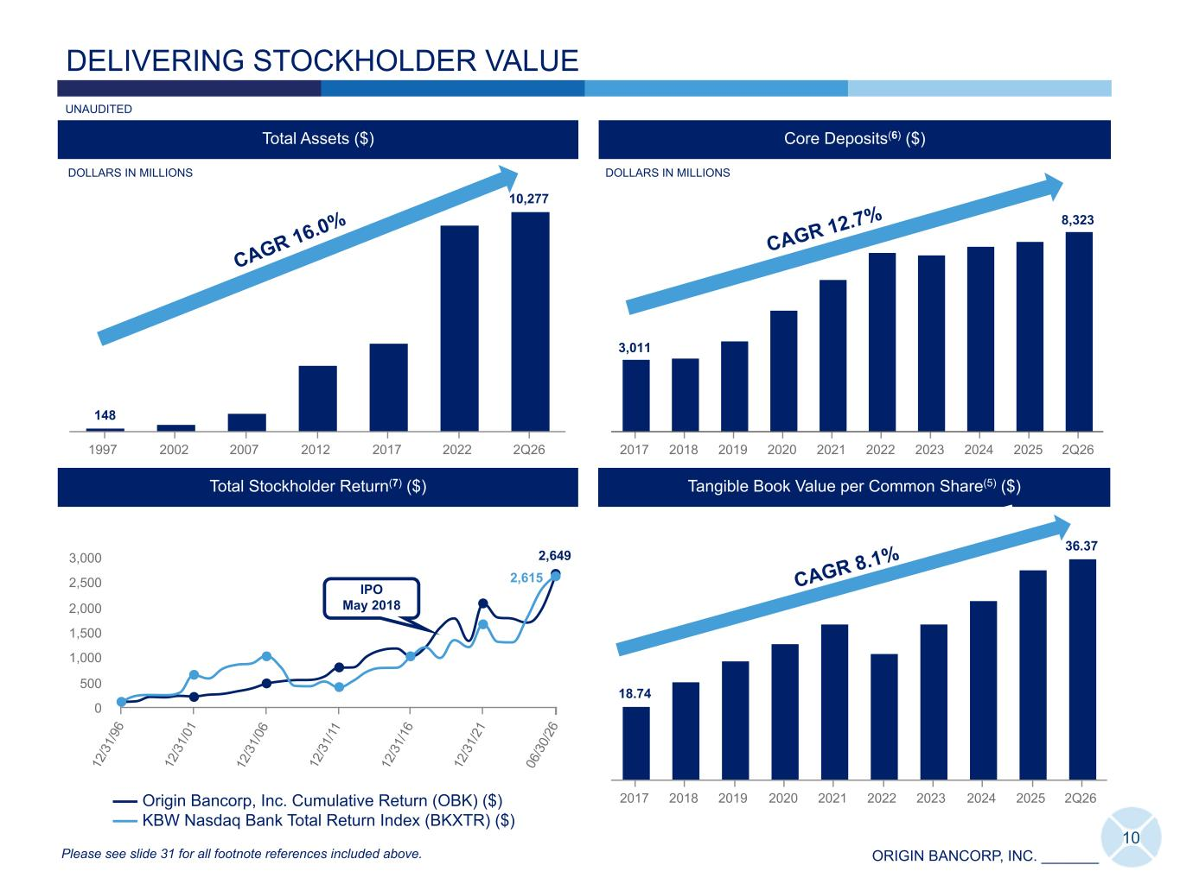
ORIGIN BANCORP, INC. _______ 148 10,277 1997 2002 2007 2012 2017 2022 2Q26 DELIVERING STOCKHOLDER VALUE DOLLARS IN MILLIONS Total Assets ($) Core Deposits(6) ($) 3,011 8,323 2017 2018 2019 2020 2021 2022 2023 2024 2025 2Q26 CAGR 16.0% CAGR 12.7% 10 2,649 2,615 Origin Bancorp, Inc. Cumulative Return (OBK) ($) KBW Nasdaq Bank Total Return Index (BKXTR) ($) 12 /3 1/ 96 12 /3 1/ 01 12 /3 1/ 06 12 /3 1/ 11 12 /3 1/ 16 12 /3 1/ 21 06 /3 0/ 26 0 500 1,000 1,500 2,000 2,500 3,000 Total Stockholder Return(7) ($) IPO May 2018 Please see slide 31 for all footnote references included above. DOLLARS IN MILLIONS UNAUDITED Tangible Book Value per Common Share(5) ($) 18.74 36.37 2017 2018 2019 2020 2021 2022 2023 2024 2025 2Q26 CAGR 8.1% 12 /3 1/ 25 148 9,725 10,277 1997 2001 2005 2009 2013 2017 2021 2025 2Q26 DOLLARS IN MILLIONS Total Assets ($) CAGR 16.0% 148 10,277 1997 2001 2005 2009 2013 2017 2021 2025 DOLLARS IN MILLIONS Total Assets ($) CAGR 16.0% 169 156 Origin Bancorp, Inc. Cumulative Return (OBK) ($) NASDAQ OMX ABA Community Bank Total Rtn (ABQX) $ 05 /0 8/ 18 12 /3 1/ 18 12 /3 1/ 19 12 /3 1/ 20 12 /3 1/ 21 12 /3 1/ 22 12 /3 1/ 23 12 /3 1/ 24 12 /3 1/ 25 06 /3 0/ 26 100 150 Total Stockholder Return(7) ($) IPO 169 216 Origin Bancorp, Inc. Cumulative Return (OBK) ($) KBW Nasdaq Bank Total Return Index (BKXTR) ($) 05 /0 8/ 18 12 /3 1/ 18 12 /3 1/ 19 12 /3 1/ 20 12 /3 1/ 21 12 /3 1/ 22 12 /3 1/ 23 12 /3 1/ 24 12 /3 1/ 25 06 /3 0/ 26 100 200 IPO Total Stockholder Return(7) ($)

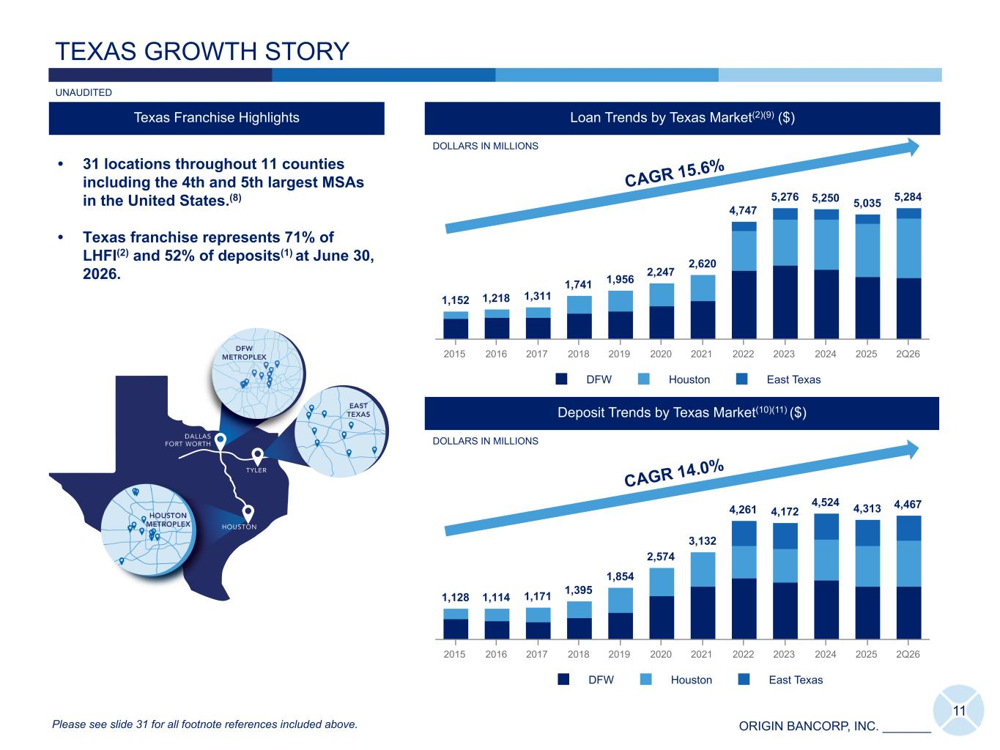
ORIGIN BANCORP, INC. _______ 11 1,152 1,218 1,311 1,741 1,956 2,247 2,620 4,747 5,276 5,250 5,035 5,284 DFW Houston East Texas 2015 2016 2017 2018 2019 2020 2021 2022 2023 2024 2025 2Q26 Deposit Trends by Texas Market(10)(11) ($) Loan Trends by Texas Market(2)(9) ($) TEXAS GROWTH STORY Texas Franchise Highlights DOLLARS IN MILLIONS • 31 locations throughout 11 counties including the 4th and 5th largest MSAs in the United States.(8) • Texas franchise represents 71% of LHFI(2) and 52% of deposits(1) at June 30, 2026. 1,128 1,114 1,171 1,395 1,854 2,574 3,132 4,261 4,172 4,524 4,313 4,467 DFW Houston East Texas 2015 2016 2017 2018 2019 2020 2021 2022 2023 2024 2025 2Q26 Please see slide 31 for all footnote references included above. DOLLARS IN MILLIONS UNAUDITED CAGR 14.0% CAGR 15.6%

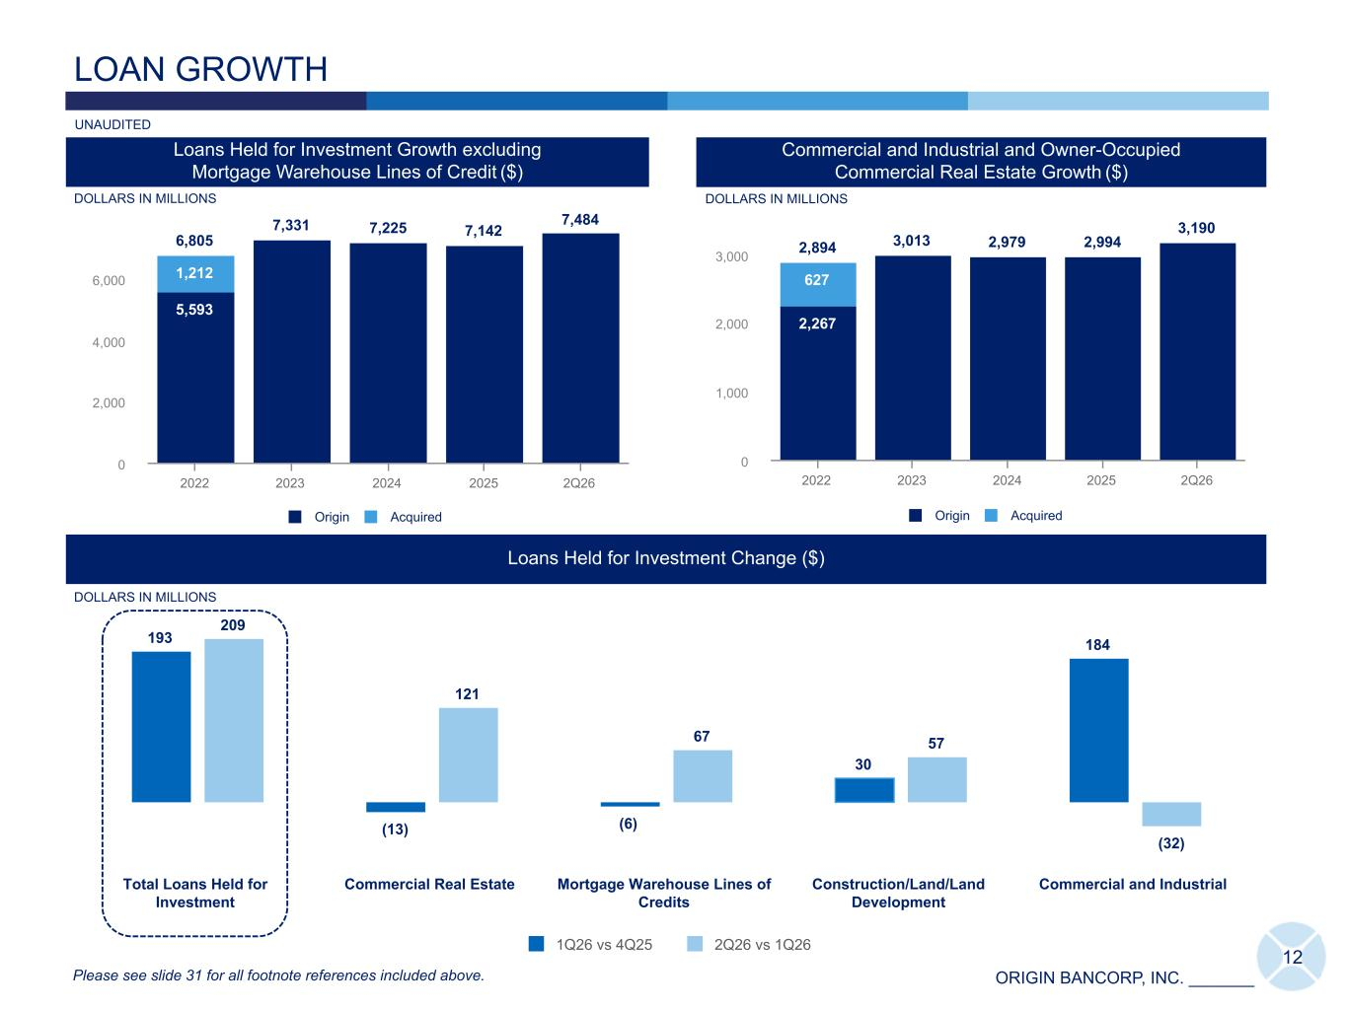
ORIGIN BANCORP, INC. _______ 193 (13) (6) 30 184 209 121 67 57 (32) 1Q26 vs 4Q25 2Q26 vs 1Q26 Total Loans Held for Investment Commercial Real Estate Mortgage Warehouse Lines of Credits Construction/Land/Land Development Commercial and Industrial LOAN GROWTH 6,805 7,331 7,225 7,142 7,484 5,593 7,142 7,484 1,212 Origin Acquired 2022 2023 2024 2025 2Q26 0 2,000 4,000 6,000 DOLLARS IN MILLIONS IDT Loans Held for Investment Growth excluding Mortgage Warehouse Lines of Credit ($) 2,894 3,013 2,979 2,994 3,190 2,267 2,994 3,190 627 Origin Acquired 2022 2023 2024 2025 2Q26 0 1,000 2,000 3,000 Loans Held for Investment Change ($) Please see slide 31 for all footnote references included above. DOLLARS IN MILLIONS UNAUDITED Commercial and Industrial and Owner-Occupied Commercial Real Estate Growth ($) 12 DOLLARS IN MILLIONS

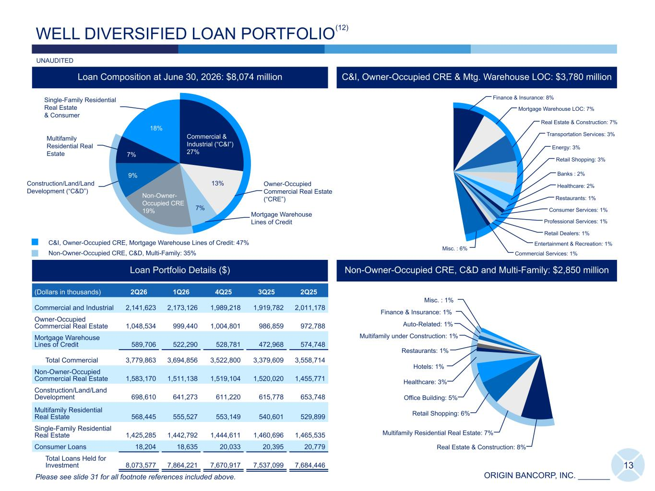
ORIGIN BANCORP, INC. _______ Commercial & Industrial (“C&I”) 27% Owner-Occupied Commercial Real Estate (“CRE”) Mortgage Warehouse Lines of Credit Non-Owner- Occupied CRE 19% Construction/Land/Land Development (“C&D”) Multifamily Residential Real Estate Single-Family Residential Real Estate & Consumer Real Estate & Construction: 8% Multifamily Residential Real Estate: 7% Retail Shopping: 6% Office Building: 5% Healthcare: 3% Hotels: 1% Restaurants: 1% Multifamily under Construction: 1% Auto-Related: 1% Finance & Insurance: 1% Misc. : 1% Finance & Insurance: 8% Mortgage Warehouse LOC: 7% Real Estate & Construction: 7% Transportation Services: 3% Energy: 3% Retail Shopping: 3% Banks : 2% Healthcare: 2% Restaurants: 1% Consumer Services: 1% Professional Services: 1% Retail Dealers: 1% Entertainment & Recreation: 1% Commercial Services: 1% Misc. : 6% 13 WELL DIVERSIFIED LOAN PORTFOLIO (Dollars in thousands) 2Q26 1Q26 4Q25 3Q25 2Q25 Commercial and Industrial 2,141,623 2,173,126 1,989,218 1,919,782 2,011,178 Owner-Occupied Commercial Real Estate 1,048,534 999,440 1,004,801 986,859 972,788 Mortgage Warehouse Lines of Credit 589,706 522,290 528,781 472,968 574,748 Total Commercial 3,779,863 3,694,856 3,522,800 3,379,609 3,558,714 Non-Owner-Occupied Commercial Real Estate 1,583,170 1,511,138 1,519,104 1,520,020 1,455,771 Construction/Land/Land Development 698,610 641,273 611,220 615,778 653,748 Multifamily Residential Real Estate 568,445 555,527 553,149 540,601 529,899 Single-Family Residential Real Estate 1,425,285 1,442,792 1,444,611 1,460,696 1,465,535 Consumer Loans 18,204 18,635 20,033 20,395 20,779 Total Loans Held for Investment 8,073,577 7,864,221 7,670,917 7,537,099 7,684,446 Loan Portfolio Details ($) C&I, Owner-Occupied CRE & Mtg. Warehouse LOC: $3,780 million C&I, Owner-Occupied CRE, Mortgage Warehouse Lines of Credit: 47% Non-Owner-Occupied CRE, C&D, Multi-Family: 35% Loan Composition at June 30, 2026: $8,074 million Please see slide 31 for all footnote references included above. UNAUDITED (12) Non-Owner-Occupied CRE, C&D and Multi-Family: $2,850 million 13% 7% 18% 7% 9%

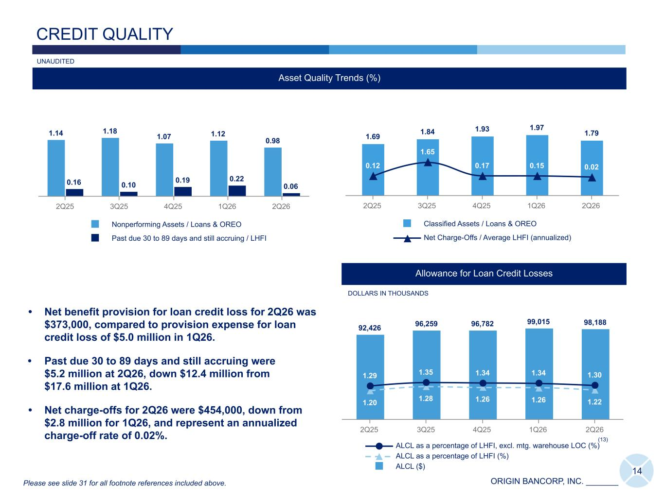
ORIGIN BANCORP, INC. _______ 1.69 1.84 1.93 1.97 1.79 0.12 1.65 0.17 0.15 0.02 Classified Assets / Loans & OREO Net Charge-Offs / Average LHFI (annualized) 2Q25 3Q25 4Q25 1Q26 2Q26 1.14 1.18 1.07 1.12 0.98 0.16 0.10 0.19 0.22 0.06 Nonperforming Assets / Loans & OREO Past due 30 to 89 days and still accruing / LHFI 2Q25 3Q25 4Q25 1Q26 2Q26 14 CREDIT QUALITY Asset Quality Trends (%) Allowance for Loan Credit Losses 92,426 96,259 96,782 99,015 98,188 1.20 1.28 1.26 1.26 1.22 1.29 1.35 1.34 1.34 1.30 ALCL as a percentage of LHFI, excl. mtg. warehouse LOC (%) ALCL as a percentage of LHFI (%) ALCL ($) 2Q25 3Q25 4Q25 1Q26 2Q26 DOLLARS IN THOUSANDS (13) Please see slide 31 for all footnote references included above. UNAUDITED 18,981 (123) (3,858) (8,605) 1Q26 Downgrades OREO net transactions Charge-offs Payments 2Q26 87,306 88,859 81,878 88,273 79,281 Total NPA ($) 2Q25 3Q25 4Q25 1Q26 2Q26 Nonperforming Asset Trends ($) • Net benefit provision for loan credit loss for 2Q26 was $373,000, compared to provision expense for loan credit loss of $5.0 million in 1Q26. • Past due 30 to 89 days and still accruing were $5.2 million at 2Q26, down $12.4 million from $17.6 million at 1Q26. • Net charge-offs for 2Q26 were $454,000, down from $2.8 million for 1Q26, and represent an annualized charge-off rate of 0.02%.

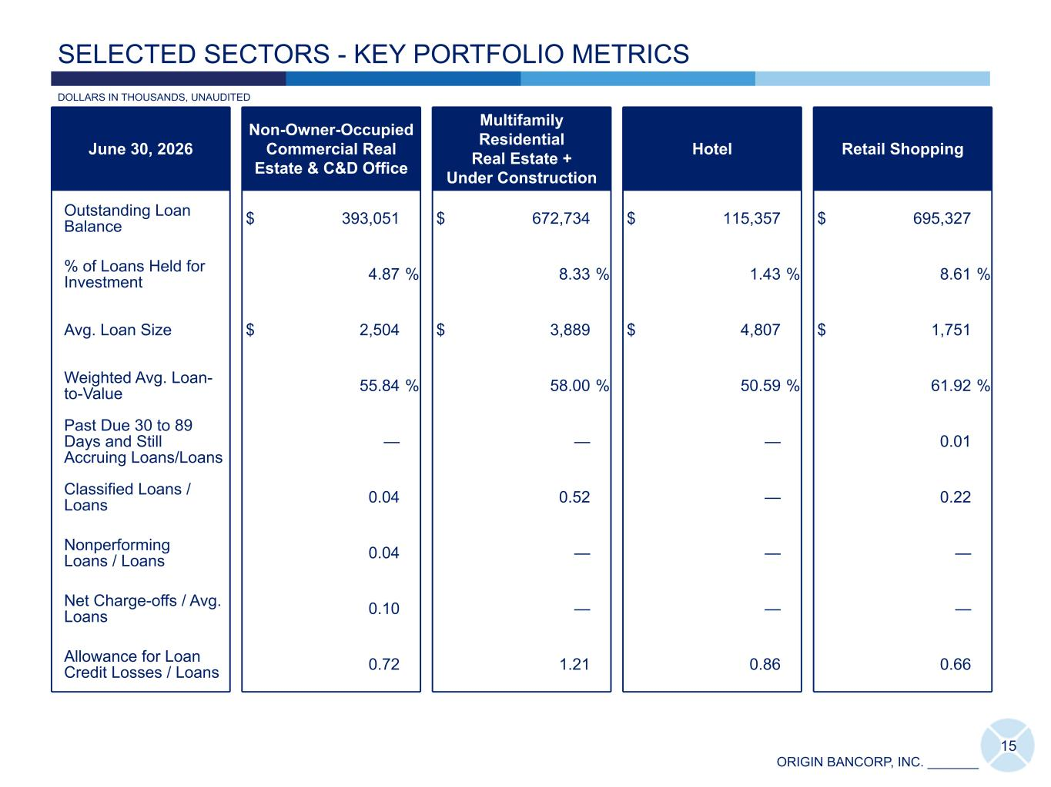
ORIGIN BANCORP, INC. _______ 15 SELECTED SECTORS - KEY PORTFOLIO METRICS June 30, 2026 Non-Owner-Occupied Commercial Real Estate & C&D Office Multifamily Residential Real Estate + Under Construction Hotel Retail Shopping Outstanding Loan Balance $ 393,051 $ 672,734 $ 115,357 $ 695,327 % of Loans Held for Investment 4.87 % 8.33 % 1.43 % 8.61 % Avg. Loan Size $ 2,504 $ 3,889 $ 4,807 $ 1,751 Weighted Avg. Loan- to-Value 55.84 % 58.00 % 50.59 % 61.92 % Past Due 30 to 89 Days and Still Accruing Loans/Loans — — — 0.01 Classified Loans / Loans 0.04 0.52 — 0.22 Nonperforming Loans / Loans 0.04 — — — Net Charge-offs / Avg. Loans 0.10 — — — Allowance for Loan Credit Losses / Loans 0.72 1.21 0.86 0.66 DOLLARS IN THOUSANDS, UNAUDITED

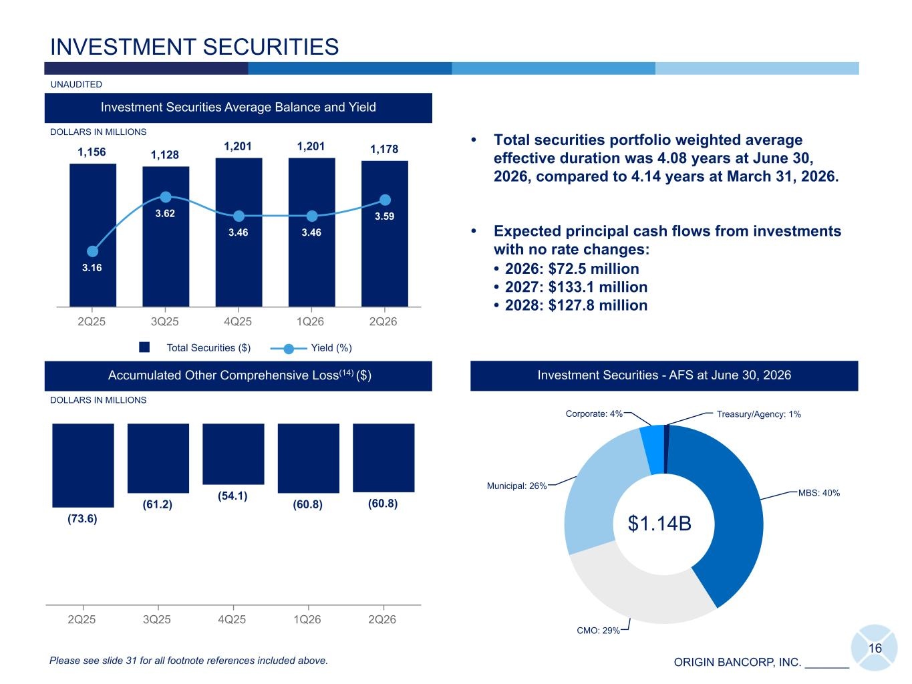
ORIGIN BANCORP, INC. _______ Treasury/Agency: 1% MBS: 40% CMO: 29% Municipal: 26% Corporate: 4% 1,156 1,128 1,201 1,201 1,178 3.16 3.62 3.46 3.46 3.59 Total Securities ($) Yield (%) 2Q25 3Q25 4Q25 1Q26 2Q26 Investment Securities Average Balance and Yield INVESTMENT SECURITIES DOLLARS IN MILLIONS • Total securities portfolio weighted average effective duration was 4.08 years at June 30, 2026, compared to 4.14 years at March 31, 2026. • Expected principal cash flows from investments with no rate changes: • 2026: $72.5 million • 2027: $133.1 million • 2028: $127.8 million 16 (73.6) (61.2) (54.1) (60.8) (60.8) 2Q25 3Q25 4Q25 1Q26 2Q26 Accumulated Other Comprehensive Loss(14) ($) Investment Securities - AFS at June 30, 2026 Please see slide 31 for all footnote references included above. $1.14B DOLLARS IN MILLIONS UNAUDITED

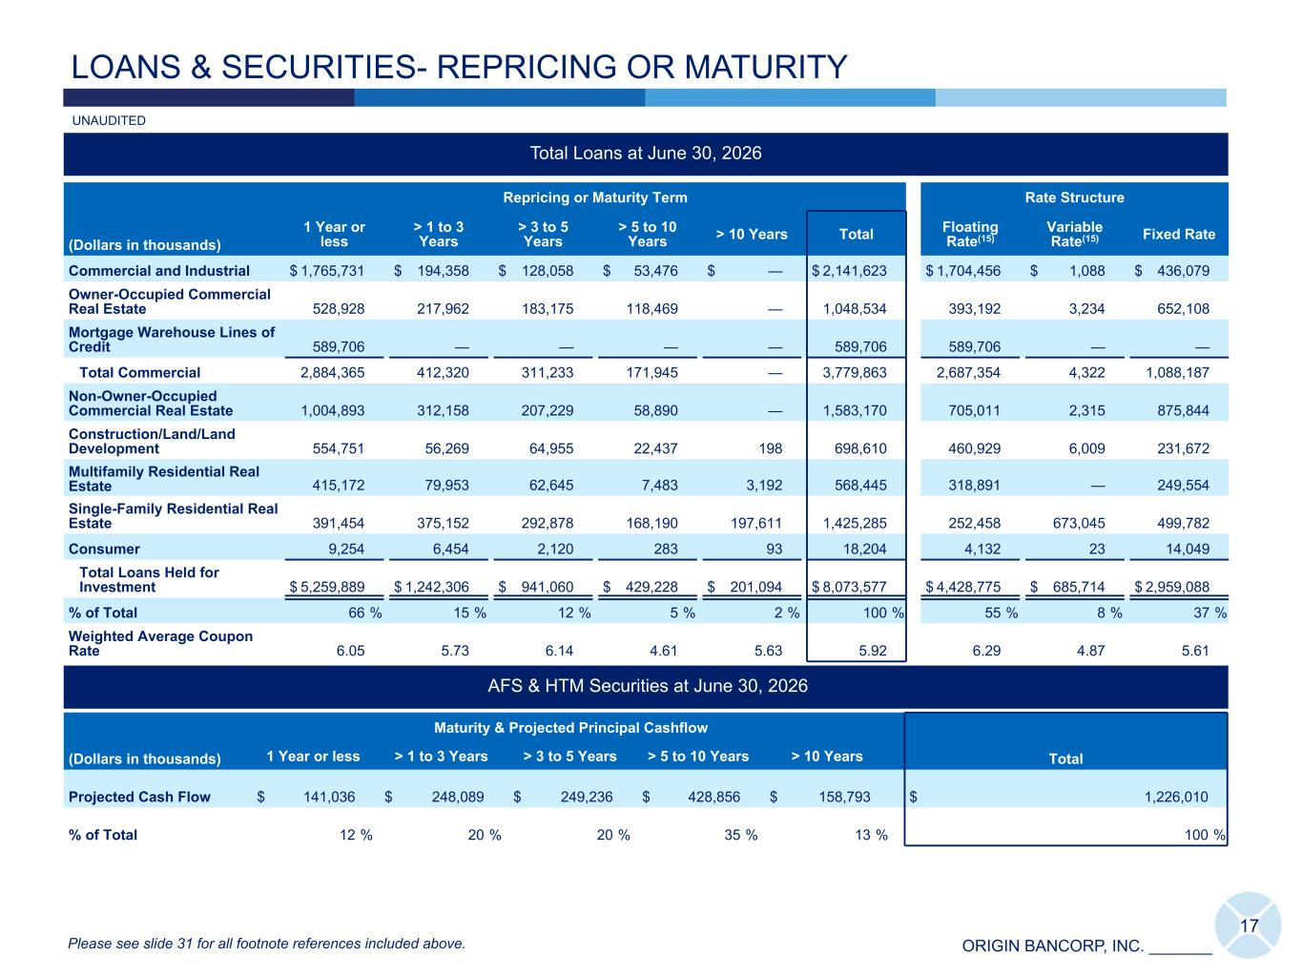
ORIGIN BANCORP, INC. _______ Total Loans at June 30, 2026 (Dollars in thousands) Repricing or Maturity Term Rate Structure 1 Year or less > 1 to 3 Years > 3 to 5 Years > 5 to 10 Years > 10 Years Total Floating Rate(15) Variable Rate(15) Fixed Rate Commercial and Industrial $ 1,765,731 $ 194,358 $ 128,058 $ 53,476 $ — $ 2,141,623 $ 1,704,456 $ 1,088 $ 436,079 Owner-Occupied Commercial Real Estate 528,928 217,962 183,175 118,469 — 1,048,534 393,192 3,234 652,108 Mortgage Warehouse Lines of Credit 589,706 — — — — 589,706 589,706 — — Total Commercial 2,884,365 412,320 311,233 171,945 — 3,779,863 2,687,354 4,322 1,088,187 Non-Owner-Occupied Commercial Real Estate 1,004,893 312,158 207,229 58,890 — 1,583,170 705,011 2,315 875,844 Construction/Land/Land Development 554,751 56,269 64,955 22,437 198 698,610 460,929 6,009 231,672 Multifamily Residential Real Estate 415,172 79,953 62,645 7,483 3,192 568,445 318,891 — 249,554 Single-Family Residential Real Estate 391,454 375,152 292,878 168,190 197,611 1,425,285 252,458 673,045 499,782 Consumer 9,254 6,454 2,120 283 93 18,204 4,132 23 14,049 Total Loans Held for Investment $ 5,259,889 $ 1,242,306 $ 941,060 $ 429,228 $ 201,094 $ 8,073,577 $ 4,428,775 $ 685,714 $ 2,959,088 % of Total 66 % 15 % 12 % 5 % 2 % 100 % 55 % 8 % 37 % Weighted Average Coupon Rate 6.05 5.73 6.14 4.61 5.63 5.92 6.29 4.87 5.61 AFS & HTM Securities at June 30, 2026 (Dollars in thousands) Maturity & Projected Principal Cashflow Total1 Year or less > 1 to 3 Years > 3 to 5 Years > 5 to 10 Years > 10 Years Projected Cash Flow $ 141,036 $ 248,089 $ 249,236 $ 428,856 $ 158,793 $ 1,226,010 % of Total 12 % 20 % 20 % 35 % 13 % 100 % LOANS & SECURITIES- REPRICING OR MATURITY 17 UNAUDITED Please see slide 31 for all footnote references included above.

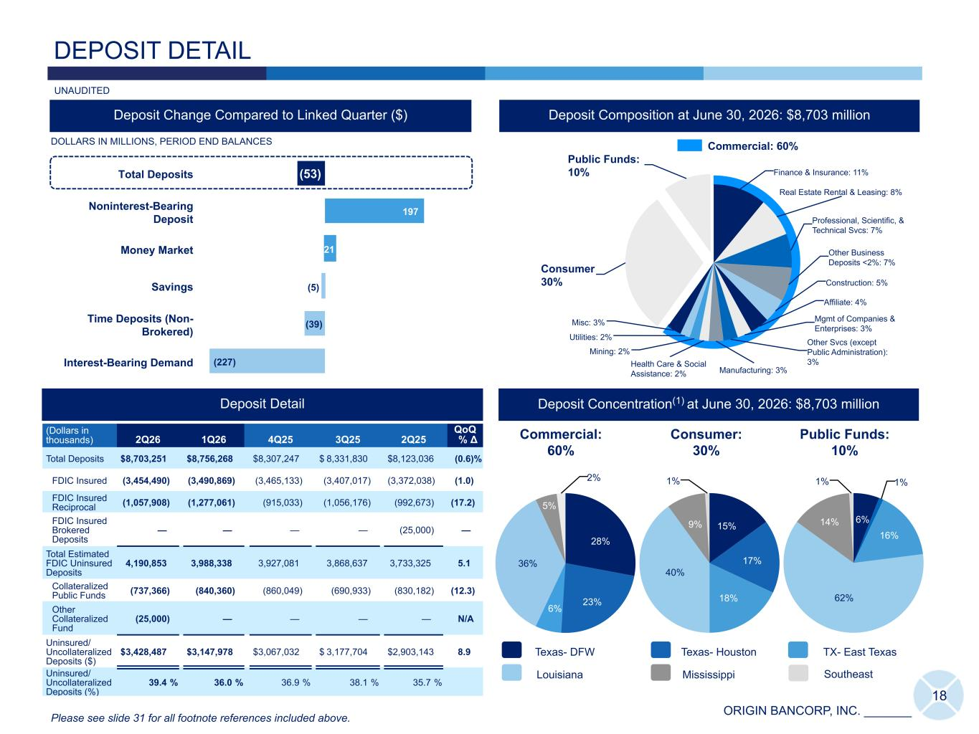
ORIGIN BANCORP, INC. _______ Finance & Insurance: 11% Real Estate Rental & Leasing: 8% Professional, Scientific, & Technical Svcs: 7% Other Business Deposits <2%: 7% Construction: 5% Affiliate: 4% Mgmt of Companies & Enterprises: 3% Other Svcs (except Public Administration): 3% Manufacturing: 3% Health Care & Social Assistance: 2% Mining: 2% Utilities: 2% Misc: 3% Consumer 30% Public Funds: 10% 28% 23% 6% 36% 5% 2% 18 DEPOSIT DETAIL (Dollars in thousands) 2Q26 1Q26 4Q25 3Q25 2Q25 QoQ % Δ Total Deposits $ 8,703,251 $ 8,486,568 $ 8,510,842 $ 8,505,464 $ 8,251,125 2.6 % FDIC Insured (3,464,116) (3,464,116) (3,442,636) (3,447,538) (3,425,268) — FDIC Insured Reciprocal (1,093,952) (1,093,952) (799,221) (801,145) (801,699) — FDIC Insured Brokered Deposits (431,609) (431,609) (636,814) (597,110) (444,989) — Total Estimated FDIC Uninsured Deposits 3,713,574 3,496,891 3,632,171 3,659,671 3,579,169 6.2 Collateralized Public Funds (714,431) (714,431) (771,419) (836,150) (849,603) — Uninsured/ Uncollateralized Deposits ($) $ 2,999,143 $ 2,782,460 $ 2,860,752 $ 2,823,521 $ 2,729,566 7.8 Uninsured/ Uncollateralized Deposits (%) 34.5 % 32.8 % 33.6 % 33.2 % 33.1 % Deposit Detail Deposit Concentration(1) at June 30, 2026: $8,703 million Deposit Composition at June 30, 2026: $8,703 million MississippiLouisiana Texas- DFW TX- East TexasTexas- Houston Please see slide 31 for all footnote references included above. UNAUDITED Southeast 15% 17% 18% 40% 9% 1% (Dollars in thousands) 2Q26 1Q26 4Q25 3Q25 2Q25 QoQ % Δ Total Deposits $ 8,703,251 $ 8,756,268 $ 8,307,247 $ 8,331,830 $ 8,123,036 (0.6) % FDIC Insured (3,454,490) (3,490,869) (3,465,133) (3,407,017) (3,372,038) (1.0) FDIC Insured Reciprocal (1,057,908) (1,277,061) (915,033) (1,056,176) (992,673) (17.2) FDIC Insured Brokered Deposits — — — — (25,000) — Total Estimated FDIC Uninsured Deposits 4,190,853 3,988,338 3,927,081 3,868,637 3,733,325 5.1 Collateralized Public Funds (737,366) (840,360) (860,049) (690,933) (830,182) (12.3) Other Collateralized Fund (25,000) — — — — N/A Uninsured/ Uncollateralized Deposits ($) $ 3,428,487 $ 3,147,978 $ 3,067,032 $ 3,177,704 $ 2,903,143 8.9 Uninsured/ Uncollateralized Deposits (%) 39.4 % 36.0 % 36.9 % 38.1 % 35.7 % Deposit Detail 6% 1% 16% 62% 14% 1% (53) 197 21 (5) (39) (227) Total Deposits Noninterest-Bearing Deposit Money Market Savings Time Deposits (Non- Brokered) Interest-Bearing Demand Deposit Change Compared to Linked Quarter ($) DOLLARS IN MILLIONS, PERIOD END BALANCES Customer Deposits +(1)MM Commercial: 60% Commercial: 60% Consumer: 30% Public Funds: 10% (53) 197 21 (5) (39) (227) Total Deposits Noninterest- Bearing Deposit Money Market Savings Time Deposits (Non- Brokered) Interest- Bearing Demand Deposit Change Compared to Linked Quarter ($) DOLLARS IN MILLIONS, PERIOD END BALANCES

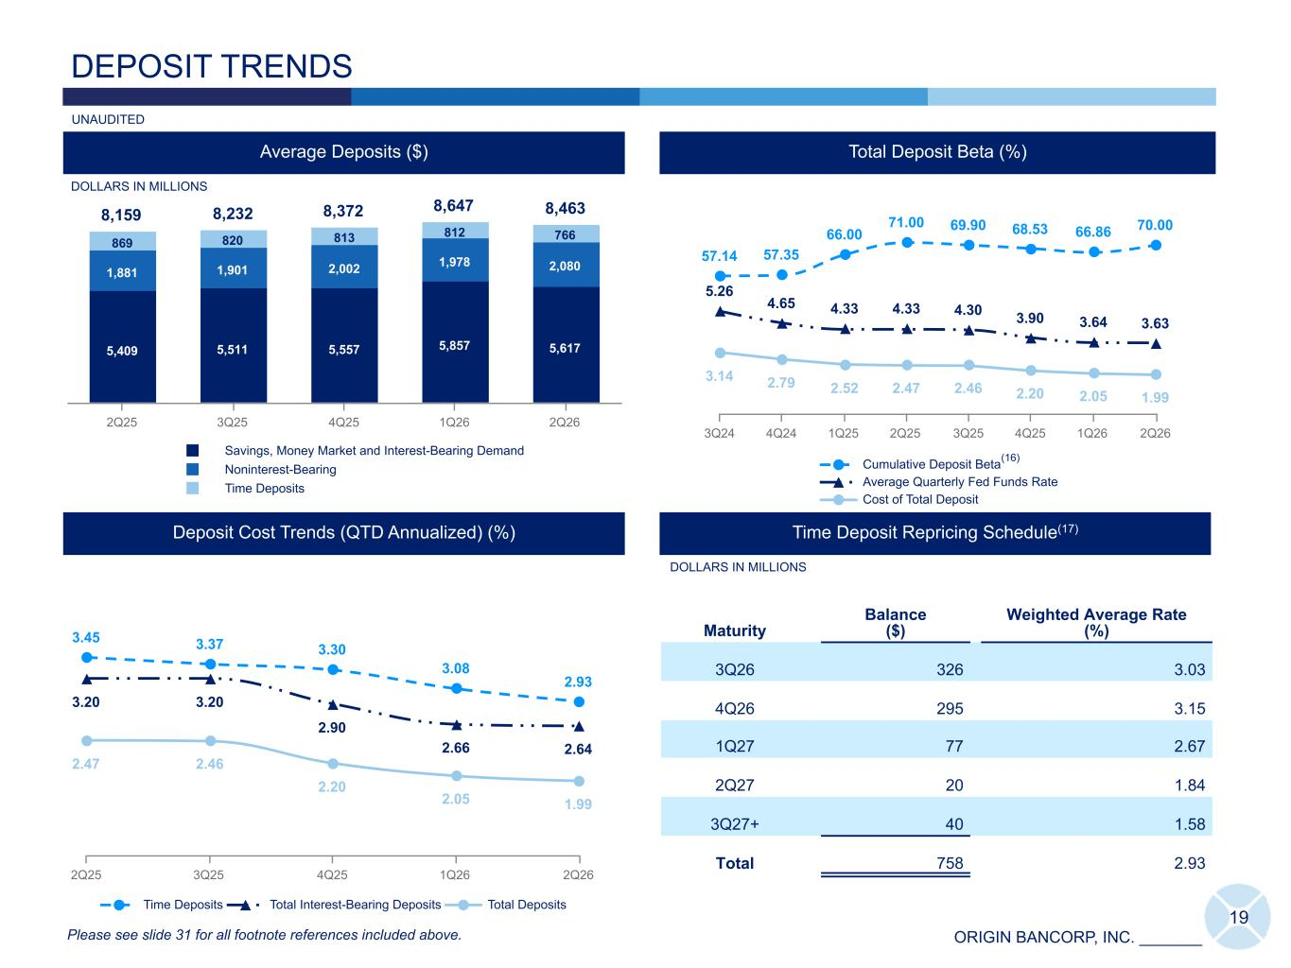
ORIGIN BANCORP, INC. _______ 3.45 3.37 3.30 3.08 2.93 3.20 3.20 2.90 2.66 2.64 2.47 2.46 2.20 2.05 1.99 Time Deposits Total Interest-Bearing Deposits Total Deposits 2Q25 3Q25 4Q25 1Q26 2Q26 19 8,159 8,232 8,372 8,647 8,463 5,409 5,511 5,557 5,857 5,617 1,881 1,901 2,002 1,978 2,080 869 820 813 812 766 Savings, Money Market and Interest-Bearing Demand Noninterest-Bearing Time Deposits 2Q25 3Q25 4Q25 1Q26 2Q26 Average Deposits ($) DEPOSIT TRENDS IDT DOLLARS IN MILLIONS UNAUDITED Deposit Cost Trends (QTD Annualized) (%) Time Deposit Repricing Schedule(17) Maturity Balance ($) Weighted Average Rate (%) 3Q26 326 3.03 4Q26 295 3.15 1Q27 77 2.67 2Q27 20 1.84 3Q27+ 40 1.58 Total 758 2.93 DOLLARS IN MILLIONS 57.14 57.35 66.00 71.00 69.90 68.53 66.86 70.00 5.26 4.65 4.33 4.33 4.30 3.90 3.64 3.63 3.14 2.79 2.52 2.47 2.46 2.20 2.05 1.99 Cumulative Deposit Beta Average Quarterly Fed Funds Rate Cost of Total Deposit 3Q24 4Q24 1Q25 2Q25 3Q25 4Q25 1Q26 2Q26 Please see slide 31 for all footnote references included above. Total Deposit Beta (%) Customer Deposits +(1)MM (16)

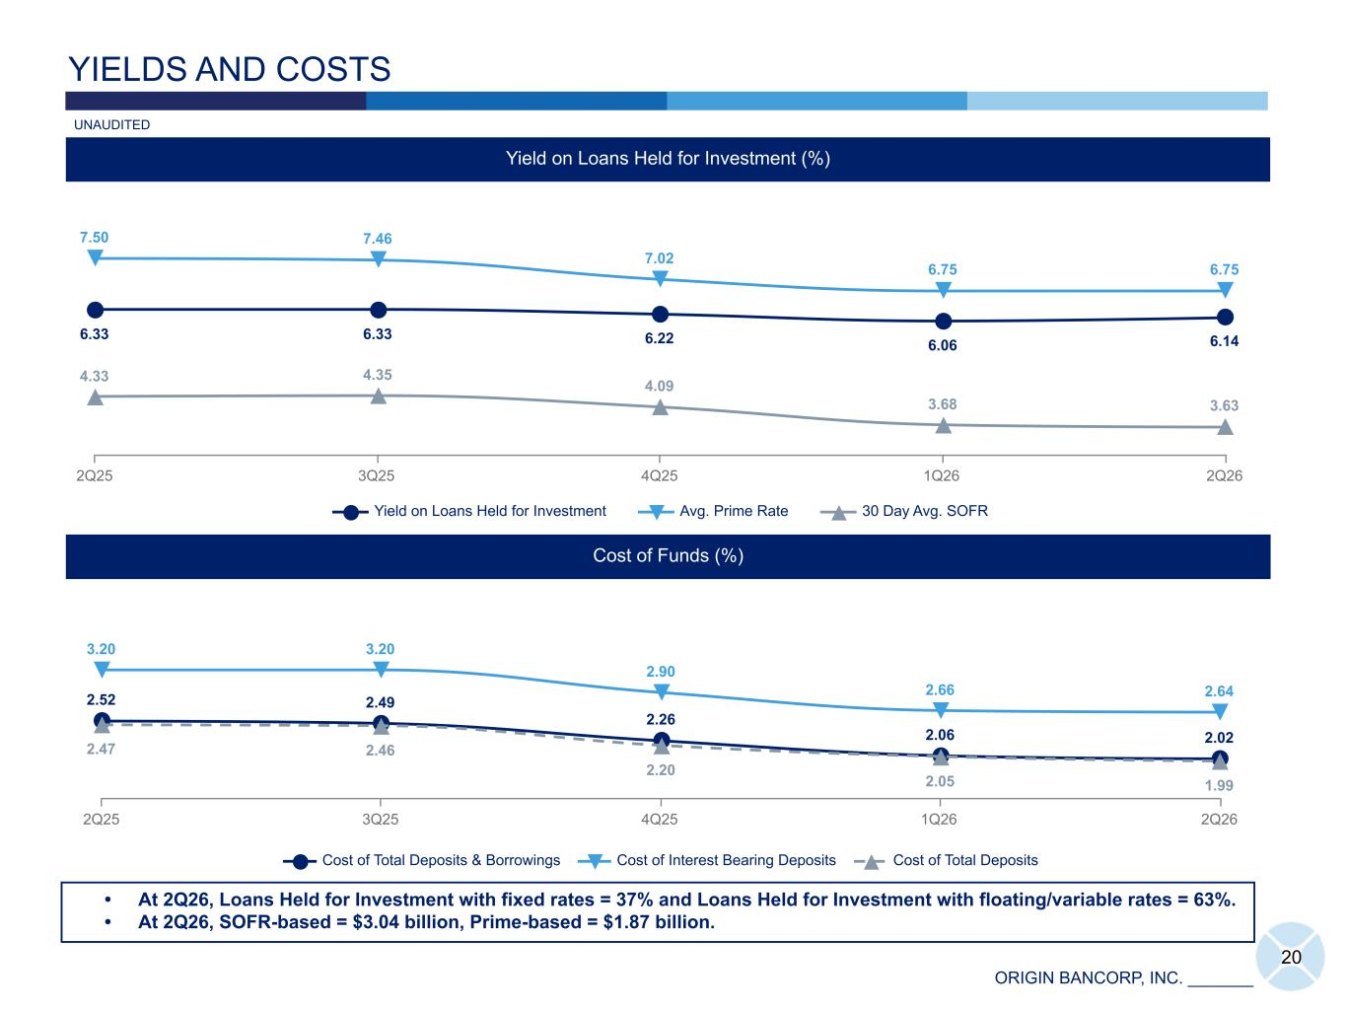
ORIGIN BANCORP, INC. _______ 2.52 2.49 2.26 2.06 2.02 3.20 3.20 2.90 2.66 2.64 2.47 2.46 2.20 2.05 1.99 Cost of Total Deposits & Borrowings Cost of Interest Bearing Deposits Cost of Total Deposits 2Q25 3Q25 4Q25 1Q26 2Q26 20 YIELDS AND COSTS Yield on Loans Held for Investment (%) Cost of Funds (%) • At 2Q26, Loans Held for Investment with fixed rates = 37% and Loans Held for Investment with floating/variable rates = 63%. • At 2Q26, SOFR-based = $3.04 billion, Prime-based = $1.87 billion. UNAUDITED 6.33 6.33 6.22 6.06 6.14 7.50 7.46 7.02 6.75 6.75 4.33 4.35 4.09 3.68 3.63 Yield on Loans Held for Investment Avg. Prime Rate 30 Day Avg. SOFR 2Q25 3Q25 4Q25 1Q26 2Q26

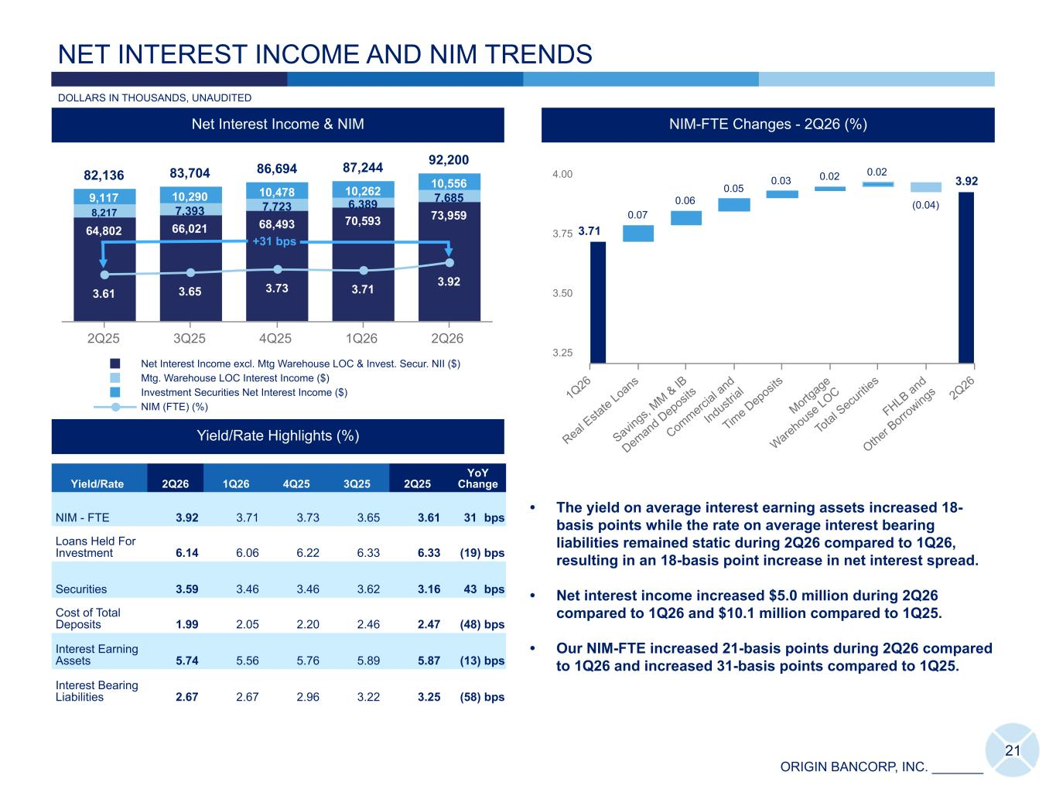
ORIGIN BANCORP, INC. _______ 82,136 83,704 86,694 87,244 92,200 64,802 66,021 68,493 70,593 73,9598,217 7,393 7,723 6,389 7,6859,117 10,290 10,478 10,262 10,556 3.61 3.65 3.73 3.71 3.92 Net Interest Income excl. Mtg Warehouse LOC & Invest. Secur. NII ($) Mtg. Warehouse LOC Interest Income ($) Investment Securities Net Interest Income ($) NIM (FTE) (%) 2Q25 3Q25 4Q25 1Q26 2Q26 21 DOLLARS IN THOUSANDS, UNAUDITED NET INTEREST INCOME AND NIM TRENDS 3.71 0.07 0.06 0.05 0.03 0.02 0.02 (0.04) 1Q26 Real E sta te Loans Savin gs, MM & IB Demand Deposits Commerci al a nd Industr ial Tim e Deposits Mortg age Warehouse LOC To tal S ecu riti es FHLB and Other B orro wings 2Q26 3.25 3.50 3.75 4.00 24.64 29.52 21.01 8.58 2.041.54 2.480.77 2.18 3.65 4.51 5.26 5.33 4.65 3.90 Cumulative NIM-FTE Beta Average Quarterly Fed Funds Rate 3Q23 4Q23 1Q24 2Q24 4Q24 1Q25 2Q25 3Q25 2Q26 NIM Beta - 2Q26 (%) 2.48 2.48 4.99 NIM-FTE Changes - 2Q26 (%) NIM-FTE Changes - 2Q26 (%) 73,32372,989 1,362 1,537 568 432 (298) (3,267) 4Q 23 RE Lo an s C&I MW LO C Othe r FH LB & O the r Bor ro wing s Sav ing s & IB Tr an sa c. Acc ts. 1Q 24 40,000 60,000 80,000 • The yield on average interest earning assets increased 18- basis points while the rate on average interest bearing liabilities remained static during 2Q26 compared to 1Q26, resulting in an 18-basis point increase in net interest spread. • Net interest income increased $5.0 million during 2Q26 compared to 1Q26 and $10.1 million compared to 1Q25. • Our NIM-FTE increased 21-basis points during 2Q26 compared to 1Q26 and increased 31-basis points compared to 1Q25. Net Interest Income & NIM 3.92 Yield/Rate 2Q26 1Q26 4Q25 3Q25 2Q25 YoY Change NIM - FTE 3.92 3.71 3.73 3.65 3.61 31 bps Loans Held For Investment 6.14 6.06 6.22 6.33 6.33 (19) bps Securities 3.59 3.46 3.46 3.62 3.16 43 bps Cost of Total Deposits 1.99 2.05 2.20 2.46 2.47 (48) bps Interest Earning Assets 5.74 5.56 5.76 5.89 5.87 (13) bps Interest Bearing Liabilities 2.67 2.67 2.96 3.22 3.25 (58) bps Yield/Rate Highlights (%) +31 bps

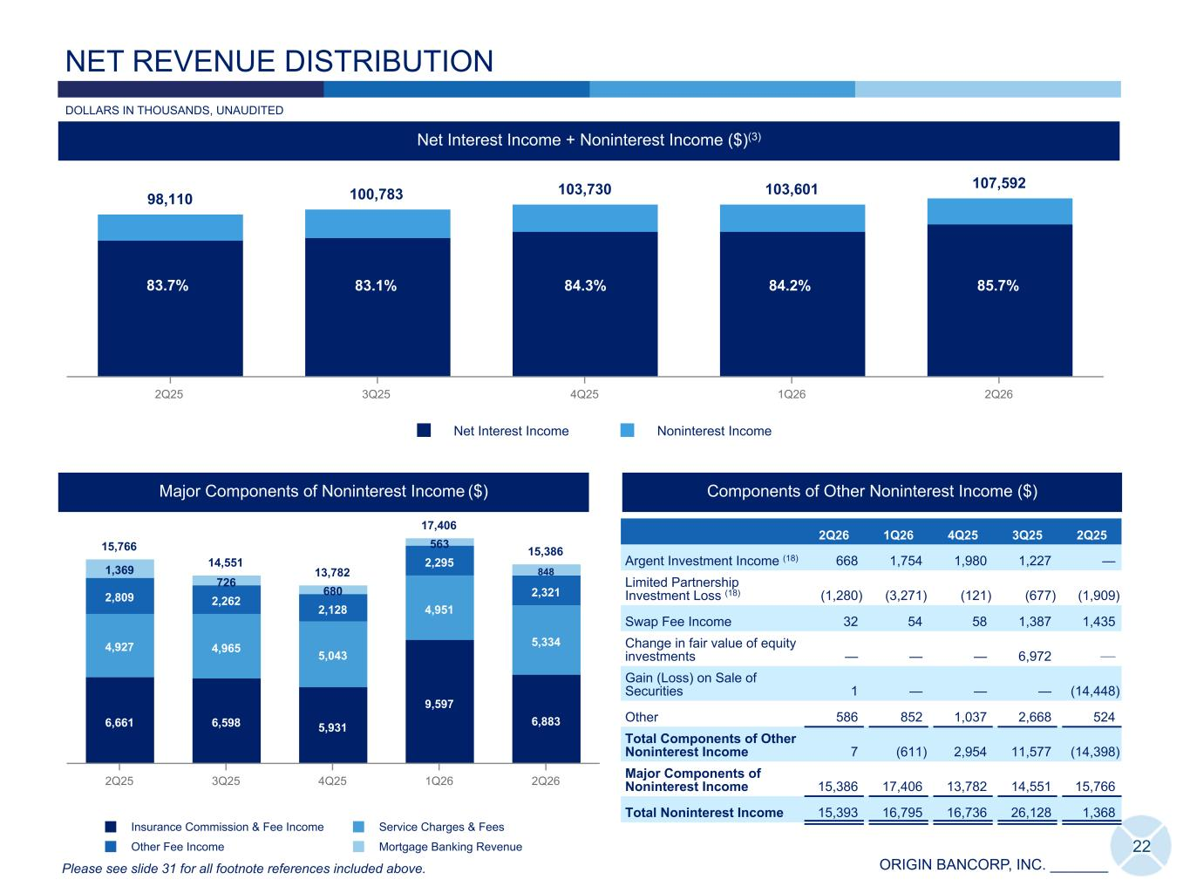
ORIGIN BANCORP, INC. _______ 98,110 100,783 103,730 103,601 107,592 Net Interest Income Noninterest Income 2Q25 3Q25 4Q25 1Q26 2Q26 15,766 14,551 13,782 17,406 15,386 6,661 6,598 5,931 9,597 6,883 4,927 4,965 5,043 4,951 5,334 2,809 2,262 2,128 2,295 2,321 1,369 726 680 563 848 Insurance Commission & Fee Income Service Charges & Fees Other Fee Income Mortgage Banking Revenue 2Q25 3Q25 4Q25 1Q26 2Q26 22 Major Components of Noninterest Income ($) Net Interest Income + Noninterest Income ($)(3) NET REVENUE DISTRIBUTION Components of Other Noninterest Income ($) 2Q26 1Q26 4Q25 3Q25 2Q25 Argent Investment Income (18) 668 1,754 1,980 1,227 — Limited Partnership Investment Loss (18) (1,280) (3,271) (121) (677) (1,909) Swap Fee Income 32 54 58 1,387 1,435 Change in fair value of equity investments — — — 6,972 — Gain (Loss) on Sale of Securities 1 — — — (14,448) Other 586 852 1,037 2,668 524 Total Components of Other Noninterest Income 7 (611) 2,954 11,577 (14,398) Major Components of Noninterest Income 15,386 17,406 13,782 14,551 15,766 Total Noninterest Income 15,393 16,795 16,736 26,128 1,368 83.7% 85.7% Please see slide 31 for all footnote references included above. DOLLARS IN THOUSANDS, UNAUDITED 84.2%84.3%83.1%

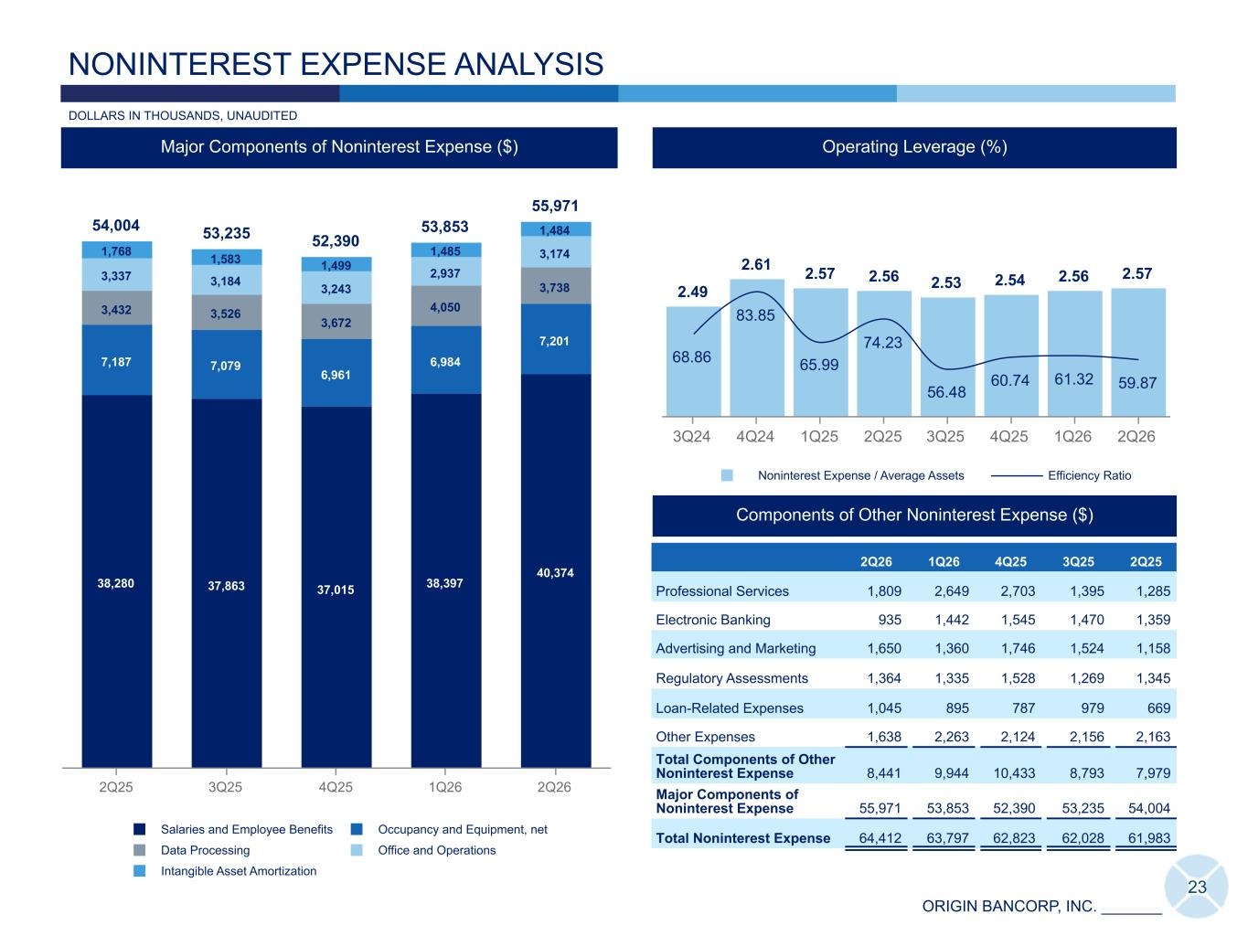
ORIGIN BANCORP, INC. _______ 23 Efficiency Ratio (%) NONINTEREST EXPENSE ANALYSIS Major Components of Noninterest Expense ($) 66.82 68.86 83.85 65.99 74.23 56.48 61.32 59.87 Consolidated Efficiency Ratio 3Q24 4Q24 1Q25 2Q25 3Q25 4Q25 1Q26 2Q26 Operating Leverage (%) 2.49 2.61 2.57 2.56 2.53 2.54 2.56 2.57 68.86 83.85 65.99 74.23 56.48 60.74 61.32 59.87 Noninterest Expense / Average Assets Efficiency Ratio 3Q24 4Q24 1Q25 2Q25 3Q25 4Q25 1Q26 2Q26 54,004 53,235 52,390 53,853 55,971 38,280 37,863 37,015 38,397 40,374 7,187 7,079 6,961 6,984 7,201 3,432 3,526 3,672 4,050 3,738 3,337 3,184 3,243 2,937 3,1741,768 1,583 1,499 1,485 1,484 Salaries and Employee Benefits Occupancy and Equipment, net Data Processing Office and Operations Intangible Asset Amortization 2Q25 3Q25 4Q25 1Q26 2Q26 Components of Other Noninterest Expense ($) 2Q26 1Q26 4Q25 3Q25 2Q25 Professional Services 1,809 2,649 2,703 1,395 1,285 Electronic Banking 935 1,442 1,545 1,470 1,359 Advertising and Marketing 1,650 1,360 1,746 1,524 1,158 Regulatory Assessments 1,364 1,335 1,528 1,269 1,345 Loan-Related Expenses 1,045 895 787 979 669 Other Expenses 1,638 2,263 2,124 2,156 2,163 Total Components of Other Noninterest Expense 8,441 9,944 10,433 8,793 7,979 Major Components of Noninterest Expense 55,971 53,853 52,390 53,235 54,004 Total Noninterest Expense 64,412 63,797 62,823 62,028 61,983 DOLLARS IN THOUSANDS, UNAUDITED

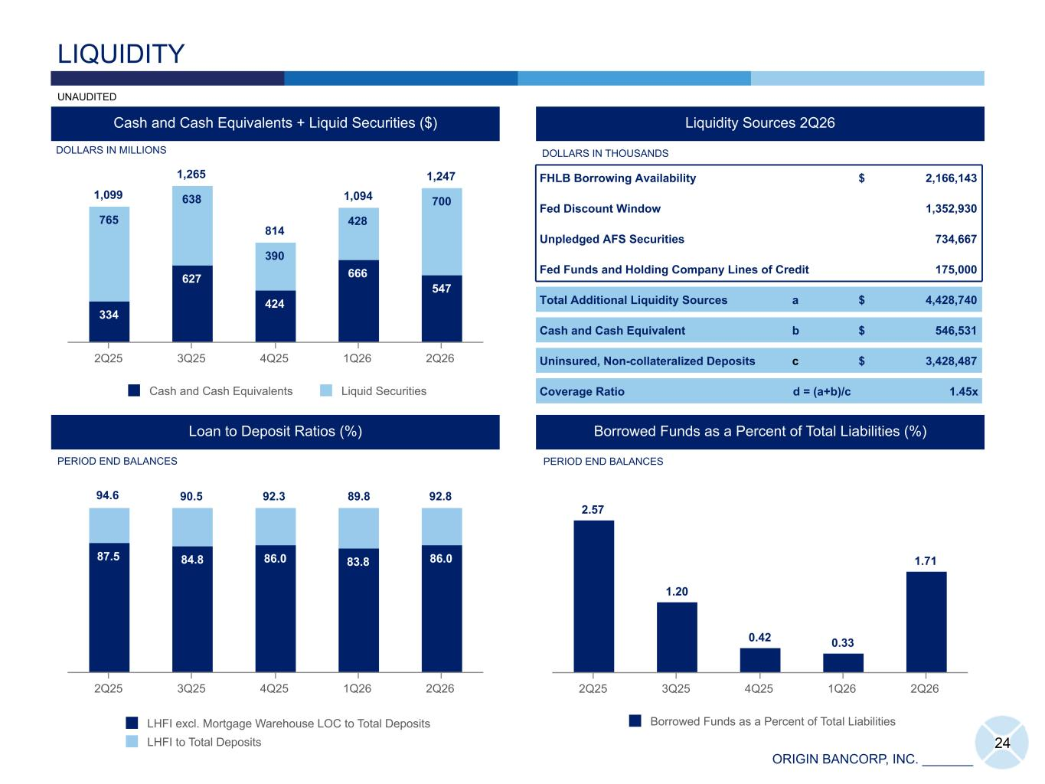
ORIGIN BANCORP, INC. _______ 87.5 84.8 86.0 83.8 86.0 LHFI excl. Mortgage Warehouse LOC to Total Deposits LHFI to Total Deposits 2Q25 3Q25 4Q25 1Q26 2Q26 1,099 1,265 814 1,094 1,247 334 627 424 666 547 765 638 390 428 700 Cash and Cash Equivalents Liquid Securities 2Q25 3Q25 4Q25 1Q26 2Q26 Cash and Cash Equivalents + Liquid Securities ($) 24 LIQUIDITY Loan to Deposit Ratios (%) UNAUDITED Liquidity Sources 2Q26 Borrowed Funds as a Percent of Total Liabilities (%) DOLLARS IN MILLIONS DOLLARS IN THOUSANDS PERIOD END BALANCES PERIOD END BALANCES 2.57 1.20 0.42 0.33 1.71 Borrowed Funds as a Percent of Total Liabilities 2Q25 3Q25 4Q25 1Q26 2Q26 FHLB Borrowing Availability $ 2,166,143 Fed Discount Window 1,352,930 Unpledged AFS Securities 734,667 Fed Funds and Holding Company Lines of Credit 175,000 Total Additional Liquidity Sources a $ 4,428,740 Cash and Cash Equivalent b $ 546,531 Uninsured, Non-collateralized Deposits c $ 3,428,487 Coverage Ratio d = (a+b)/c 1.45x 94.6 90.5 92.3 89.8 92.8

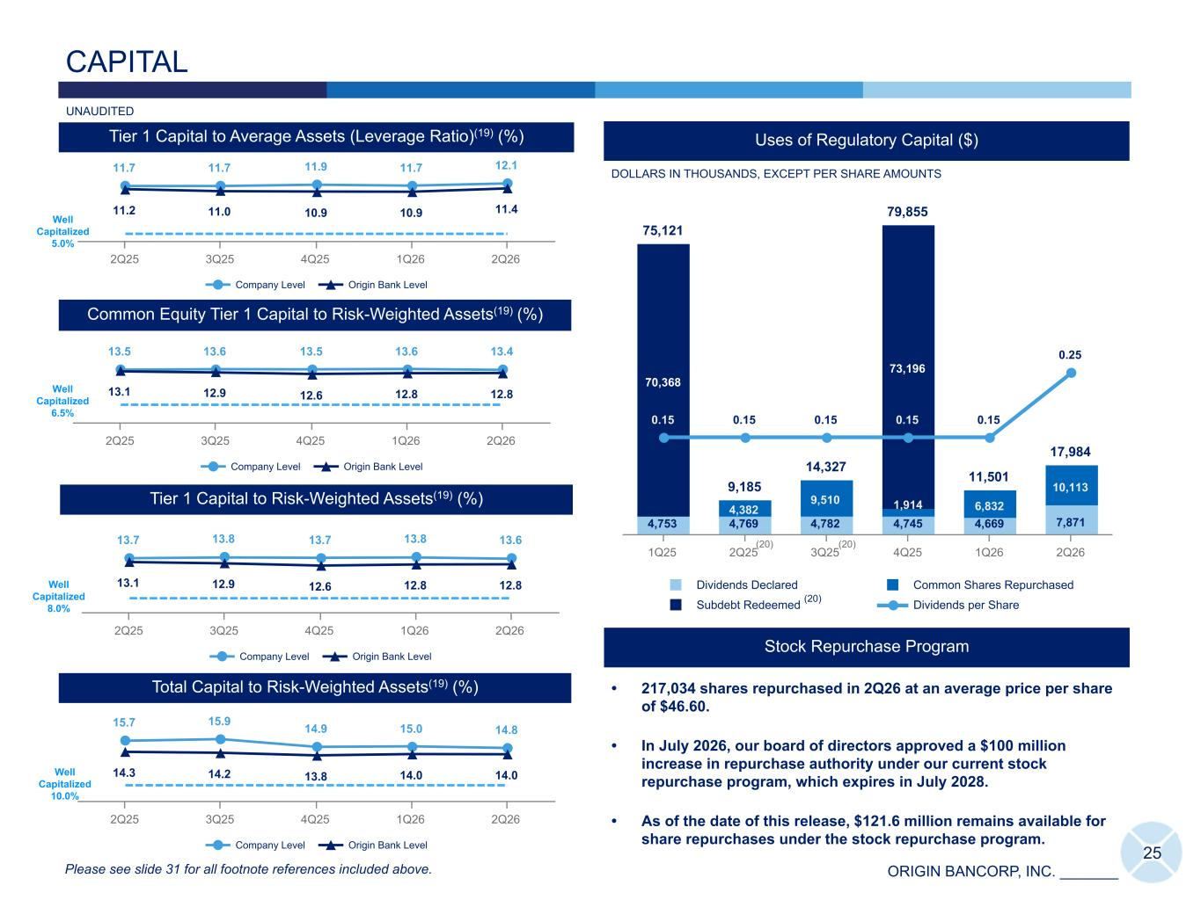
ORIGIN BANCORP, INC. _______ 25 CAPITAL Common Equity Tier 1 Capital to Risk-Weighted Assets(19) (%) ICap ICap Total Capital to Risk-Weighted Assets(19) (%) Tier 1 Capital to Risk-Weighted Assets(19) (%) Tier 1 Capital to Average Assets (Leverage Ratio)(19) (%) Please see slide 31 for all footnote references included above. UNAUDITED Stock Repurchase Program • 217,034 shares repurchased in 2Q26 at an average price per share of $46.60. • In July 2026, our board of directors approved a $100 million increase in repurchase authority under our current stock repurchase program, which expires in July 2028. • As of the date of this release, $121.6 million remains available for share repurchases under the stock repurchase program. 11.7 11.7 11.9 11.7 12.1 11.2 11.0 10.9 10.9 11.4 Company Level Origin Bank Level 2Q25 3Q25 4Q25 1Q26 2Q26 13.7 13.8 13.7 13.8 13.6 13.1 12.9 12.6 12.8 12.8 Company Level Origin Bank Level 2Q25 3Q25 4Q25 1Q26 2Q26 15.7 15.9 14.9 15.0 14.8 14.3 14.2 13.8 14.0 14.0 Company Level Origin Bank Level 2Q25 3Q25 4Q25 1Q26 2Q26 13.5 13.6 13.5 13.6 13.4 13.1 12.9 12.6 12.8 12.8 Company Level Origin Bank Level 2Q25 3Q25 4Q25 1Q26 2Q26 Well Capitalized 5.0% Well Capitalized 6.5% Well Capitalized 10.0% Well Capitalized 8.0% 75,121 9,185 14,327 79,855 11,501 17,984 4,753 4,769 4,782 4,745 4,669 7,871 4,382 9,510 1,914 6,832 10,113 70,368 73,196 0.15 0.15 0.15 0.15 0.15 0.25 Dividends Declared Common Shares Repurchased Subdebt Redeemed Dividends per Share 1Q25 2Q25 3Q25 4Q25 1Q26 2Q26 Uses of Regulatory Capital ($) DOLLARS IN THOUSANDS, EXCEPT PER SHARE AMOUNTS (20) (20) (20)

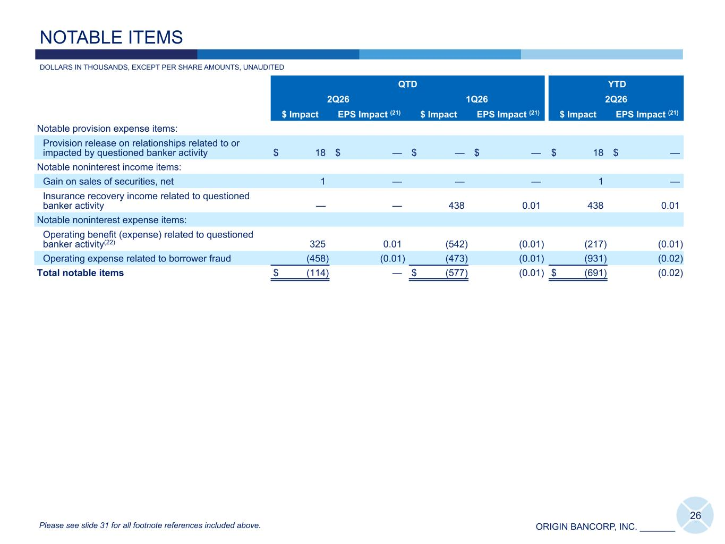
ORIGIN BANCORP, INC. _______ QTD YTD 2Q26 1Q26 2Q26 $ Impact EPS Impact (21) $ Impact EPS Impact (21) $ Impact EPS Impact (21) Notable provision expense items: Provision release on relationships related to or impacted by questioned banker activity $ 18 $ — $ — $ — $ 18 $ — Notable noninterest income items: Gain on sales of securities, net 1 — — — 1 — Insurance recovery income related to questioned banker activity — — 438 0.01 438 0.01 Notable noninterest expense items: Operating benefit (expense) related to questioned banker activity(22) 325 0.01 (542) (0.01) (217) (0.01) Operating expense related to borrower fraud (458) (0.01) (473) (0.01) (931) (0.02) Total notable items $ (114) — $ (577) (0.01) $ (691) (0.02) 26 DOLLARS IN THOUSANDS, EXCEPT PER SHARE AMOUNTS, UNAUDITED NOTABLE ITEMS Please see slide 31 for all footnote references included above.

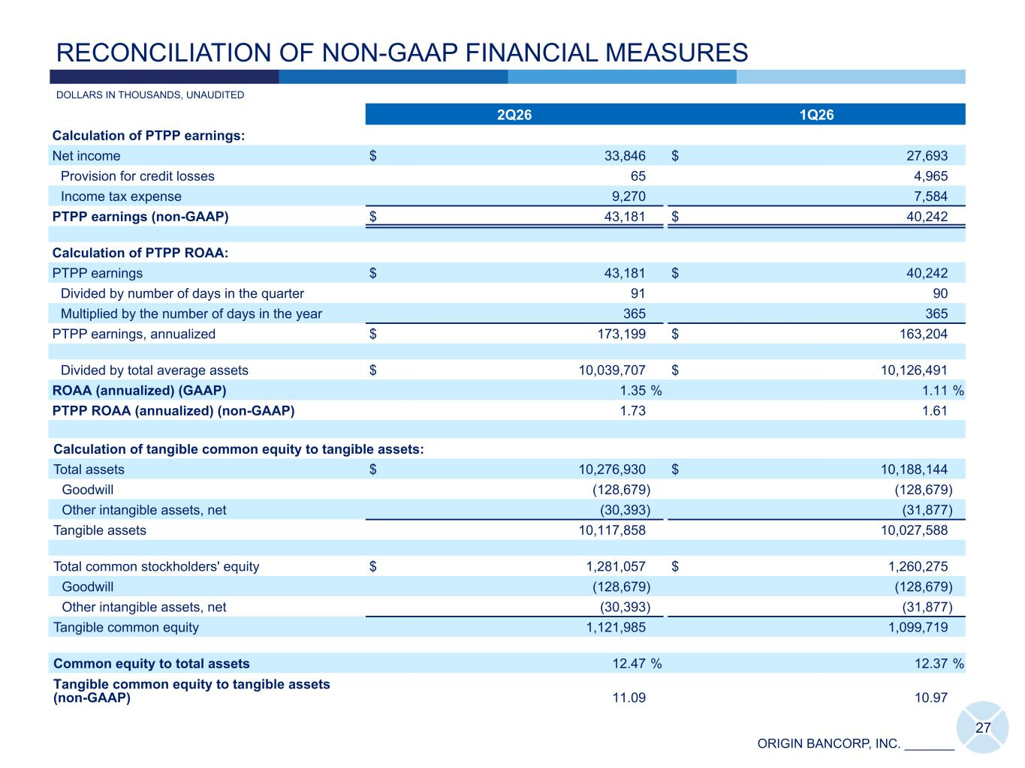
ORIGIN BANCORP, INC. _______ 2Q26 1Q26 Calculation of PTPP earnings: Net income $ 33,846 $ 27,693 Provision for credit losses 65 4,965 Income tax expense 9,270 7,584 PTPP earnings (non-GAAP) $ 43,181 $ 40,242 Calculation of PTPP ROAA: PTPP earnings $ 43,181 $ 40,242 Divided by number of days in the quarter 91 90 Multiplied by the number of days in the year 365 365 PTPP earnings, annualized $ 173,199 $ 163,204 Divided by total average assets $ 10,039,707 $ 10,126,491 ROAA (annualized) (GAAP) 1.35 % 1.11 % PTPP ROAA (annualized) (non-GAAP) 1.73 1.61 Calculation of tangible common equity to tangible assets: Total assets $ 10,276,930 $ 10,188,144 Goodwill (128,679) (128,679) Other intangible assets, net (30,393) (31,877) Tangible assets 10,117,858 10,027,588 Total common stockholders' equity $ 1,281,057 $ 1,260,275 Goodwill (128,679) (128,679) Other intangible assets, net (30,393) (31,877) Tangible common equity 1,121,985 1,099,719 Common equity to total assets 12.47 % 12.37 % Tangible common equity to tangible assets (non-GAAP) 11.09 10.97 27 DOLLARS IN THOUSANDS, UNAUDITED RECONCILIATION OF NON-GAAP FINANCIAL MEASURES

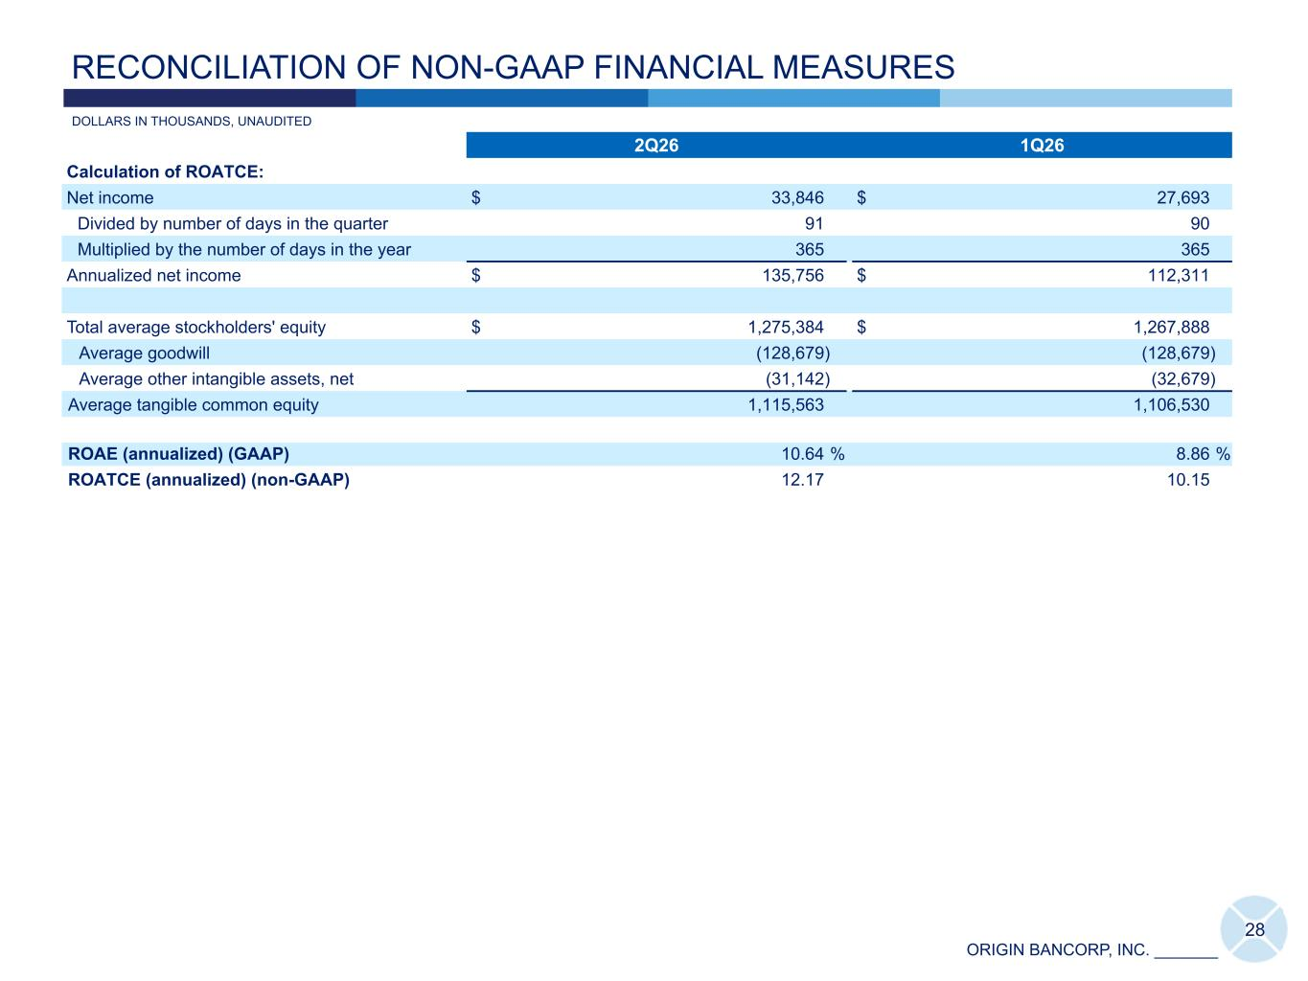
ORIGIN BANCORP, INC. _______ 2Q26 1Q26 Calculation of ROATCE: Net income $ 33,846 $ 27,693 Divided by number of days in the quarter 91 90 Multiplied by the number of days in the year 365 365 Annualized net income $ 135,756 $ 112,311 Total average stockholders' equity $ 1,275,384 $ 1,267,888 Average goodwill (128,679) (128,679) Average other intangible assets, net (31,142) (32,679) Average tangible common equity 1,115,563 1,106,530 ROAE (annualized) (GAAP) 10.64 % 8.86 % ROATCE (annualized) (non-GAAP) 12.17 10.15 28 DOLLARS IN THOUSANDS, UNAUDITED RECONCILIATION OF NON-GAAP FINANCIAL MEASURES

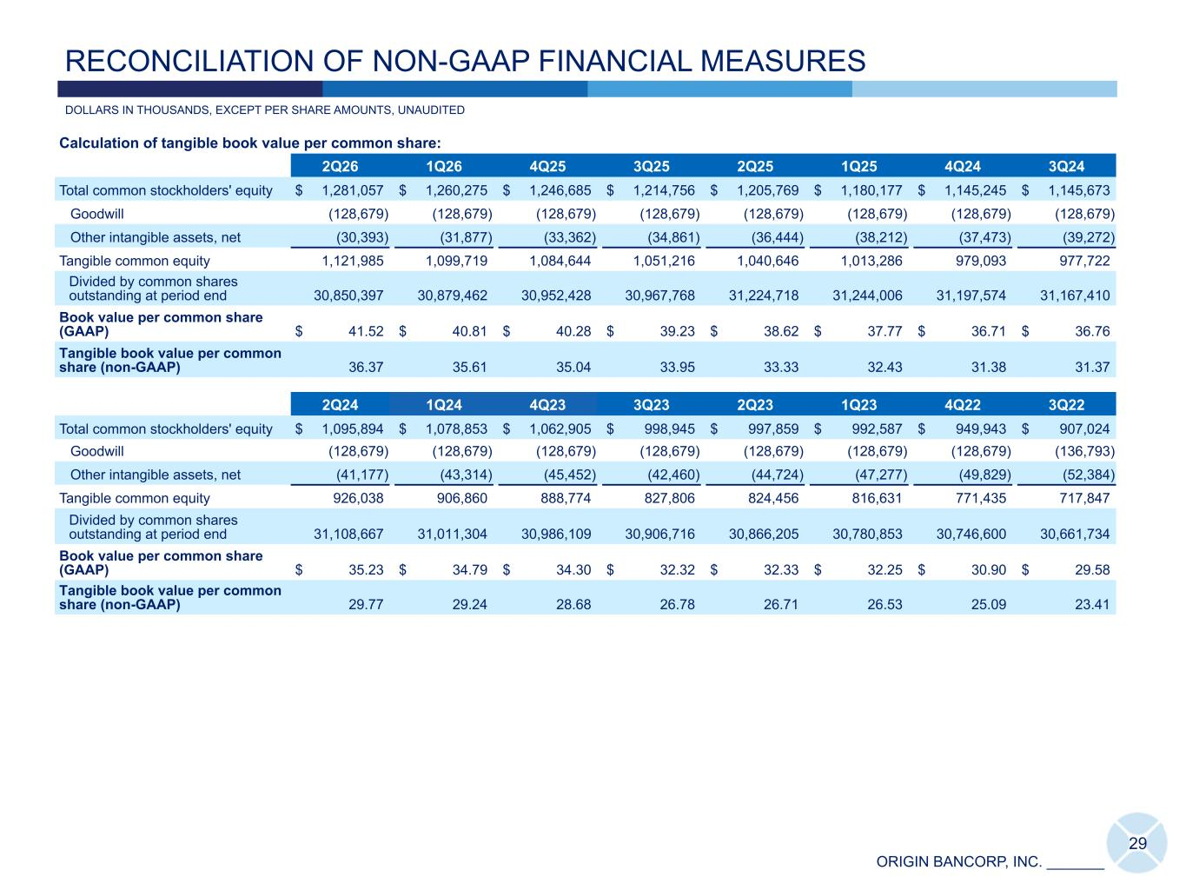
ORIGIN BANCORP, INC. _______ Calculation of tangible book value per common share: 2Q26 1Q26 4Q25 3Q25 2Q25 1Q25 4Q24 3Q24 Total common stockholders' equity $ 1,281,057 $ 1,260,275 $ 1,246,685 $ 1,214,756 $ 1,205,769 $ 1,180,177 $ 1,145,245 $ 1,145,673 Goodwill (128,679) (128,679) (128,679) (128,679) (128,679) (128,679) (128,679) (128,679) Other intangible assets, net (30,393) (31,877) (33,362) (34,861) (36,444) (38,212) (37,473) (39,272) Tangible common equity 1,121,985 1,099,719 1,084,644 1,051,216 1,040,646 1,013,286 979,093 977,722 Divided by common shares outstanding at period end 30,850,397 30,879,462 30,952,428 30,967,768 31,224,718 31,244,006 31,197,574 31,167,410 Book value per common share (GAAP) $ 41.52 $ 40.81 $ 40.28 $ 39.23 $ 38.62 $ 37.77 $ 36.71 $ 36.76 Tangible book value per common share (non-GAAP) 36.37 35.61 35.04 33.95 33.33 32.43 31.38 31.37 2Q24 1Q24 4Q23 3Q23 2Q23 1Q23 4Q22 3Q22 Total common stockholders' equity $ 1,095,894 $ 1,078,853 $ 1,062,905 $ 998,945 $ 997,859 $ 992,587 $ 949,943 $ 907,024 Goodwill (128,679) (128,679) (128,679) (128,679) (128,679) (128,679) (128,679) (136,793) Other intangible assets, net (41,177) (43,314) (45,452) (42,460) (44,724) (47,277) (49,829) (52,384) Tangible common equity 926,038 906,860 888,774 827,806 824,456 816,631 771,435 717,847 Divided by common shares outstanding at period end 31,108,667 31,011,304 30,986,109 30,906,716 30,866,205 30,780,853 30,746,600 30,661,734 Book value per common share (GAAP) $ 35.23 $ 34.79 $ 34.30 $ 32.32 $ 32.33 $ 32.25 $ 30.90 $ 29.58 Tangible book value per common share (non-GAAP) 29.77 29.24 28.68 26.78 26.71 26.53 25.09 23.41 29 RECONCILIATION OF NON-GAAP FINANCIAL MEASURES DOLLARS IN THOUSANDS, EXCEPT PER SHARE AMOUNTS, UNAUDITED

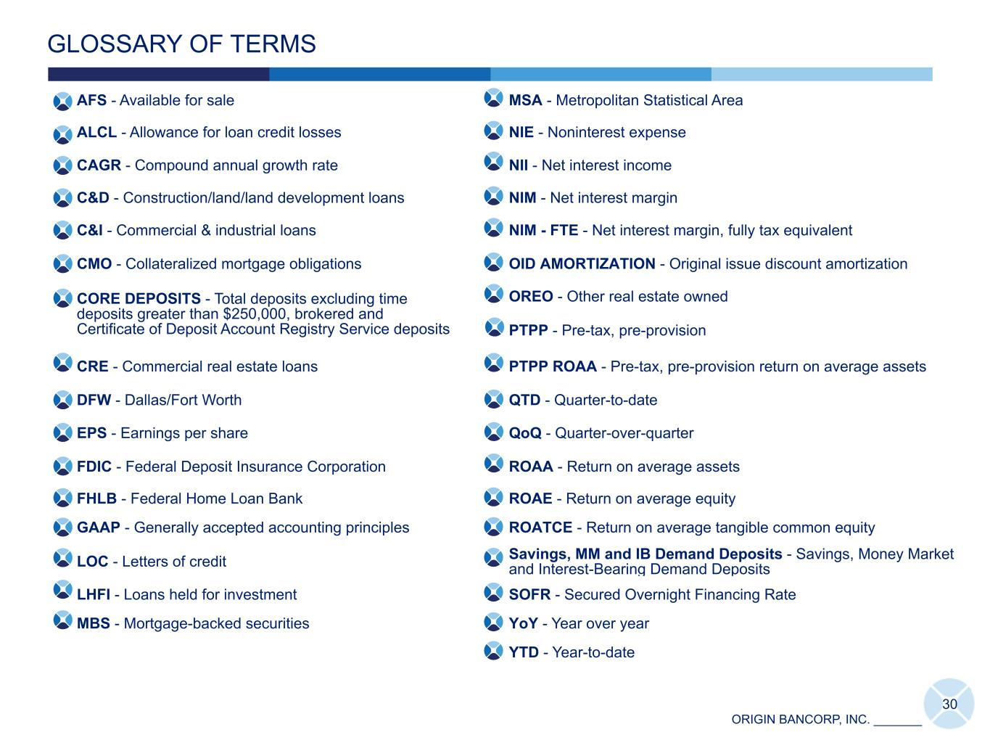
ORIGIN BANCORP, INC. _______ AFS - Available for sale MSA - Metropolitan Statistical Area ALCL - Allowance for loan credit losses NIE - Noninterest expense CAGR - Compound annual growth rate NII - Net interest income C&D - Construction/land/land development loans NIM - Net interest margin C&I - Commercial & industrial loans NIM - FTE - Net interest margin, fully tax equivalent CMO - Collateralized mortgage obligations OID AMORTIZATION - Original issue discount amortization CORE DEPOSITS - Total deposits excluding time deposits greater than $250,000, brokered and Certificate of Deposit Account Registry Service deposits OREO - Other real estate owned PTPP - Pre-tax, pre-provision CRE - Commercial real estate loans PTPP ROAA - Pre-tax, pre-provision return on average assets DFW - Dallas/Fort Worth QTD - Quarter-to-date EPS - Earnings per share QoQ - Quarter-over-quarter FDIC - Federal Deposit Insurance Corporation ROAA - Return on average assets FHLB - Federal Home Loan Bank ROAE - Return on average equity GAAP - Generally accepted accounting principles ROATCE - Return on average tangible common equity LOC - Letters of credit Savings, MM and IB Demand Deposits - Savings, Money Market and Interest-Bearing Demand Deposits LHFI - Loans held for investment SOFR - Secured Overnight Financing Rate MBS - Mortgage-backed securities YoY - Year over year YTD - Year-to-date GLOSSARY OF TERMS 30

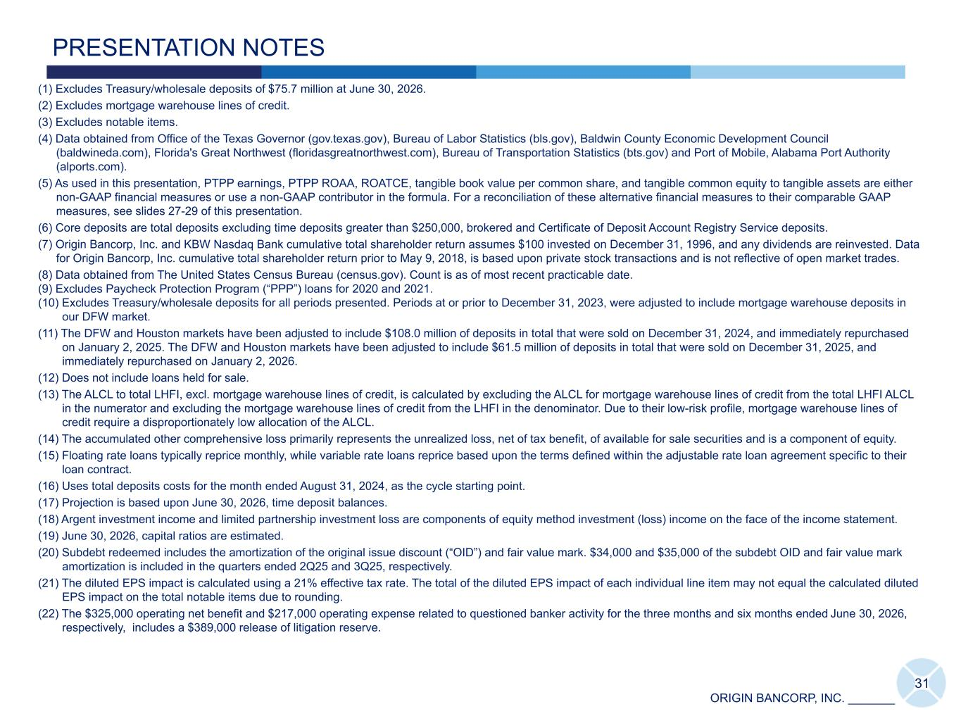
ORIGIN BANCORP, INC. _______ 31 PRESENTATION NOTES (1) Excludes Treasury/wholesale deposits of $75.7 million at June 30, 2026. (2) Excludes mortgage warehouse lines of credit. (3) Excludes notable items. (4) Data obtained from Office of the Texas Governor (gov.texas.gov), Bureau of Labor Statistics (bls.gov), Baldwin County Economic Development Council (baldwineda.com), Florida's Great Northwest (floridasgreatnorthwest.com), Bureau of Transportation Statistics (bts.gov) and Port of Mobile, Alabama Port Authority (alports.com). (5) As used in this presentation, PTPP earnings, PTPP ROAA, ROATCE, tangible book value per common share, and tangible common equity to tangible assets are either non-GAAP financial measures or use a non-GAAP contributor in the formula. For a reconciliation of these alternative financial measures to their comparable GAAP measures, see slides 27-29 of this presentation. (6) Core deposits are total deposits excluding time deposits greater than $250,000, brokered and Certificate of Deposit Account Registry Service deposits. (7) Origin Bancorp, Inc. and KBW Nasdaq Bank cumulative total shareholder return assumes $100 invested on December 31, 1996, and any dividends are reinvested. Data for Origin Bancorp, Inc. cumulative total shareholder return prior to May 9, 2018, is based upon private stock transactions and is not reflective of open market trades. (8) Data obtained from The United States Census Bureau (census.gov). Count is as of most recent practicable date. (9) Excludes Paycheck Protection Program (“PPP”) loans for 2020 and 2021. (10) Excludes Treasury/wholesale deposits for all periods presented. Periods at or prior to December 31, 2023, were adjusted to include mortgage warehouse deposits in our DFW market. (11) The DFW and Houston markets have been adjusted to include $108.0 million of deposits in total that were sold on December 31, 2024, and immediately repurchased on January 2, 2025. The DFW and Houston markets have been adjusted to include $61.5 million of deposits in total that were sold on December 31, 2025, and immediately repurchased on January 2, 2026. (12) Does not include loans held for sale. (13) The ALCL to total LHFI, excl. mortgage warehouse lines of credit, is calculated by excluding the ALCL for mortgage warehouse lines of credit from the total LHFI ALCL in the numerator and excluding the mortgage warehouse lines of credit from the LHFI in the denominator. Due to their low-risk profile, mortgage warehouse lines of credit require a disproportionately low allocation of the ALCL. (14) The accumulated other comprehensive loss primarily represents the unrealized loss, net of tax benefit, of available for sale securities and is a component of equity. (15) Floating rate loans typically reprice monthly, while variable rate loans reprice based upon the terms defined within the adjustable rate loan agreement specific to their loan contract. (16) Uses total deposits costs for the month ended August 31, 2024, as the cycle starting point. (17) Projection is based upon June 30, 2026, time deposit balances. (18) Argent investment income and limited partnership investment loss are components of equity method investment (loss) income on the face of the income statement. (19) June 30, 2026, capital ratios are estimated. (20) Subdebt redeemed includes the amortization of the original issue discount (“OID”) and fair value mark. $34,000 and $35,000 of the subdebt OID and fair value mark amortization is included in the quarters ended 2Q25 and 3Q25, respectively. (21) The diluted EPS impact is calculated using a 21% effective tax rate. The total of the diluted EPS impact of each individual line item may not equal the calculated diluted EPS impact on the total notable items due to rounding. (22) The $325,000 operating net benefit and $217,000 operating expense related to questioned banker activity for the three months and six months ended June 30, 2026, respectively, includes a $389,000 release of litigation reserve.

Exhibit 99.3
FOR IMMEDIATE RELEASE
July 22, 2026

Origin Bancorp, Inc. Announces Declaration of Quarterly Cash Dividend
RUSTON, LOUISIANA (July 22, 2026) - Origin Bancorp, Inc. (NYSE: OBK) ("Origin"), the holding company for Origin Bank, today announced that on July 22, 2026, its board of directors declared a quarterly cash dividend of $0.25 per share of its common stock. The cash dividend will be paid on August 31, 2026, to stockholders of record as of the close of business on August 14, 2026.
About Origin Bancorp, Inc.
Origin Bancorp, Inc. is a financial holding company headquartered in Ruston, Louisiana. Origin’s wholly owned bank subsidiary, Origin Bank, was founded in 1912 in Choudrant, Louisiana. Deeply rooted in Origin’s history is a culture committed to providing personalized relationship banking to businesses, municipalities, and personal clients to enrich the lives of the people in the communities it serves. Origin provides a broad range of financial services and currently operates more than 57 locations in Dallas/Fort Worth, East Texas, Houston, North Louisiana, Mississippi, Alabama and the Florida Panhandle. In addition, Origin provides a broad range of insurance agency products and services through its wholly owned insurance agency subsidiary, Forth Insurance, LLC. For more information, visit www.origin.bank and www.forthinsurance.com.
Forward-Looking Statements
When used in filings by Origin Bancorp, Inc. (the "Company") with the Securities and Exchange Commission (the "SEC"), in the Company's press releases or other public or stockholder communications, and in oral statements made with the approval of an authorized executive officer, the words or phrases "anticipates," "believes," "estimates," "expects," “foresees,” "intends," "plans," "projects," and similar expressions or future or conditional verbs such as "could," "may," “might,” "should," "will," and "would" or variations of such terms" are intended to identify "forward-looking statements" within the meaning of the Private Securities Litigation Reform Act of 1995. Such statements are subject to certain risks and uncertainties that could cause actual results to differ materially from historical earnings and those presently anticipated or projected. Factors that might cause such a difference include among other things: the expected payment date of its quarterly cash dividend; changes in economic conditions; other legislative changes generally; changes in policies by regulatory agencies; fluctuations in interest rates; the risks of lending and investing activities, including changes in the level and direction of loan delinquencies and write-offs and changes in estimates of the adequacy of the allowance for loan losses; the Company's ability to access cost-effective funding; fluctuations in real estate values and both residential and commercial real estate market conditions; demand for loans and deposits in the Company's market area; competition; and changes in management’s business strategies and other factors set forth in the Company's filings with the SEC.
The Company does not undertake and specifically declines any obligation - to update or revise any forward-looking statements to reflect events or circumstances that occur after the date of such statements or to reflect the occurrence of anticipated or unanticipated events.
Contact Information
Investor Relations
Chris Reigelman
318-497-3177
chris@origin.bank

Media Contact
Ryan Kilpatrick
318-232-7472
rkilpatrick@origin.bank

